**Pryce aPPlication**



**DESIGN & DEVELOPED BY**

**PEGASUS TECHNOLOGIES**



Table of Contents

1. Inventory 4

1.1 Payment Mode Master 4

1.2 Supplier Master 9

1.3 Customer Master 15

1.4 Document Number 20

1.5 Parameter Master 26

1.6 Unit Master 32

1.7 Product Brand Master 37

1.8 Product Category Master 41

1.9 Model Master 47

1.10 Option Category Master 53

1.11 Bill of Material 57

1.12 Product Builder Page 63

1.13 Label Builder 66

1.14 Product Master 68

1.15 Ship Expenses 80

1.16 Rack Setup 84

1.17 Opening Stock 90

1.18 Transfer Request 91

1.19 Transfer In 95

1.20 Transfer Out 98

1.21 Physical Inventory 103

1.22 Stock Adjustment 108

1.23 Product Ledger- 111

1.24 Product Stock 112

1.25 Serial Movement 113

2.Purchase 114

2.1 Purchase Request 114

2.2 Department Approval 120

2.3 Purchase Inquiry 121

2.4 Purchase Quotation 130

2.5 Purchase Order 138

2.6 Purchase Invoice- 156

2.7 Purchase Back Order 167

2.8 Purchase Good Receive 170

2.9 Purchase Return 178

3.Sales 185

3.1 Sales Inquiry 185

3.2 Sales Quotation 194

3.3 Predesign Sales Quotation 203

3.4 Sales Order 209

3.5 Sales Invoice 223

3.6 Sales Invoice Posting 233

3.7 Sales Return 235

3.8 Delivery Voucher 243

3.9 Sales Back Order 250

3.10 Sales Commission 253

# Inventory-

Inventory is often the largest item in the current assets category, and must be accurately counted and valued at the end of each accounting period to determine a company's profit or loss.

# 1.1 Payment Mode Master:-

It’s a Payment Mode Master Page. In this you can add new payment mode. Like Cash, Credit, Loyalty.

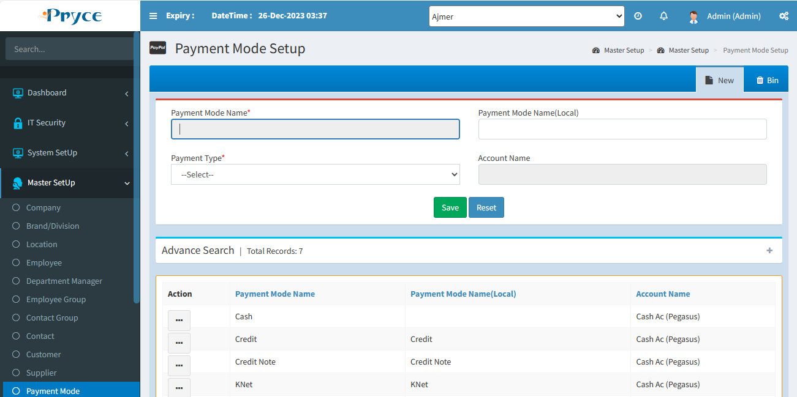

**PageLoad–**

**Here two main function called on page load**

FillGridBin();

FillGrid();

In both functions, the same class is called, and its name is Set_Payment_Mode_Master.cs.

**Save-**

On Save Button Click this function Called btnCSave_Click

In this data Get,save and update,Delete using this procedure

sp_Set_Payment_Mode_Master_Insert

sp_Set_Payment_Mode_Master_Update

sp_Set_Payment_Mode_Master_RowStatus

sp_Set_Payment_Mode_Master_SelectRow

**Reset-** BtnReset_Click this function call on Reset button.

# 1.2 Supplier Master:-

**List-**

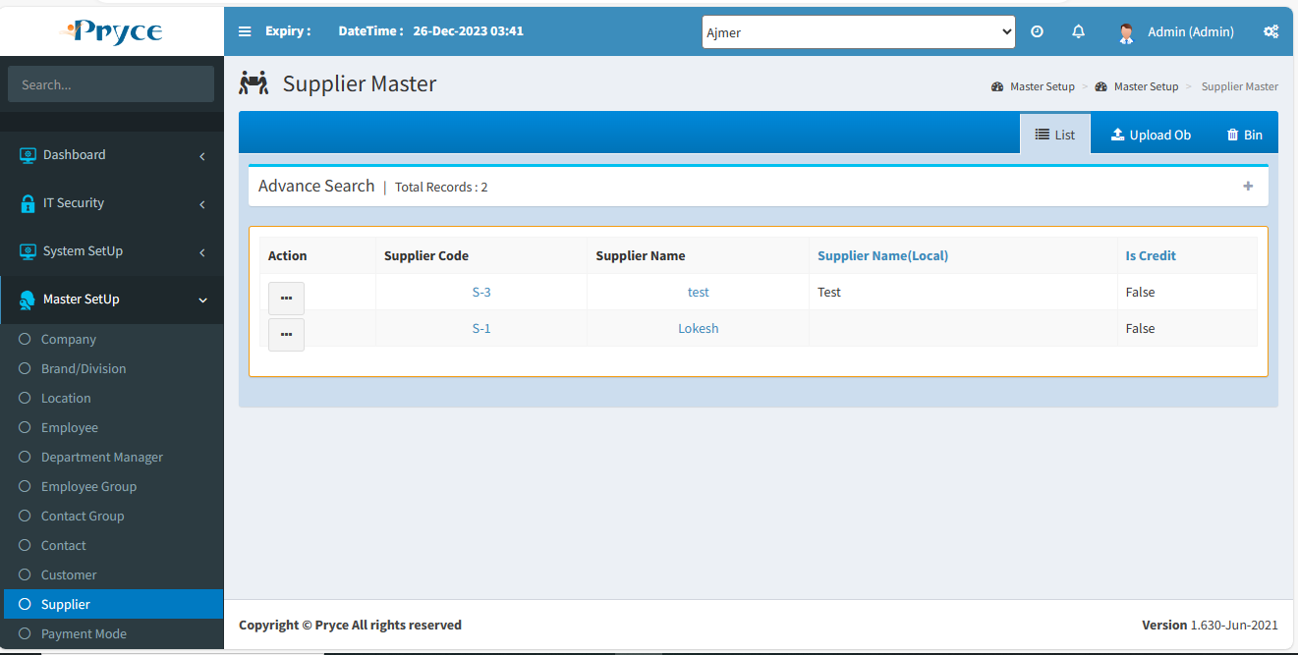

**Page Load:-**

1.There are few function call on page load

* FillGroup();
* FillCurrencyDDL();
* FillProductCategory();
* FillCountryCode();
* FillLocation();
* FillGrid();
* getPageControlsVisibility();

**1.FillGroup:-**

In this function get all contact group form this Class and function

Class=Ems_groupMaster

Function=GetGroupMasterTrueAllData();

In this GetGroupMasterTrueAllData get data throw this Proceduer

sp_Ems_GroupMaster_SelectRow

**2.FillCurrencyDDL:-**

In this function All Currency get from currencyMaster.cs class from this function

GetCurrencyMaster();

And this proceduere is used sp_Sys_CurrencyMaster_SelectRow

**3.FillProductCategory:-**

In this function All Category get from Inv_ProductCategoryMaster.cs class from thi function

GetProductCategoryTrueAllData(CompanyId)

And this procedure is used sp_Inv_Product_CategoryMaster_SelectRow

**4.FillCountryCode:-**

In this function All Country Get From this class Country_Currency.cs from this function

Here optype=2 used

GetCurrencyByCountryId(CountryID,OpType)

This Procedure is used for Get_CurrencyByCountryId get data

**5. Filllocation:-**

In this function All Location Get From this Class LocationMaster.cs from this function

GetLocationMaster(string CompanyId)

And OPType=2

From this Procedure sp_Set_LocationMaster_SelectRow

**6. FillGrid:-**

In this function get All Supplier from this Class Set_Supplier.Cs from this function

GetSupplierAllTrueData(string strCompanyId, string strBrandId)

And OpType=2

From this procedure sp_Set_Suppliers_SelectRow

**7. getPageControlsVisibility:-**

In this function Get visible controls from this class PageControllSettings.cs

**1.Save:- On Save this click event is called btnSupplierSave_Click**

* In this Click Event First Update Suppliers Using this class and function
* Class=Set_Supplier.cs
* Function= UpdateSupplierMaster
* Procedure= sp_Set_Suppliers_Update
* Afeter Update Supplier if Bank Detais found then first Delete Bank reference form this table Set_SupplierMaster_BankReferences

1. **And after delete Again Insert BankReference Using this function**

* InsertSupplierBankRecord
* This function Found on this class Set_Supplier.cs
* Procedure: sp_Set_SupplierMaster_BankReferences_Insert

1. **After insert Bank reference its delete ContactpriceList Using Supplier Id**

* Using this function DeleteContactPriceList()
* This function Found on this class Contact_priceList.cs
* Optype:1
* Proceduere: sp_Contact_PriceList_DeleteRow

4**.After Delete ContactPriceList Again Insert CustomerPriceList**

* Using this Function InsertContact_PriceList()
* This Function Found In this Class Contact_PriceList.cs
* Proceduere: sp_Contact_PriceList_Insert

**5.After Insert ContactPriceList Delete Product Category Using Supplier Id**

* Using This Function DeleteProductCategory()
* This fucnction found in this class Ems_Contact_ProductCategory.cs
* Proceduere:sp_Ems_Contact_ProductCategory_Delete

**6.After Delete Product Category Again Insert ProductCategory**

* Using This Function InsertProductCategory()
* This function found on this class Ems_Contact_ProductCategory.cs
* Proceduere : sp_Ems_Contact_ProductCategory_Insert

**7.After Insert Product Category Delete Address Child**

* Using This Function DeleteAddressChild()
* This Function Found In Set_AddressChild.cs Class
* Procedure: sp_Set_AddressChild_RowStatus

**8.After Delete Get Address By Address Name And After get Insert Again**

* Data Get From this Function GetAddressDataByAddressName() this function found in this class Set_AddressMaster.cs
* Proceduere: sp_Set_AddressMaster_SelectRow
* And Insert From this Function InsertAddressChild() this function Found In this class Set_AddressChild.cs
* Proceduere: sp_Set_AddressChild_Insert

**9.After This Process Delete Contact Bank Detail by ContactId And GroupId**

* Using This Function DeleteContactBankDetail_By_ContactId_And_GroupId
* This Function Found In this Class sp_Contact_BankDetail_DeleteRow
* Proceduere: sp_Contact_BankDetail_DeleteRow

**10.After Delete Get Bank By Bank Name And Insert In Database**

* Using this Function Get Bank GetBankMasterByBankName()
* This Function Found In Set_BankMaster.Cs Class
* Proceduer sp_Set_BankMaster_SelectRow
* Insert Data Using this Function InsertContact_BankDetail this Function Found In Contact_BankDetails.Cs Class
* Procedure: sp_Contact_BankDetail_Insert

**The Commit the transaction of this page**

Supplier Ob Upload Setcion

On Import Section Click Event Called btnUploadExcel_Click

In this Function Check Excel

After Check Excel He Upload Excel On update Button

btnSaveExcelData_Click this click event called on this update button

here is two function called according on check box condition

saveObExcelData();

saveAgeingExcelData();

1. saveObExcelData : In this function first get supplier Account No. from Ac_ParameterMaster.cs Class from this function GetSupplierAccountNo();

Then get otherAccountId using supplier id and currency id from Ac_AccountMaster.cs class From this Procedure sp_Ac_AccountMaster_SelectRow using Optype=6

1. after getting Insert Account Master using this function InsertAc_AccountMaster And Ac_AccountMaster.cs Class,Procedure sp_Ac_AccountMaster_Update
2. If Other AccountId not Equal to Zero then delete Other Account Id

Then Insert Data in Sub Chart of Account from Ac_SubChartOfAccount.cs Class using this Function And Procedure Function =InsertSubCOA

Procedure= sp_Ac_SubChartOfAccount_Insert

2. saveAgeingExcelData:- in this function you can get first supplier Account NO then delete entry that exist with same invoice

Class:Ac_Ageing_Details

Function : DeleteAgeingDetailByInvoice

After delete Ageing details Insert again ageing detail

Class: Ac_Ageing_Details

Function: InsertAgeingDetail

# 1.3 Customer Master:-

On Page Load there are few functions are called which is

1. FillGridBin();
2. FillGroup();
3. FillCurrencyDDL();
4. FillGrid();
5. FillCustomerCountryCode(objLocation.GetLocationMasterById(Session["CompId"].ToString(), Session["LocId"].ToString()).Rows[0]["Field1"].ToString());
6. FillProductCategory();
7. FillCountryCode();
8. FillOpeningLocation();
9. getPageControlsVisibility();

1. FillGridBin(): in this function you can get Deleted data from Set_CustomerMaster.cs class from this function GetCustomerAllFalseData()

* Procedure : sp_Set_CustomerMaster_SelectRow
* Optype: 3

1. FillGroup(): In this function get All Groups From Ems_GroupMaster.cs class from this function GetGroupMasterTrueAllData();

* Procedure: sp_Ems_GroupMaster_SelectRow
* Optype: 2

1. FillCurrencyDDL():In this function we can get all currency from this CurrencyMaster.cs from this function GetCurrencyMaster();

* Procedure: sp_Sys_CurrencyMaster_SelectRow and Optype:1

1. FillGrid(): In this function get all customer where IsActive=1 from this class

Set_CustomerMaster.cs

* Procedure: sp_Set_CustomerMaster_SelectRow And Optype:2
* FillCustomerCountryCode():- In this function Fill Customer Country Code using CurrencyId.

1. FillProductCategory(): In this function Get All True Category from this class

* Its name is Inv_ProductCategoryMaster.cs from this function GetProductCategoryTrueAllData()
* Procedure: sp_Inv_Product_CategoryMaster_SelectRow and Optype=1

1. FillCountryCode(): In this function we can get Country Id by Location Currency Id
2. FillOpeningLocation():In this function get all location from locationMaster.cs class using this function GetLocationMaster()

Procedure: sp_Set_LocationMaster_SelectRow and Optype=2

ON Save Customer when you click on save button then save button hit this function

1. btnCustomerSave_Click(): In this function he can update customer Master after all procedure check like perameter and page permission the he call this functiomn UpdateContactMaster() on Ems_Contactmaster class and

then first delete sub chart of account and and again insert sub_chartof account  
using Ac_SubChartofAccount.cs

Then Insert ContactPriceList from Contact_PriceList.cs class using this function InsertContact_PriceList and this procedure sp_Contact_PriceList_Insert

Then Insert data in address child table using this function InsertAddressChild

And this class Set_AddressChild.cs

2.Opning balance Upload Section: On upload section when you upload excel then click on Import button its onclick function is

btnUploadExcel_Click: in this function Data get from excel and fill in grid

when click on Update button then its onclick function is

btnSaveExcelData_Click:in this function is there are two function

1. saveObExcelData():In this function first get Account No from Ac_parameterMaster.cs class from this function GetCustomerAccountNo()

then get OtherAccountId from Ac_AccountMaster.cs Class from this function GetCustomerAccountByCurrency()

Procedure : sp_Ac_AccountMaster_SelectRow and OpType:6

If Other AccountId is equal to zero then create new account in account master from this class Ac_AccountMaster

From this function InsertAc_AccountMaster

Procedure: sp_Ac_AccountMaster_Update AndOpType=2

If other Account id is not equal to zero then delete SubChart of Account From this class Ac_SubChartOfAccount.cs and this function deleteOtherAcIdAndFyId();

Then insert SubChart of Account using this class,function and Procedure

Class: Ac_SubChartOfAccount.cs

Function: InsertSubCOA

Procedure: sp_Ac_SubChartOfAccount_Insert

1. saveAgeingExcelData(): In this function Same first get customer Account no. then first delete Delete Ageing Detail by invoice no from this class and function

class:Ac_Ageing_Detail.cs

function: DeleteAgeingDetailByInvoice

after delete insert new record in ageing detail from this class,function,Procedure

Class: Ac_Ageing_Detail.cs

Function: InsertAgeingDetail

Procedure: sp_Ac_Ageing_Detail_Insert

# 1.4 Document Number:-

Page Load: On Page Load there are two functions are called

* FillModule();
* FillObject();

1. FillModule:-in this function get Module Names from Doc_ModuleMaster.cs class from this function and procedure

function: GetModuleName()

Procedure: sp_Doc_ModuleMaster_SelectRow And optype=1

1. FillObject:-In this function get object Names by Module Id from this class,function and Procedure

Class:Doc_Objectentry.cs

Function: GetObjectNameByModuleId();

Procedure: sp_Doc_ObjectEntry_SelectRow And optype=3

Form Code: btnbind_Click in this function its called FillGrid Function

FillGrid(): In this function its visible according object Id and module Id

Save: In this function if edit id is blank then its called Insert Function and if edit id is not equals to blank then he first call delete function then call insert function

Class:Set_DocNumber.cs

Insert function = InsertDocumentNumber And Procedure= sp_Set_DocNumber_Insert

Delete function= DeleteDocumentNumberbyModuleIdandObjectId and procedure= sp_Set_DocNumber_DeleteRow

# 5 Company Master:-

PageLoad: These functions are called on this page

* FillGridBin();
* FillGrid();
* FillCountryDDL();
* FillCurrencyDDL();
* FillddlParentCompanyDDL();
* FillCountryCode();
* FillLocationType();
* FillLabourLaw();
* RootFolder();

1. FillGridBin:-In this function get all inactive companies from this class and function and procedure

* Class:CompanyMaster.cs
* Function: GetCompanyMasterInactive()
* Procedure: sp_Set_CompanyMaster_SelectRow and Optype=3

1. FillGrid:-In this function get all company from this class,function and procedure

* Class:CompanyMaster.cs
* Function: GetCompanyMaster
* Procedure: sp_Set_CompanyMaster_SelectRow and Optype=1

1. FillCountryDDL:-In this function get all country from this class,function and procedure

* Class:CountryMaster.cs
* Function: GetCountryMaster
* Procedure: sp_Sys_CountryMaster_SelectRow and Optype=1

1. FillCurrencyDDL:-In this function get all currency from this class,function,and Procedure

* Class:CurrencyMaster.cs
* Function: GetCurrencyMaster
* Procedure: sp_Sys_CurrencyMaster_SelectRow And optype=1

1. FillddlParentCompanyDDL:-In this function first get all company from this class,function and Procedure

* Class:CompanyMaster.cs
* Function: GetCompanyMaster
* Procedure: sp_Set_CompanyMaster_SelectRow And optype=1
* The Filter According CompanyId Using DataView then Get All Parent Company

1. FillCountryCode:-In this function first get currencyId then Get Country Id by currency id From this class,function and Procedure

* Class:Country_Currency.cs
* Function:GetCurrencyByCountryId
* Procedure: Get_CurrencyByCountryId And optype:2

1. FillLocationType:In this function Get All active Location From this class,function and Prpocedure

* Class: Sys_Locationtype_Master.cs
* Function: GetAllActiveRecord
* Procedure: sp_Sys_LocationType_Master_SelectRow and optype:2

1. FillLabourLaw:Get All Labour Law name and Id from this class,functionand Procedure

* Class:hr_labourLaw_config.cs
* Function: GetAllTrueRecord
* Procedure: sp_hr_laborLaw_config_SelectRow And Optype:2

1. RootFolder:-In this function Get Set FileManager path and Check Directory exist or not If Directory not exist then create

* Save: btnSave_Click() In this Function If Edit Id is equal to blank then its call insert function and if edit id found then its call update function from this class
* Class:CompanyMaster.cs
* Insert Function: InsertCompanyMaster
* Procedure: sp_Set_CompanyMaster_Insert
* Update Function: UpdateCompanyMaster
* Procedure: sp_Set_CompanyMaster_Update

# 6 Brand/Devision:-

Page Load Functions:

* FillGridBin();
* FillGrid();
* RootFolder();

1. FillGridBin:-In this function Get All InActive brands from this class,function and Procedure

* Class:BrandMaster.cs
* Function: GetBrandMasterInactive()
* Procedure: sp_Set_BrandMaster_SelectRow And Optye=3

1. FillGrid:-In this function Get All Active Brand From this Function,Class And Procedure

* Class:BrandMaster.cs
* Function: GetBrandMaster
* Procedure: sp_Set_BrandMaster_SelectRow And Optype:2

1. RootFolder: In this function Get Set FileManager path and Check Directory exist or not If Directory not exist then create

Save: btnSave_Click in this function if editid is equal to blank then call Insert Function Otherwise Update Function Called from this class and functions

* Class:BrandMaster.cs
* Insert Function: InsertBrandMaster
* Procedure: sp_Set_BrandMaster_Insert
* Update Function: UpdateBrandMaster
* Procedure: sp_Set_BrandMaster_Update
* After Insert Brand then insert User Data Pernission from this class,function And Procedure
* Class:UserDataPermission.cs
* Function: InsertUserDataPermission
* Procedure: sp_Set_UserDataPermission_Insert
* Then Insert Address in Address Child Table From this Class,Function And procedure
* Class:Set_AddressChild.cs
* Function: InsertAddressChild
* Procedure: sp_Set_AddressChild_Insert

# Location Master:-

PageLoad Functions:

* FillGridBin()
* FillBrand()
* FillGrid()
* FillddlParentLocationDDL()
* FillCurrencyDDL()
* FillLocationType()
* FillLabourLaw()
* getPageControlsVisibility()
* RootFolder()

1. FillGridBin:-In this function Get All inactive Location From this Class,Function And Procedure

* Class:LocationMaster.cs
* Function: GetLocationMasterInactive
* Procedure: sp_Set_LocationMaster_SelectRow And optype=3

1. FillBrand:-In this function first get all brands from this class,function and Procedure

* Class:BrandMaster.cs
* Function: GetBrandMaster()
* Procedure: sp_Set_BrandMaster_SelectRow And Optype=2
* Then check which brand permission is allowed for current user then bind in dropdown

1. FillGrid:-In this function get all active Locations get from this class,function and procedure

* Class:LocationMaster.cs
* Function: GetLocationMaster()
* Procedure: sp_Set_LocationMaster_SelectRow And Optype=2

1. FillddlParentLocationDDL: In this function get All active Location and bind in dropdown
2. FillCurrencyDDL: In this function get all Currency from this class,function and Procedure

* Class:CurrencyMaster.cs
* Function: GetCurrencyMaster()
* Procedure: sp_Sys_CurrencyMaster_SelectRow And Optype=1

1. FillLocationType:In this function get all Location Type From this class ,function And procedure

* Class:Sys_locationType_Master.cs
* Function: GetAllActiveRecord()
* Procedure: sp_Sys_LocationType_Master_SelectRow And opType=2

1. FillLabourLaw:Get All Labour Law name and Id from this class,functionand Procedure

* Class:hr_labourLaw_config.cs
* Function: GetAllTrueRecord
* Procedure: sp_hr_laborLaw_config_SelectRow And Optype:2

1. getPageControlsVisibility:In this function Field Show According Permissions
2. RootFolder: In this function Get Set FileManager path and Check Directory exist or not If Directory not exist then create

Next:-its OnClick function is btnSave_Click

When you click on this function then first Check if editid==”” then insert Location Master From this class,function and Procedure

Class:LocationMaster.cs

Function: InsertLocationMaster

Procedure: sp_Set_LocationMaster_Insert

Then Check if applicationType is equal to “Cloud” then insert Defult Permission to admin then insert financial record From This Class,function And Procedure

Class: Ac_FinancialYear_Detail.cs

Function: InsertFinancialYearDetail

Procedure: sp_Ac_FinancialYear_Detail_Insert

Then Insert Application Parameter From This Class,Function,Procedure

Class:Set_ApplicationParameter.cs

Fucntion:InsertApplicationParameterMaster

Procedure: sp_Set_ApplicationParameter_Insert

If EditId Found then update Location Master From this class,Function,Object

Class:LocationMater.cs

Function: UpdateLocationMaster

Procedure: sp_Set_LocationMaster_Update

Then Insert Application Parameter And Delete Address Child And Again insert Address Child

Save: when you click on Save Button then its hit this function btnSaveDept_Click

In this function its insert Location Department Master from this class,function Class:Set_Location_Department.cs

Function: InsertLocationDepartmentMaster

Procedure: sp_Set_Location_Department_Insert

Then Insert Child node Save from this function childNodeSave

# 1.6 Employee Master:-

Page Load:these function are called on page load

1. Check_Financial_Year_Status();
2. SetHalfDay();
3. FillLeaveTypeDDL();
4. FillDesignationDDL();
5. FillQualificationDDL();
6. FillReligionDDL();
7. FillNationalityDDL();
8. FillddlLocationList();
9. btnList_Click(null, null);
10. FillCurrencyDDL();
11. FillCurrency1DDL();
12. ddlCompany_SelectedIndexChanged(null, null);
13. rbtOT_OnCheckedChanged(null, null);
14. FillteamLeader();
15. FillCountryCode();
16. FillddlRole();
17. setListLocationValue();
18. imbBtnGrid_Click(null, null);
19. FilldeviceGroup();
20. GetDocumentNumber();
21. getPageControlsVisibility();
22. FillGrade();
23. setModuleWiseControls(); //set tab visibility as of application
24. RootFolder();
25. Check_Financial_Year_Status():-in this function we can check financial year close or not
26. SetHalfDay():-In this function we can get Application Parameter Value by Parameter Name

* From this class,function,procedure and parameter
* Class:Set_ApplicationParameter.cs
* Function: GetApplicationParameterValueByParamName
* Procedure: sp_Set_ApplicationParameter_SelectRow And Optype=1
* Parameter: Half_Day_Count

1. FillLeaveTypeDDL():-In this function we can get all type of leave get from this function,class and procedure

* Class:LeaveMaster.cs
* Function: GetLeaveMaster
* Procedure: sp_Att_LeaveMaster_SelectRow and Optype=2

1. FillDesignationDDL():In this function we can get all type of designation from this class,function and procedure

* Class:DesignationMaster
* Function:GetDesignationMaster()
* Procedure: sp_Set_DesignationMaster_SelectRow and optype=2

1. FillQualificationDDL(): In this function we can get all qualification detail from this class,function and procedure

* Class:QualificationMaster.cs
* Function:GetQualificationMaster.cs
* Procedure:sp_Set_QualificationMaster_SelectRow And Optype=2

1. FillReligionDDL():In this function get All Religion from this class,function and Procedure

* Class:ReligionMaster.cs
* Function: GetReligionMaster()
* Procedure: sp_Set_ReligionMaster_SelectRow and Optype=2

1. FillNationalityDDL():In this function Get all nationality from this class,function and Procedure

* Class:NationalityMaster.cs
* Function: GetNationalityMaster();
* Procedure: sp_Set_NationalityMaster_SelectRow and Optype=2

1. FillddlLocationList():In this function get all locations from this class,function and Procedure

* Class:LocationMaster.cs
* Function: GetLocationMaster()
* Procedure: sp_Set_LocationMaster_SelectRow and Optype=2

1. btnList_Click:In this click event function activate List Section
2. FillCurrencyDDL:In this function get All Currency From this class,function and procedure

* Class:CurrencyMaster.cs
* Function:GetCurrencyMaster()
* Procedure: sp_Sys_CurrencyMaster_SelectRow and optye=1

1. FillCurrency1DDL():In this function Same Procedure Called According Point no 10.
2. ddlCompany_SelectedIndexChanged: In this function Get Role Prmission And Brand
3. FillteamLeader:In this function First Get Employee From EmployeeMaster Class And The Filter Who is team Leader
4. FillCountryCode:In this function Get All Country Code From this class and function And Procedure

* Class:CountryMaster.cs
* Function:getCountryCallingCode()
* Procedure: sp_Sys_CountryMaster_SelectRow and optype=5

1. FillddlRole :In this function Get All RoleMaster Form this class , function and Procedure

* Class:RoleMaster.cs
* Function:GetRoleMaster
* Procedure: sp_Set_RoleMaster_SelectRow And Optype

1. setListLocationValue():In this function we can select Department and Location’s according selected value
2. imbBtnGrid_Click : In this click event function we can hide and show some pannel
3. FilldeviceGroup :In this function we can get all device master in from this class ,function and procedure

* Class:Att_DeviceGroupMaster.cs
* Function: GetHeaderAllTrueRecord
* Procedure: sp_Att_DeviceGroupMaster_SelectRow and Optype =2

1. GetDocumentNumber: In this function get Document no of this class,function And procedure

* Class:Set_DocNumber.cs
* Function:GetDocumentNo
* Procedure: In this function one are called its name is GetDocumentNumberAll in this function call a procedure sp_Set_DocNumber_SelectRow

1. getPageControlsVisibility:In this function we can set page controll visibility
2. FillGrade:In this function we can add grade in grade dropdown
3. setModuleWiseControls: In this function we can hide and show some pannel according application module permissions
4. RootFolder: In this function we can add root folder for file manger

* **SAVE:** On Save this click event is called its name is btnSave_Click in this click event function if editid found then this function is call from this class,function,procedure
* Class:EmployeeMaster.cs
* Function:UpdateEmployeeMaster
* Procedure: sp_Set_EmployeeMaster_Update
* If editid not found then this function is called
* Class: InsertEmployeeMaster
* Procedure: sp_Set_EmployeeMaster_Insert
* **Delete**:On this click event is called btnDelete_Command in this click event function this class,function and procedure is called
* Class:EmployeeMaster.cs
* Function:DeleteEmployeeMaster
* Procedure: sp_Set_EmployeeMaster_RowStatus

# 1.6 Department Manager:-

**Page Load**:these function are called on page load

* fillLocation()
* FillGrid()
* FillCountryCode()

1. fillLocation:In this function get All Location From this class,function and Procedure

* Class:LocationMaster.cs
* Function:GetLocationMaster
* Procedure: sp_Set_LocationMaster_SelectRow and Optype=2

1. FillGrid:In this function Get All department by Location Id from this class,function and Procedure

* Class:Set_Location_Department
* Function: GetDepartmentByLocationId
* Procedure: sp_Set_Location_Department_SelectRow and Optype=2

1. FillCountryCode:In this function get All Country from this class,function and Procedure

* Class:CountryMaster.cs
* Function: getCountryCallingCode
* Procedure: sp_Sys_CountryMaster_SelectRow and Optype=5

1. **Save**:On Save its called this click event function btnCSave_Click.In this function

If editId found then its update department from this class,function and procedure

* Class:Set_Location_Department.cs
* Function: UpdateLocationDepartmentMaster
* Procedure: sp_Set_Location_Department_Update
* If editId not found then its Showing Mesaage “First click on edit button in below grid”

1. **Delete**:On Delete its called this click event its name is IbtnDelete_Command in this click event its called this class,function and procedure

* Class:Set_Location_Department.cs
* Function: DeleteLocationMasterByTransId
* Procedure: sp_Set_Location_Department_Delete and Optyce=2

# 1.6 Employee Group:-

**Page Load**:these function are called on page load

* FillGridBin()
* FillGrid();
* FillddlLocation();
* FillddlDeaprtment();

1. **FillGridBin**: In this function Get all deleted records from this class,function and procedure

* Class:Set_EmployeeGroupMaster.cs
* Function: GetEmployeeGroup_MasterInactive
* Procedure: sp_Set_EmployeeGroup_Master_SelectRow and Optype=3

1. FillGrid:In this function Get All Employee Group From this class , function and Procedure

* Class:Set_EmployeeGroupMaster.cs
* Function: GetEmployeeGroup_Master
* Procedure: sp_Set_EmployeeGroup_Master_SelectRow And Optype=2

1. FillddlLocation:In this function we can get all Location from this class,function and procedure

* Class:LoactionMaster.cs
* Function: GetLocationMaster  
  Procedure: sp_Set_LocationMaster_SelectRow and Optype=2

1. FillddlDeaprtment:In function this Fill Department in dropdown

**Save**:OnClick its Called this click event called is btnCSave_Click in this click event function if editid found then its called update function from this class,function and Procedure

* Class:Set_EmployeeGroupMaster.cs
* Function: UpdateEmployeeGroup_Master
* Procedure: sp_Set_EmployeeGroup_Master_Update
* if editid not found then its called insert function from this class,function and procedure
* Class:Set_EmployeeGroupMaster.cs
* Function: InsertEmployeeGroup_Master
* Procedure: sp_Set_EmployeeGroup_Master_Insert

Delete:In this button its called this click event function IbtnDelete_Command. In this click event function this function,class and procedure are called

* Class:Set_EmployeeGroupMaster.cs
* Function: DeleteEmployeeGroup_Master
* Procedure: sp_Set_EmployeeGroup_Master_RowStatus

# 1.6 City Master:-

**Page Load**:these function are called on page load

1. fillCountry()
2. fillGridBin();
3. AllPageCode();
4. FillGrid();
5. fillCountry:Get All Country from this class,function and procedure

* Class:CountryMaster.cs
* Function: GetCountryMaster
* Procedure: sp_Sys_CountryMaster_SelectRow and Optype=2

1. fillGridBin:In this Function Get Alll Deleted City from this class

* Class:CityMaster.cs
* Function: GetAllIsActiveFalseCities
* Procedure: sp_Sys_CityMaster_Select And Optype=2

1. AllPageCode:In this function We can Show Some Paneel According Page Permission
2. FillGrid:In this function We can get All Citys from this class,function and procedure

* Class: CityMaster.cs
* Function: GetAllIsActiveTrueCities
* Procedure: sp_Sys_CityMaster_Select and Optype=2

**Save**: on save its call btnSave_Click event in this event if hdnTrans_id found then its call this update function from this class,function and procedure

* Class:CityMaster.cs
* Function: InsertCity
* Procedure: sp_Sys_CityMaster_insert

If hdnTrans_id is blank then its called insert function from this class,function and procedure

* Class:CityMaster.cs
* Function: UpdateCity
* Procedure: sp_Sys_CityMaster_insert

Delete:On Delete Click its Call Javascript Function its name is btnDeleteClick in this function its call a Page method its name is DeleteByTrans_Id in this method its call this class ,function and procedure for update

* Class:CityMaster.cs
* Function: SetCityIsActiveFalse
* Procedure: sp_sys_CityMaster_Update

# 1.7 State Master:-

**Page Load**:these function are called on page load

* fillCountry();
* fillGridBin();
* AllPageCode();
* FillGrid();

1. fillCountry():Get All Country from this class,function and procedure

* Class:CountryMaster.cs
* Function: GetCountryMaster
* Procedure: sp_Sys_CountryMaster_SelectRow and Optype=2

1. fillGridBin():In this function get all deletd sates from this class,function and Procedure

* Class:StateMaster.cs
* Function: GetAllIsActiveFalseState
* Procedure: sp_sys_statemaster_Select and Optype=2

1. AllPageCode():In this function We can Show Some Paneel According Page Permission
2. FillGrid:In this function we can get all active states from this class,function and procedure

* Class:StateMaster.cs
* Function: GetAllIsActiveTrueState
* Procedure: sp_sys_statemaster_Select And optype=2

Save:On Save its Call btnSave_Click In this function if hdnTrans_id is not blank then its call update function from this class,function and procedure

* Class:StateMaster.cs
* Function: UpdateState
* Procedure: sp_sys_statemaster_Insert

Delete:On Delete its Call Javascript Function its name is btnDeleteClick in this function its Call an Page Method From its Name Is DeleteByTrans_Id In this Function its Call A Update Function From this Class, function And procedure

* Class:StateMaster.cs
* Function: SetStateIsActiveFalse
* Procedure: sp_sys_statemaster_Update

# 1.8 Unit Master:-

**Page Load**:these function are called on page load

* AllPageCode();
* FillConversionUnitDDL();
* FillGridBin();
* FillGrid();

1. AllPageCode():In this function We can Show Some Paneel According Page Permission
2. FillConversionUnitDDL():In this function we can get first all unit from this class,function and Procedure

* Class:Inv_UnitMaster.cs
* Function: GetUnitMaster
* Procedure: sp_Inv_UnitMaster_SelectRow And Optype=2

Then filter conversaion unit from unit then fill dropdown

1. FillGridBin():In this function we can get all deleted units from this class,Function and Procedure

* Class:Inv_UnitMaster.cs
* Function: GetUnitMasterInactive
* Procedure: sp_Inv_UnitMaster_SelectRow And optype=3

1. FillGrid():in this function we can get all unit from database from this class,function and procedure

* Class:Inv_unitMaster.cs
* Function: GetUnitMaster
* Procedure: sp_Inv_UnitMaster_SelectRow And Optype=2

Save:on Save click its call btnSave_Click function In this function if editid found then its call insert function form this class,function and procedure

Class:Inv_unitMaster.cs

Function: InsertUnitMaster

ProcedureL: sp_Inv_UnitMaster_Insert

If editid found then its call Update function from this class,function and Procedure

Class:Inv_UnitMaster.cs

Function: UpdateUnitMaster

Procedure: sp_Inv_UnitMaster_Update

Delete:On Delete its call this function IbtnDelete_Command in this function Delete Unit from this class,function and Procedure

* Class:inv_unitMaster
* Function: DeleteUnitMaster
* Procedure: sp_Inv_UnitMaster_RowStatus

# 1.9 Manufacturing Brand:-

**Page Load**:these function are called on page load

* AllPageCode();
* FillGrid();
* RootFolder();

1. AllPageCode():In this function We can Show Some Paneel According Page Permission
2. FillGrid(): In this Function get all brand from this class,function and Procedure

* Class:Inv_ProductBrandMaster.cs
* Function: GetProductBrandTrueAllData()
* Procedure: sp_Inv_ProductBrandMaster_SelectRow

1. RootFolder():In this function we can set RootPath of FileManger

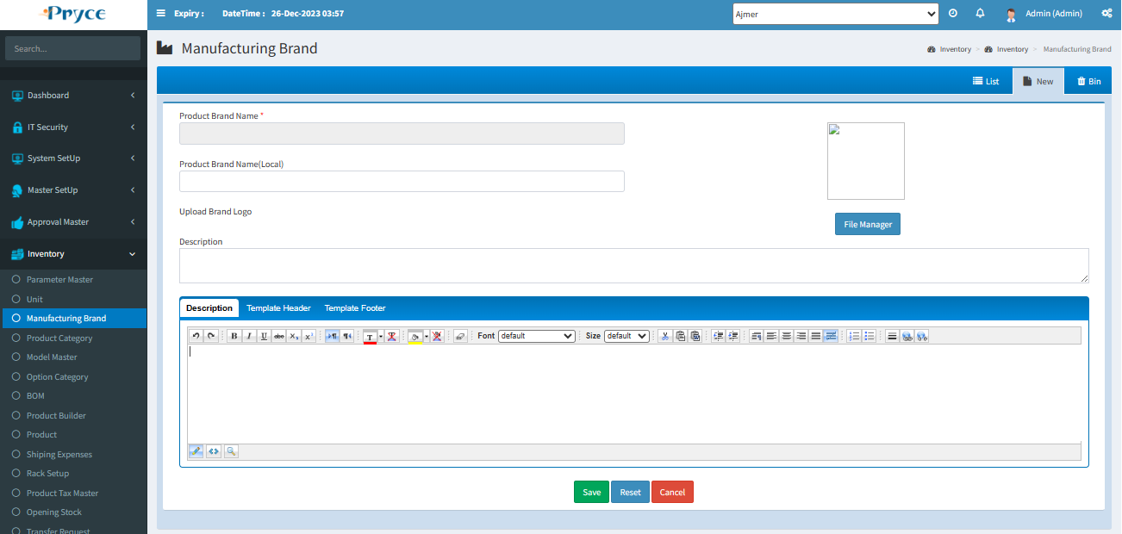

**Save:on Save button clcik its call** btnCSave_Click Function in this function if editid found then its call update function from this class,function and procedure

* Class:Inv_ProductBrandMaster.cs
* Function: UpdateProductBrandMaster
* Procedure: sp_Inv_ProductBrandMaster_Update

If EditId not Found then its call insert function from this class and function

* Class:inv_productBrandMaster.cs
* Function: InsertProductBrandMaster
* Procedure: sp_Inv_ProductBrandMaster_Insert

Delete:On delete function itrs called this function IbtnDelete_Command in this function

In this function its called this class,function and Procedure

* Class:Inv_ProductBrandMaster.cs
* Function: DeleteProductBrandMaster
* Procedure: sp_Inv_ProductBrandMaster_RowStatus

# 1.10 Product Category Master:-

**Page Load**:these function are called on page load

* AllPageCode()
* FillProductCategory()
* FillGrid()
* RootFolder()

1. AllPageCode():In this function We can Show Some Paneel According Page Permission
2. FillProductCategory():In this class Get Allk product category From this class,function and procedure

* Class:Inv_productCategoryMaster.cs
* Function:GetProductCategoryTrueAllData
* Procedure;’ sp_Inv_Product_CategoryMaster_SelectRow and Optype=1

1. FillGrid():In this Function Same Get All Product Category From this Class,Function and Procdure

* Class:Inv_ProductCategoryMaster.cs
* Function: GetProductCategoryTrueAllData
* Procedure: sp_Inv_Product_CategoryMaster_SelectRow and Optype=1

1. RootFolder():In this function we can set RootPath of FileManger

**Save**:On Save Its Call this click event function btnSave_Click

In this class If EditId Found Then Its call Update Function From this Class ,Function And Procedure

* Class:Inv_ProductCategoryMaster.cs
* Function: UpdateProductCategoryMaster
* Procedure: sp_Inv_Product_CategoryMaster_Update

If edit id Found Blank then its Call this Function ,class and procedure

* Class:Inv_ProductCategoryMaster.cs
* Function: InsertProductCategoryMaster
* Procedure: sp_Inv_Product_CategoryMaster_Insert

**Delete**:On this Click Event Function its Call this Function IbtnDelete_Command In this Function its Call this class,Function And Procedure

* Class:Inv_ProductCategoryMaster.cs
* Function: DeleteProductCategoryMaster
* Procedure: sp_Inv_Product_CategoryMaster_RowStatus

When its delete product Categroy then its check And Delete Product Category Detail Delete From this Class And Function Procedure

* Class:Inv_ProductCategoryDetail.cs
* Function: ProductCategoryDetail_Delete
* **Procedure:** Inv_Product_CategoryDetail_Delete

# 1.11 Model Master:-

**Page Load**:these function are called on page load

1. AllPageCode()
2. GetDocumentNumber()
3. FillProductCategory()
4. FillModelCategory()
5. FillGrid(true)
6. FillCurrency();
7. AllPageCode():In this function We can Show Some Paneel According Page Permission
8. GetDocumentNumber():In this Function Get DocumentMaster from this class DocNumber.cs
9. FillProductCategory():In this function get all Product Category From this class,function and Procedure

* Class: Inv_ProductCategoryMaster.cs
* Function: GetProductCategoryAllData
* Procedure: sp_Inv_Product_CategoryMaster_SelectRow

1. FillModelCategory(): In this function we can get all model category from this class,function and Procedure

* Class:Inv_ProductCategoryMaster.cs
* Function: GetProductCategoryTrueAllData
* Procedure: sp_Inv_Product_CategoryMaster_SelectRow and Optype=2

FillGrid():In this function Get All Model Master From This Class,Function and Procedure

Class:Inv_ModelMaster.cs

Function: GetModelMaster

Procedure: sp_Inv_ModelMaster_SelectRow and Optye=3

FillCurrency():In this function we can get all currency from class,function and procedure

Class:CurrencyMaster.cs

Function: GetCurrencyMaster

Procedure: sp_Sys_CurrencyMaster_SelectRow and optype=1

**Save-**

On Save Click its call btnSave_Click Click event Function in this Function if edited not found then its call update function from this class,function and Procedure

* Class:Inv_modelMaster.cs
* Function: UpdateModelMaster
* Procedure: sp_Inv_ModelMaster_Update

If editid found then its call insert Function then its call update function from this class,function and procedure

* Class:Inv_modelMaster.cs
* Function: InsertModelMaster
* Procedure: sp_Inv_ModelMaster_Insert

**Delete**:on delete command its call IbtnDelete_Command in this function its call this call

Function,class and procedure

* Class: Inv_modelMaster.cs
* Fucntion: DeleteModelMaster
* Procedure: sp_Inv_ModelMaster_RowStatus

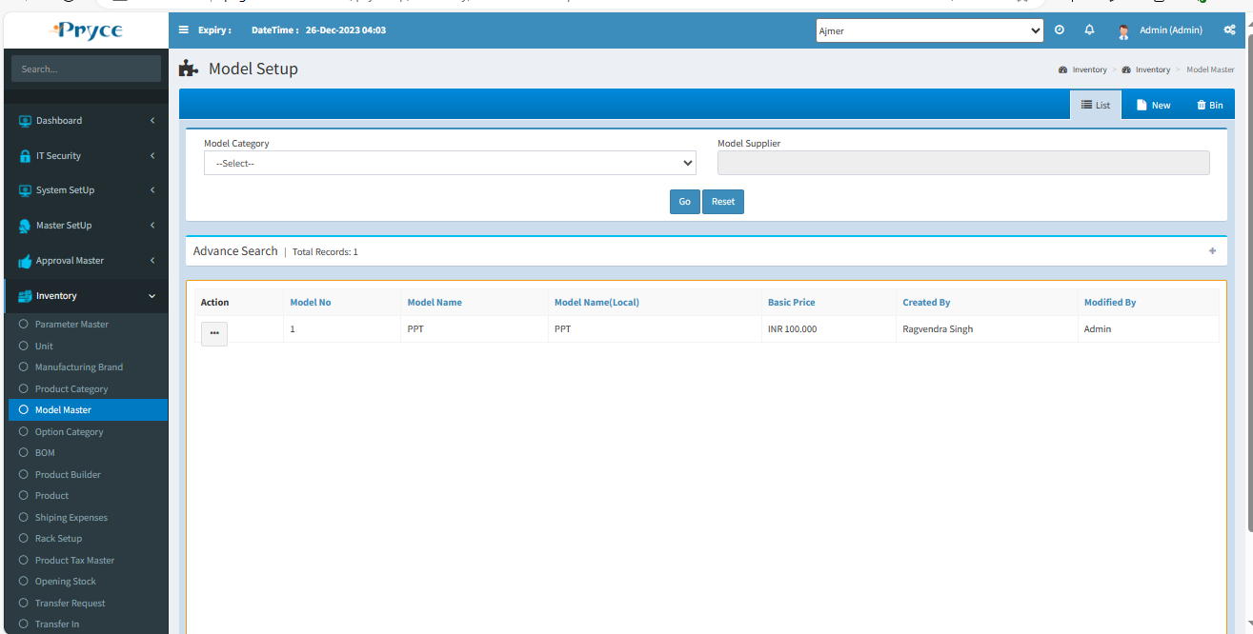

# 1.10 Option Category Master:-

**Page Load**:these function are called on page load

* AllPageCode(clsPagePermission);
* FillGrid();

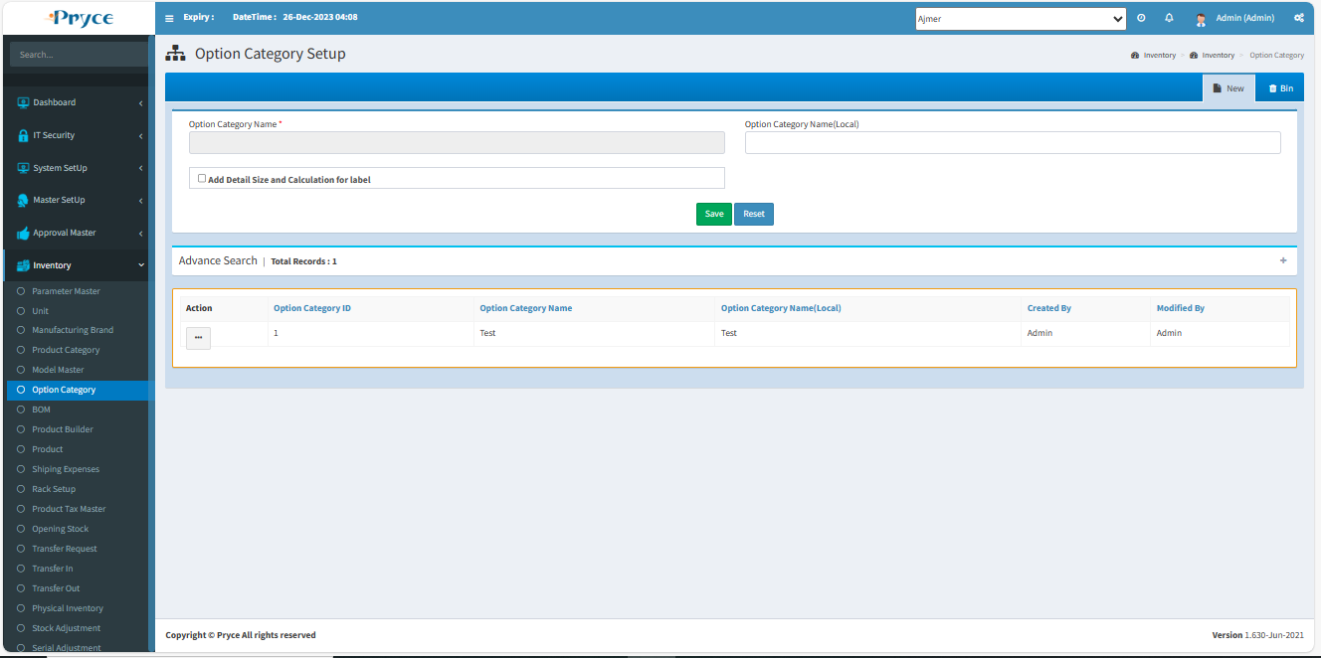

1. AllPageCode(): In this function We can Show Some Paneel According Page Permission
2. FillGrid():In this function we can get all function from this class,function and Procedure

* Class:Inv_optionCategoryMaster.cs
* Function: GetOptionCategoryTrueAll
* Procedure: sp_Inv_ProductOptionCategory_SelectRow and optype=2

**Save**:On Save Click this click event function is call btnCSave_Click in this function if editid found then its call update function call from this class,function and procedure

* Class:Inv_OptionCategoryMaster.cs
* Function: UpdateOptionCategory
* Procedure: sp_Inv_ProductOptionCategory_Update

If editid not found then its call insert function from this class,function and procedure

* Class:Inv_OptionCategoryMaster.cs
* Function: InsertOptionCategory
* Procedure: sp_Inv_ProductOptionCategory_Insert

**Delete**:On delete function its call this click event function IbtnDelete_Command In this function its call this Class,function and Procedure

* Class:Inv_OptionCategoryMaster.cs
* Function: DeleteOptionCategory
* Procedure: sp_Inv_ProductOptionCategory_RowStatus

# 1.11 Bill of Material:-

**Page Load**:these function are called on page load

* AllPageCode();
* Reset_Child();
* FillModelGrid();
* FillPrinter();

1. AllPageCode():In this function We can Show Some Paneel According Page Permission
2. Reset_Child():In this function reset all text field blank set
3. FillModelGrid():In this function get all Model from this class,function and Procedure:

* Class:Inv_ModelMaster.cs
* Function: GetModelMaster
* Procedure: sp_Inv_ModelMaster_SelectRow And Optye=3

1. FillPrinter():In this function get printerMaster from this class,function and procedure

* Class:Set_printerMaster.cs
* Function: GetPrinterMaster
* Procedure: sp_Set_set_PrinterMaster_SelectRow and Optype=2

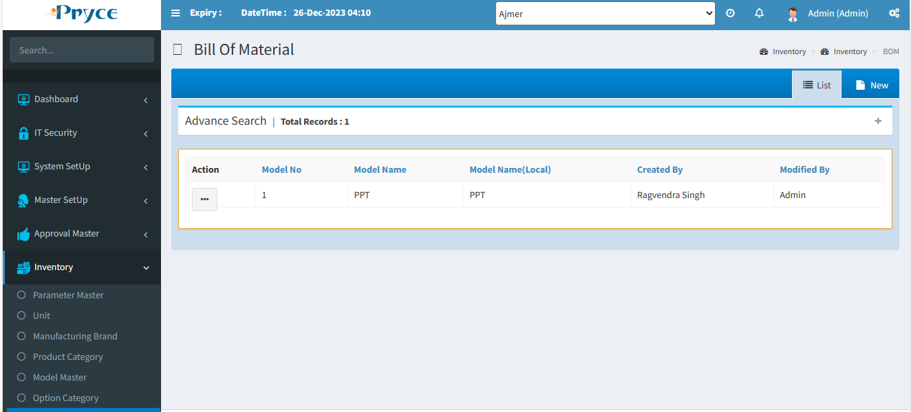

**Save**: when you click on save button its call btnSave_Click function in this function its chek if hdnDetailEdit.Value=”” then its call insert function from this class,function and Procedure

* Class:BillOfMeterial.cs
* Function: Insert_BOM
* Procedure: sp_Inv_BOM_Insert

If hdnDetailEdit.Value !=”” then its call update function from this class,function and Procedure

* Class: BillOfMeterial.cs
* Function: Update_BOM
* Procedure: sp_Inv_BOM_Update

Delete:when you click on delete button its call this function IbtnDelete_Command in this function its call this class,function and Procedure

* Class:BillOfMeterial.cs
* Function: DeleteOrRestore_BOM
* Procedure: sp_Inv_BOM_Delete

After any one function call from this the its call FillGrid() Function In this Function its Get BOM by ModelId From this Class,function and Procedure

* Class:BillOfMeterial.cs
* Function: BOM_ByModelId
* Procedure: sp_Inv_BOM_SelectRow and Optype=3

# 1.12 Product Builder Page:-

**Page Load**:these function are called on page load

* AllPageCode(clsPagePermission);
* FillModelGrid();
* FillModelCategory();

1. AllPageCode():In this function We can Show Some Paneel According Page Permission
2. FillModelGrid():In this function first get all model from this class,function and Procedure

* Class: Inv_ModelMaster.cs
* Function: GetModelMaster
* Procedure: sp_Inv_ModelMaster_SelectRow and optype=3

Then filter set where IsLabel='False'

1. FillModelCategory():In this function we can get all model category from this function,class and procedure

* Class:Inv_Model_Category.cs
* Function: GetAllRecord_for_ProductBuilder
* Procedure: sp_Inv_Model_Category_SelectRow and Optype=4

**Report**:when you click on report button then its call btnReport_Click function in this function its open report its path is

../Inventory_Report/UserPartNo_Report.aspx

**Price List:** when you click on Price List Button its call btnPriceList_Click function in this function we can get data from this function sp_Inv_BOM_SelectRow and after get we can open report its url is

../Inventory_Report/PriceListReport.aspx?ModelId="”

**Add Product:**When you click on Add Product button then its call btnAddProduct_Click function in if DtQuotationItemList null in session then its call this function,class and Procedure

* Class:Inv_ProductMaster.cs
* Function: GetProductMasterTrueAll
* Procedure: sp_Inv_ProductMaster_SelectRow and Optype=2

If DtQuotationItemList not null in session then its call this function,class and Procedure

* Class:Inv_ProductMaster.cs
* Function: GetProductMasterTrueAll
* Procedure: sp_Inv_ProductMaster_SelectRow and optype=2

But the main difference is its check that is add product is available in session or not

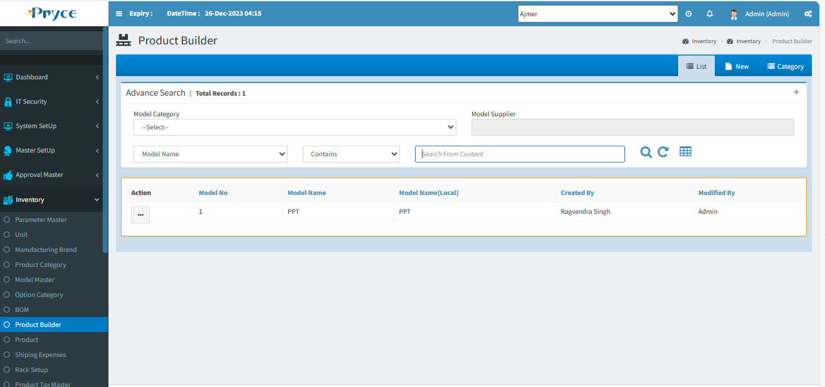

# 1.14 Product Master:-

**Page Load**:these function are called on page load

* AllPageCode(clsPagePermission);
* FillddlBrandSearch(ddlbrandsearch);
* FillddlBrandSearch(ddlBinBrandSearch);
* FillProductBrand();
* FillBrand();
* FillProductCategory();
* FillProductCategorySerch(ddlcategorysearch);
* FillProductCategorySerch(ddlBinCategorySearch);
* FillddlBrandSearch(ddlReOrderProductBrand);
* FillProductCategorySerch(ddlReOrderProductcategory);
* FillLocation();
* FillDataListGrid(1);
* fillproductId();
* GetLocationCountry();
* getPageControlVisibility();
* RootFolder();

1. AllPageCode():In this function We can Show Some Paneel According Page Permission
2. FillddlBrandSearch():In this function Get All true Product Barand Data from this class,function and procedure

* Class:Inv_ProductBrandMaster.cs
* Function: GetProductBrandTrueAllData
* Procedure: sp_Inv_ProductBrandMaster_SelectRow And Optype=2

1. FillddlBrandSearch():In this function Same data get according point 2
2. FillProductBrand():In this function Same data get according point 2
3. FillBrand():In this function get brand From this class,function and Procedurfe

* Class:BrandMaster.cs
* Function: GetBrandMaster()
* Procedure: sp_Set_BrandMaster_SelectRow And Optype=2

1. FillProductCategory():In this function get all Product Category from this class,function and Procedure

* Class:Inv_ProductCategoryMaster.cs
* Function: GetProductCategoryTrueAllData
* Procedure: sp_Inv_Product_CategoryMaster_SelectRow and Optype=1

1. FillProductCategorySerch():In this function Same data get according point 6
2. FillddlBrandSearch():In this function get Product Brand From this function,class and Procedure:

* Class: Inv_ProductBrandMaster.cs
* Function: GetProductBrandTrueAllData
* Procedure: sp_Inv_ProductBrandMaster_SelectRow and Optype=2

1. FillProductCategorySerch(ddlReOrderProductcategory): In this function Same data get according point 6
2. FillLocation():In this function we can get Locations From this class,function and Procedure

* Class:LocationMaster.cs
* Function: GetLocationMaster
* Procedure: sp_Set_LocationMaster_SelectRow and Optype=2

1. FillDataListGrid():In this function get All Product by Page number from this class,function and Procedure

* Class: Inv_ProductMaster.cs
* Function: GetProductMaster_By_PageNumber
* Procedure: sp_Inv_ProductMaster_SelectRow_by_pageNo

1. fillproductId():In this function get Document Number from this class,function and Procedure

* Class:Set_DocNumber.cs
* Function: GetDocumentNumberAll
* Procedure: sp_Set_DocNumber_SelectRow

1. GetLocationCountry():in this function get product Country From this class,function and procedure

* Class:CountryMaster.cs
* Function: GetCountryMasterById
* Procedure: sp_Sys_CountryMaster_SelectRow And Optype=2

1. getPageControlVisibility():In this function Set PageControl visibility
2. RootFolder():In this function we can set File Manager Root Path Set

**Save-**

On Save its call btnSave_Clcik Function in this function if hdnProductId.value==””then its call insert Function From this class,function and procedure

* Class: inv_ProductMaster.cs
* Function: InsertProductMaster
* Procedure: sp_Inv_ProductMaster_Insert
* Then check rack name is not equals to blank then insert rack from this class ,function and Procedure
* Class:Inv_RackDetail.cs
* Function: InsertRackDetail
* Procedure: Inv_RackDetail_Insert
* Then insert productLabelInfo from this class,function and Procedure
* Class:Inv_ProductMaster.cs
* Function: InsertProductLabelInfo
* Procedure: sp_Inv_ProductLabel_Insert
* Then Insert ProductTaxMaster from this class,function and Procedure
* Class:ProductTaxMaster.cs
* Function: InsertProductTaxMaster
* Procedure: sp_Inv_ProductTaxMaster_Insert

If hdnProductId.value!=”” then its call Update function call from this class,function and Procedure

Class:Inv_ProductMaste.cs

Function: UpdateProductMaster

Procedure: sp_Inv_ProductMaster_Update

Then Insert ProductLabel Info From this class,function and Procedure

* Class:Inv_ProductMaster.cs
* Function: InsertProductLabelInfo
* Procedure: sp_Inv_ProductLabel_Insert

Then Delete ProductCategory from this class,function and Procedure

* Class:Inv_Product_Category.cs
* Function: DeleteProductCategory
* Procedure: sp_Inv_Product_Category_Delete

Then Delete Product Company Brand From this class,function and User

* Class:Inv_Product_CompanyBrand.cs
* Function: DeleteProductCompanyBrand
* Procedure: sp_Inv_Product_CompanyBrand_Delete

Then Delete ProductLocation From this class,function and Procedure

* Class:Inv_Product_Location.cs
* Function: DeleteProductLocation
* Procedure: sp_Inv_Product_Location_Delete

Then Delete Product Image from inv_Product_image table using ProductId

Then Delete Product Brand From this Class,function and Procedure

* Class:Inv_Product_Brand.cs
* Function: DeleteProductBrand
* Procedure: sp_Inv_Product_Brand_Delete

Then Delete Product Suppliers From this class,function and Procedure

* Class:Inv_ProductSuppliers.cs
* Function: DeleteProductSuppliers
* Procedure: sp_Inv_Product_Suppliers_DeleteRow

Then Delete Releted Product From this class,function and Procedure

* Class:Inv_Product_RelProduct.cs
* Function: DeleteRelatedProduct
* Procedure: sp_Inv_Product_RelProduct_DeleteRow

Then Delete rack detail by location id and product id from this class,function and Procedure

* Class: Inv_RackDetail.cs
* Function: DeleteRackDetail_By_LocationId_and_ProductId
* Procedure: Inv_RackDetail_Delete

Then Insert Agin Rack detail as we mention in insert condition

Then Insert Product Company Brand From this class,function and procedure

* Class:Inv_Product_CompanyBrand.cs
* Function: InsertProductCompanyBrand
* Procedure: sp_Inv_Product_CompanyBrand_Insert

Then Insert Product Image Using this class,function and Procedure

* Class:Inv_ProductImage.cs
* Function: InsertProductImage
* Procedure: sp_Inv_Product_Image_Insert

Then Insert Product Brand From this class,function and Procedure

* Class:Inv_Product_Brand.cs
* Function: InsertProductBrand
* Procedure: sp_Inv_Product_Brand_Insert

Then Insert Product Category from this class ,function and procedure

* Class:Inv_Product_Category.cs
* Function: InsertProductCategory
* Procedure: sp_Inv_Product_Category_Insert

Then Insert Product Supplier From this class,function and procedure

* Class:Inv_ProductSuppliers.cs
* Function: InsertProductSuppliers
* Procedure: sp_Inv_Product_Suppliers_Insert

Then Insert Releted Product From this class,function and Procedure

* Class:Inv_Product_RelProduct.cs
* Function: InsertRelatedProduct
* Procedure: sp_Inv_Product_RelProduct_Insert

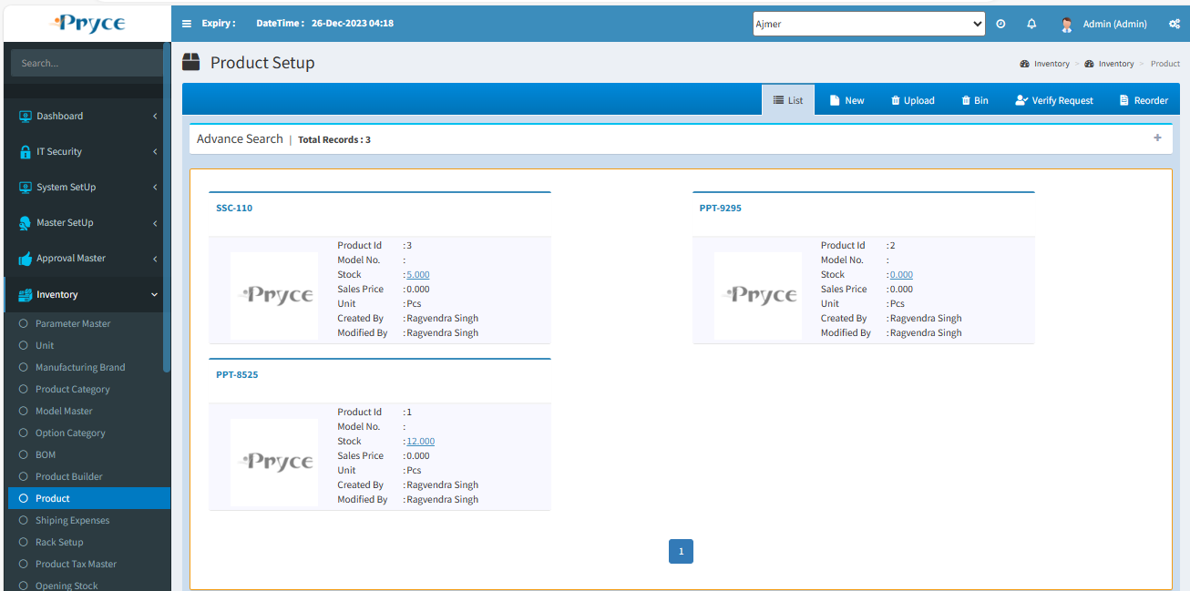

# 1.15 Ship Expenses:-

It is Ship Expenses. In This form you can save shipping expenses.

There are Three tabs-

* List
* New
* Bin

**List-**

In this tab you will get all saved Ship Expenses and you can search the record, according to the search criteria and also edit and delete.

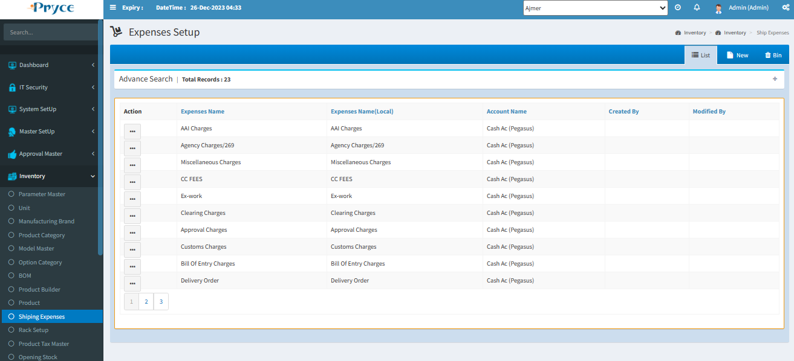

**Sorting**-

You can also sort the record in ascending & descending order after the click on the header of the list record(which is underlined).

**Search Criteria –**



Here you can search according to the field of Expenses name,Expenses name(Local),Account name then you will get a list of related shipping expenses.

**Search-**  After that click on the search button and you get records according to the search criteria on a record list.

**Refresh-**  After that you want to get again all records, then click on the refresh button.

**Edit-**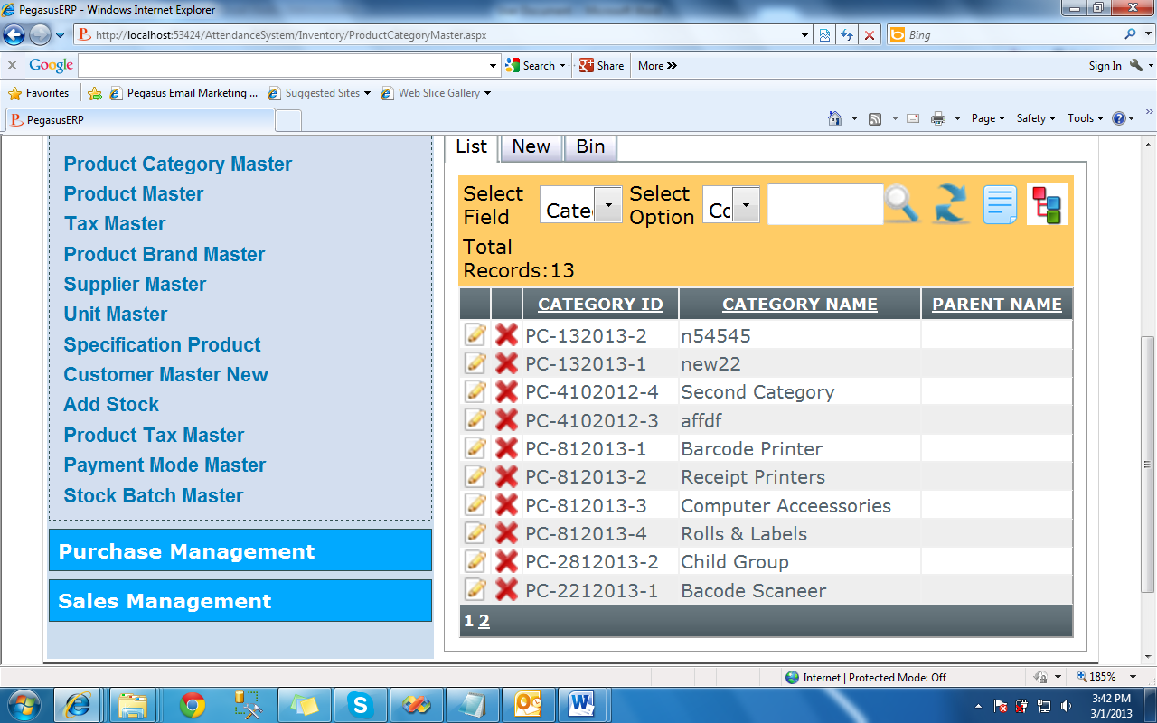

When you want to edit any record than click on the edit button in a list.

After clicking,the edit page will be open.

Here you can edit require field & save.

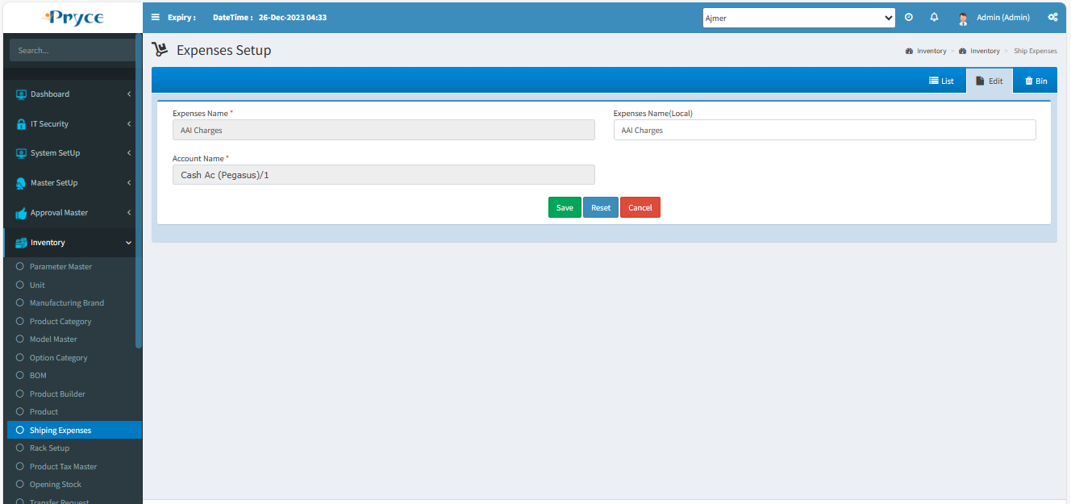

**Delete-**

When you want to delete any record than click on delete button.

**New-**

In this tab you will get an Entry Form where you can save and Update expenses.

In this “Expenses Name” either you select or manually type. Also Expenses Name (Local) type manually.

Account Name selects from the suggestion list.

**Save-** Click on save button for new record add and save in the list.

**Reset-** By this Reset the record or clear the record.

**Cancel-**When you click on the cancel button, then you will get in List tab and all fields will be reset.

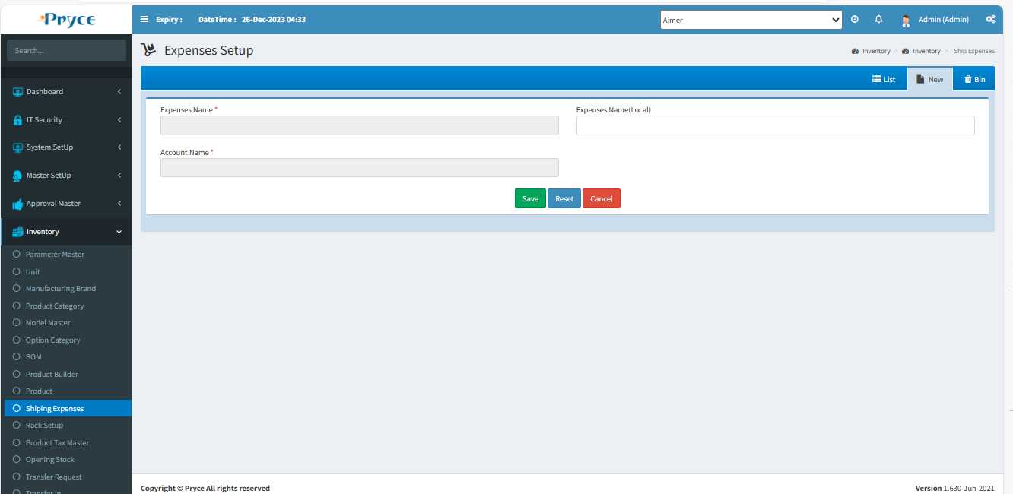

**Bin-**

* In this tab you will get all deleted records from list, where you can again restore record.
* **Select all-**  In this you can select all records by clicking select all button.
* **Restore button- ** In this you can restore selected record by clicking on restore button and again add record in list or grid.
* In this you can also able to select the record individually by checked in the check box.
* Also, you search the particular record in the search window and when you want to the restore, then checked and click on the restore button.

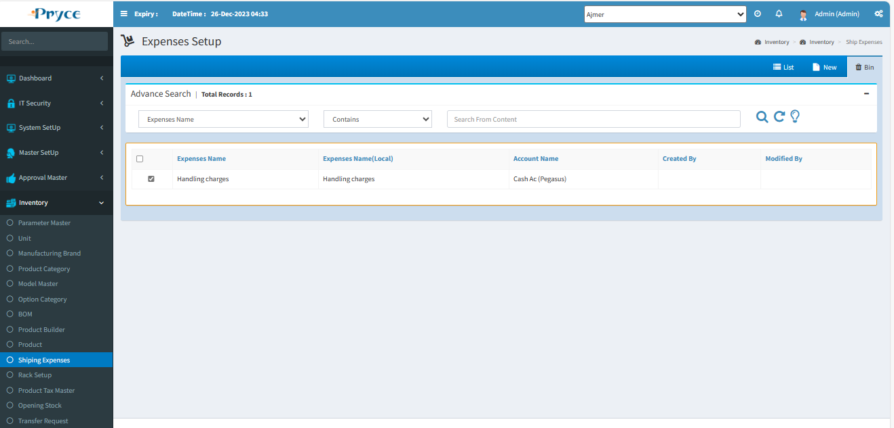

# 1.16 Rack Setup:-

It is Rack setup page. In this page you can add Rack. You can choose parent Rack in saving Rack.

This page has no limitations to save rack and main rack. A rack master page is created to store the product. In particular location in warehouse.

There are Three tabs-

* List
* New
* Bin

**List-**

In this tab you will get all saved Rack and you can search the record, according to the search criteria and also edit and delete.

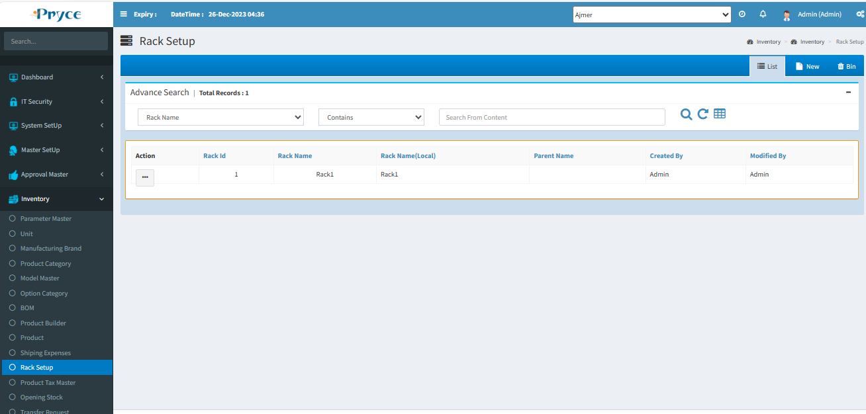

**Sorting**-

You can also sort the record in ascending & descending order after the click on the header of the list record (which is underlined).

**Search Criteria –**



Here you can search according to the field of Expenses name,Expenses name(Local),Account name then you will get a list of related rack.

**Search-**  After that click on the search button and you get records according to search criteria in a record list.

**Refresh-**  After that you want to get again all records, then click on the refresh button.

**Tree Format-**

In this you can display record in tree format by clicking on Tree button.

You can also edit and update by click on a tree node.

If you want to again go in List tab by clicking on Tree button.

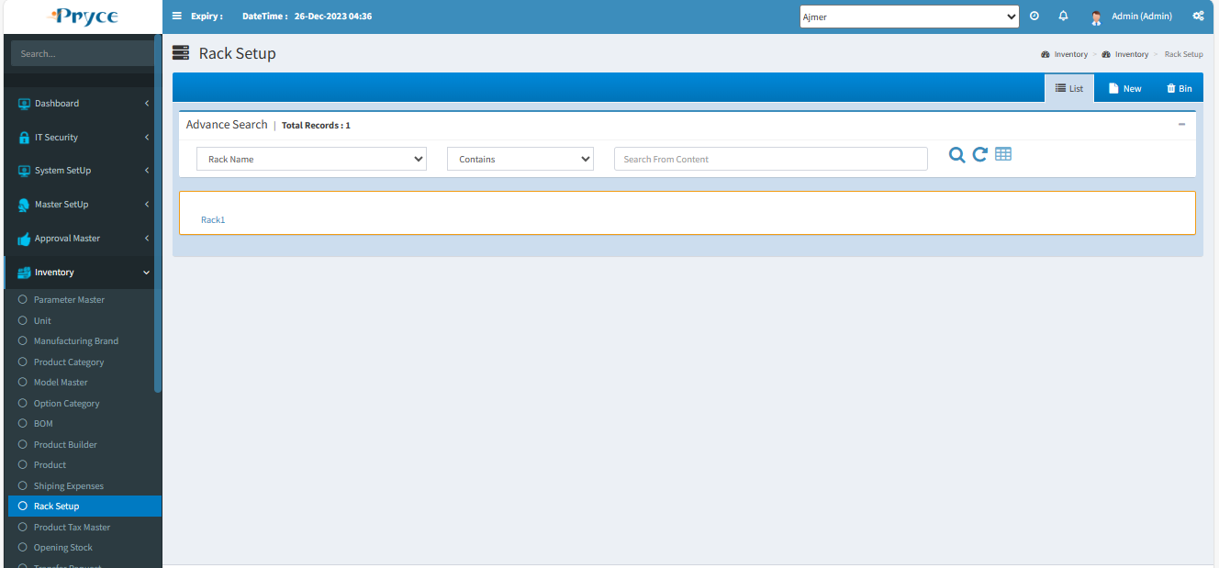

**Edit-**

When you want to edit any record than click on the edit button in a list.

After clicking, the edit page will be open.

Here you can edit require field & save.

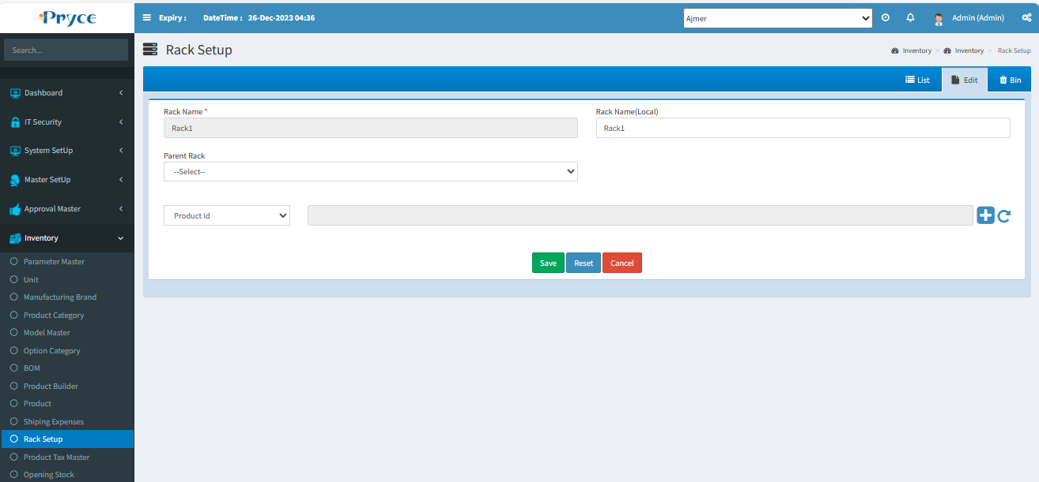

**Delete-**

When you want to delete any record than click on delete button.

**New-**

In this tab you will an get Entry Form where you can save and Update Rack.

In this you can manually type Rack Name,Rack Name(Local), select Parent Rack and select with check box product in product list.

**Save-** Click on save button for new record add and save in the list.

**Reset-** By this Reset the record or clear the record.

**Cancel-**When you click on the cancel button, then you will get in a List tab and all fields will be reset.

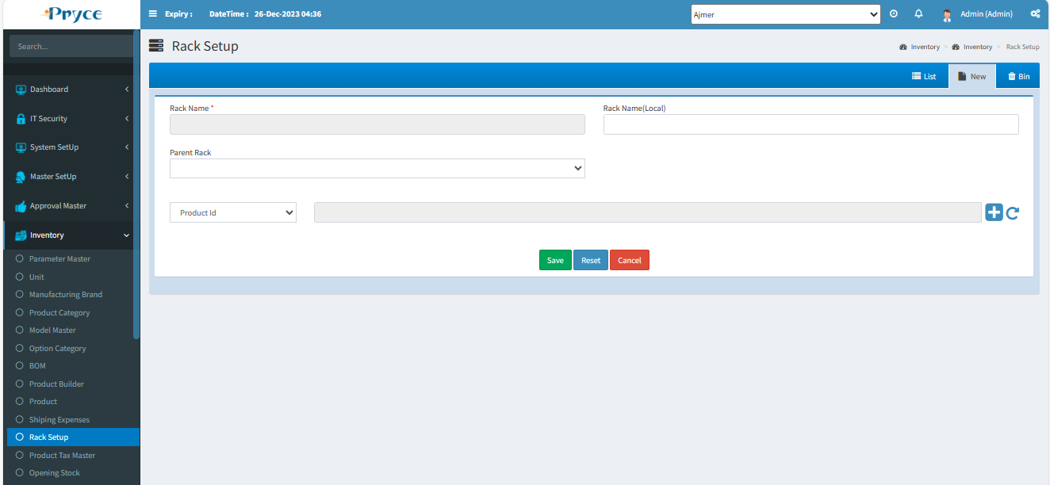

**Bin-**

* In this tab you will get all deleted records from list,where you can again restore record.
* **Select all-**  In this you can select all records by clicking select all button.
* **Restore button- ** In this you can restore selected record by clicking on restore button and again add record in list or grid.
* In this you can also able to select the record individually by checked in the check box.
* Also, you search the particular record in the search window and when you want to restore, then checked and click on the restore button.

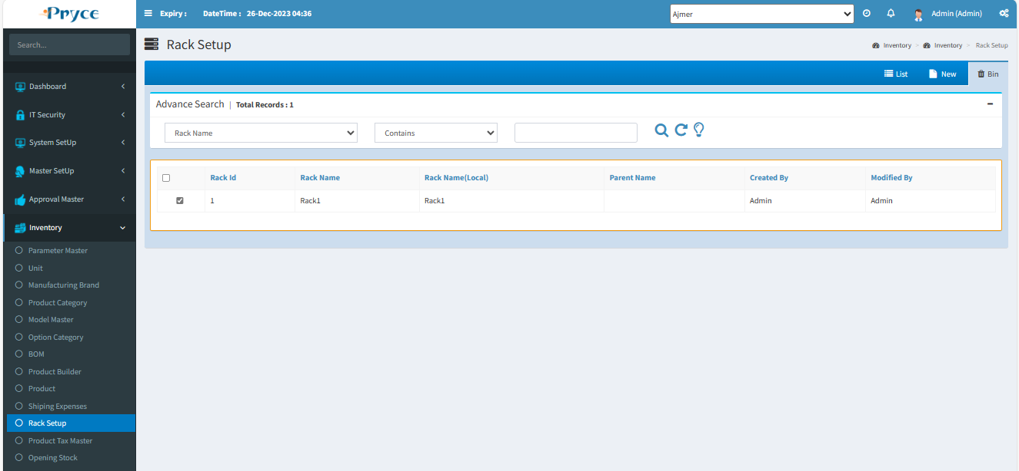

# 1.17 Opening Stock:-

**Opening stock**is the value of goods available for sale in the beginning of an accounting period.

Here you can update the excel sheet for opening stock.

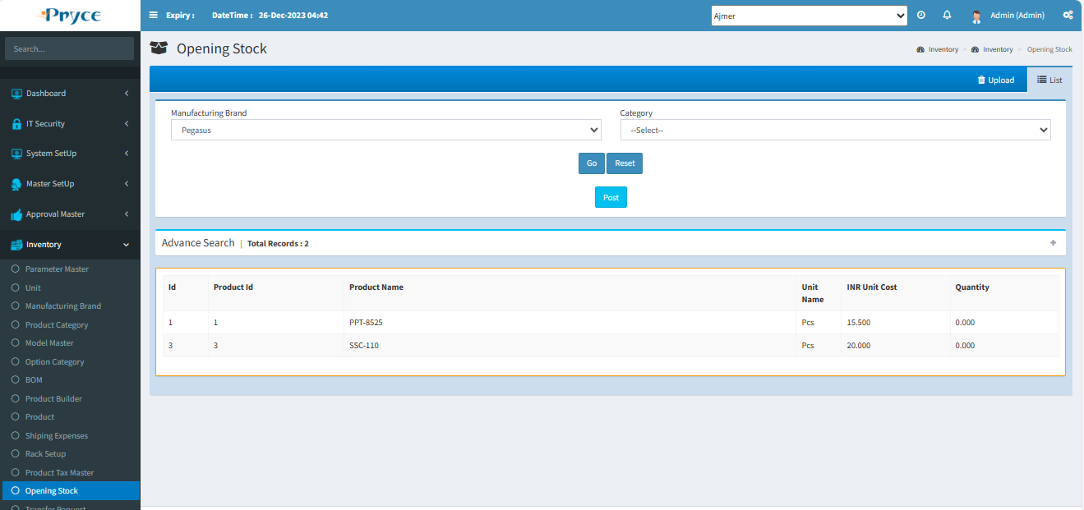

**Search Criteria –**



Here you can search according to the field of product name, unit, product Id then you will get a list of related opening stock record.

**Search-**  After that click on the search button and you get records according to search criteria in a record list.

**Refresh-**  After that you want to get again all records, and then click on the refresh button.

**Post-** When you click on “Post” then all opening stock records are saved.

Here you also download the excel sheet of opening stock record.

# 1.18 Transfer Request:-

In this page user can Transfer Request for product from another location.Those send request show in another location “Transfer Out” sub module of Inventory in “Request”tab.

There are Four tabs-

* List
* New
* Bin

**List-**

In this tab you will get all saved Transfer Request and you can search the record, according to the search criteria and also edit and delete.

**Status**- Status is following two types-

**Not Open**-You can edit and delete the record until the response from the request location against this request.

**Transfer Out**- You can’t edit and delete the record after the response from the request location.

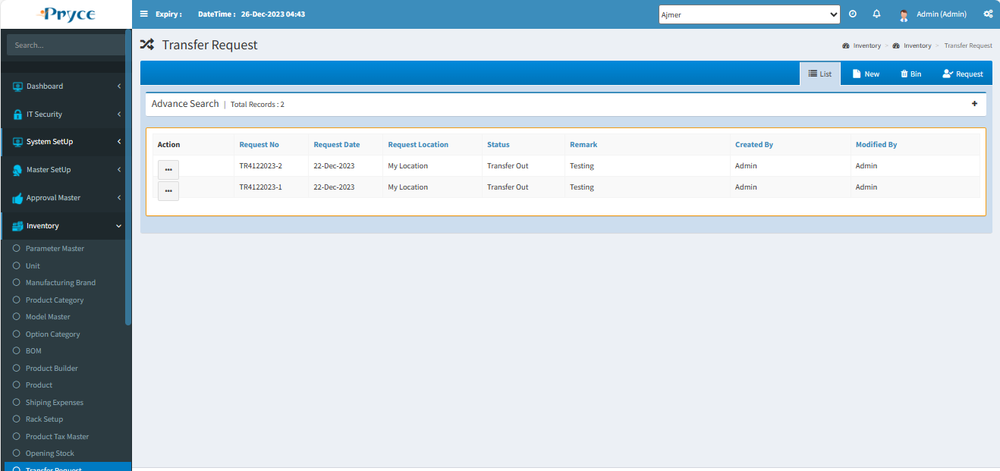

**Sorting**-

You can also sort the record ascending & descending order after the click on the header of the list record.

**Search Criteria –**



Here you can search according to the field of Request No.,Request Location,Status,Created By then you will get a list of related requests.

**Search-**  After that click on the search button and you get records according to search criteria in a record list.

**Refresh-**  After that you want to get again all records, then click on the refresh button.

**Edit-**

When you want to edit the record, then click on the edit button.

After that edit page will open.Here you can add & edit the field and save.

**Note:-After saving the record your request will go to the request location.**

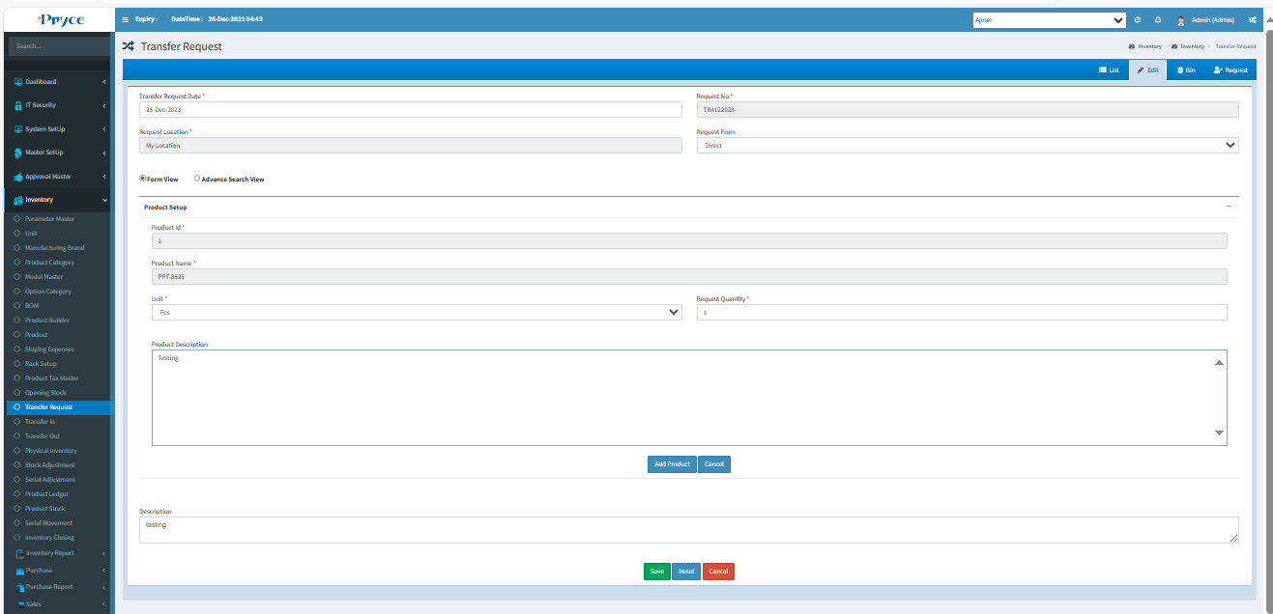

**Delete-**

When you want to delete any record than click on delete button.

**New-**

In this tab you can create new requests for product.

**Request No-** This is an auto generated according the user required format and you can also edit this request number.

**Request Location-** Here you select the location from a suggestion list where you want to send a request.

Add product from “Form View” & “Advance Search View” and save,This record Save in list of requests.

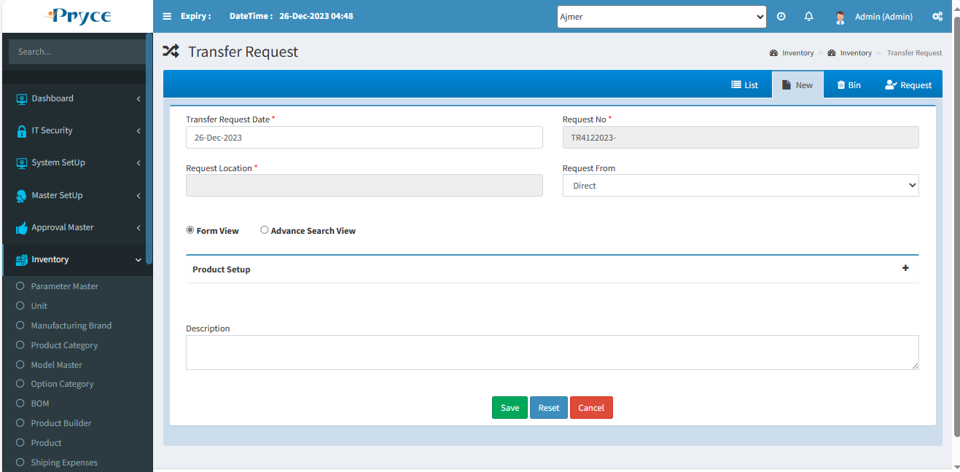

**Bin-**

* In this tab you will get all deleted records from list,where you can again restore record.
* **Select all-**  In this you can select all records by clicking select all button.
* **Restore button- ** In this you can restore selected record by clicking on restore button and again add record in list or grid.
* In this you can also able to select the record individually by checked in the check box.
* Also, you search the particular record in the search window and when you want to restore, then checked and click on the restore button.

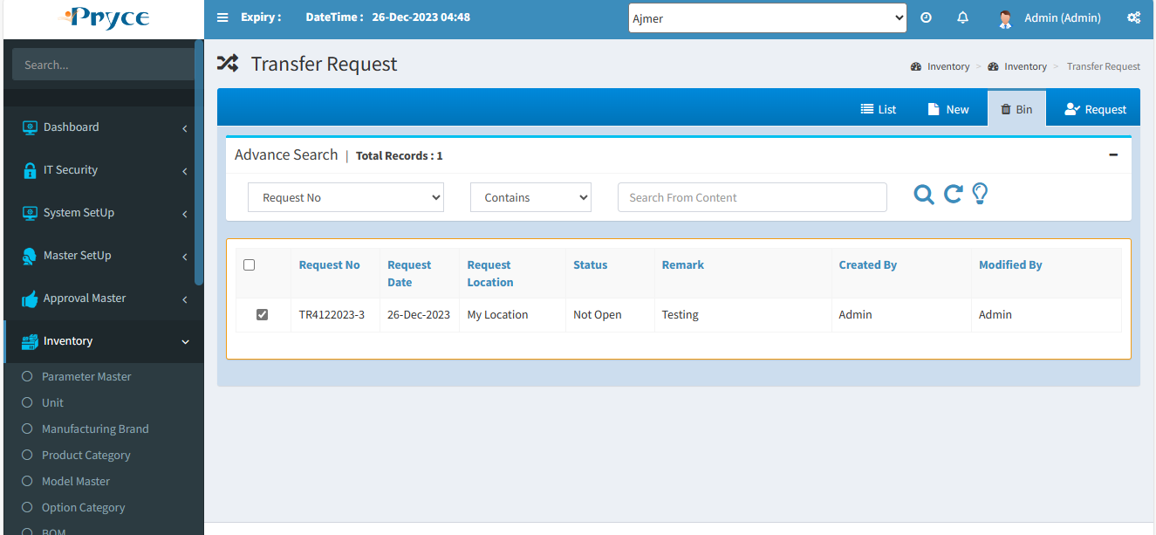

# 1.19 Transfer In:-

In this page user can Receive the quantity against the “Transfer Request Location”.

**Note:-**The stock is increased by the number of received quantities in the current location and decreased in the request location.

There are Two tabs-

List

New

**List-**

In this tab you will get all saved Transfer records against requested location,Also location or “Transfer from” you can show in list and you can search the record, according to the search criteria and also edit & post the record.

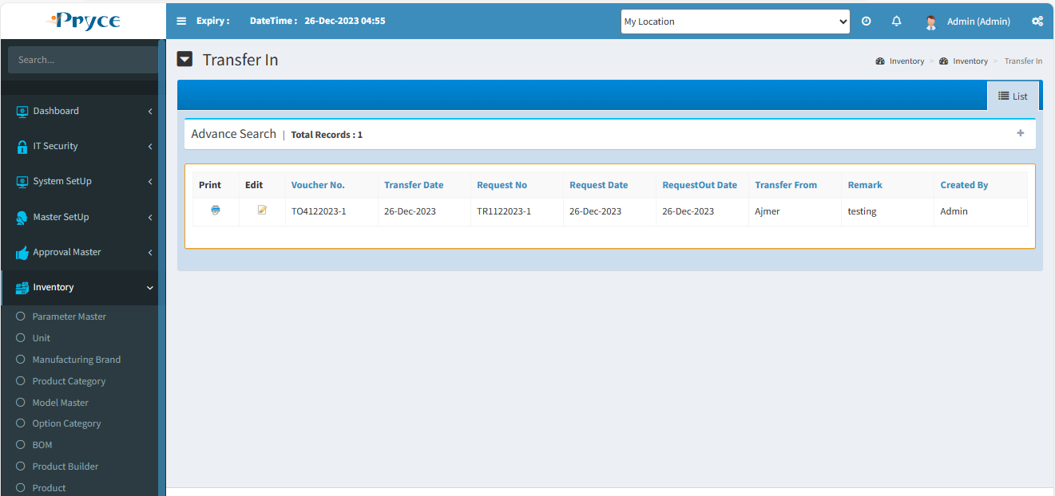

**Sorting**-

You can also sort the record in ascending & descending order after the click on the header of the list record(which is underlined).

**Search Criteria –**

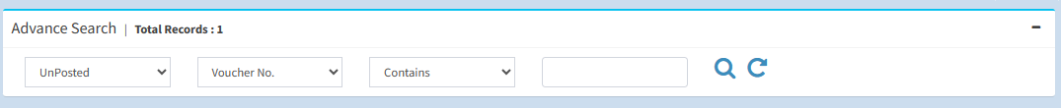

Here you can search according to the field of Voucher No.,Transfer Date,Request No.,Transfer From,Created By then you will get a list of related requests.

**Search-**  After that click on the search button and you get records according to search criteria in a record list.

**Refresh-**  After that you want to get again all records, then click on the refresh button.

**Edit-** 

When you want to the edit record, then click on the edit button.

After click on edit button than edit page open for editing the record.And you can either save or post the record.

**Note-** After post the record you can’t edit this record.

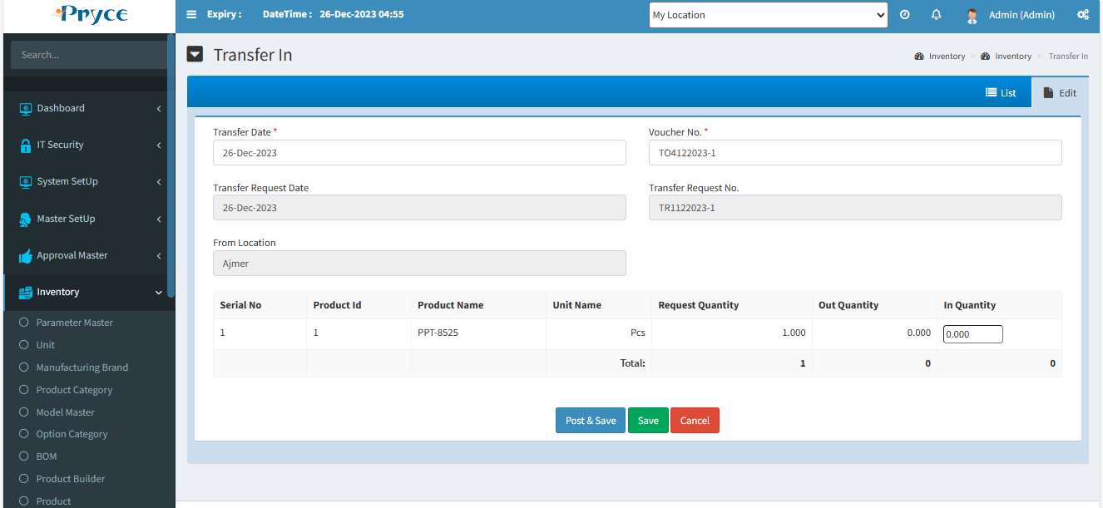

**New-**

You can’t directly come in new tab you can just edit the transfer.

# 1.20 Transfer Out:-

In this page all transfer out record show,Those records come from requesting location.

There are Four tabs-

* List
* New
* Bin
* Request

**List-**

In this tab you will get all saved Transfer out record against requested location,Also show requested location field or “To Transfer” you can show in list and you can search the record according to the search criteria and also edit & post the record.

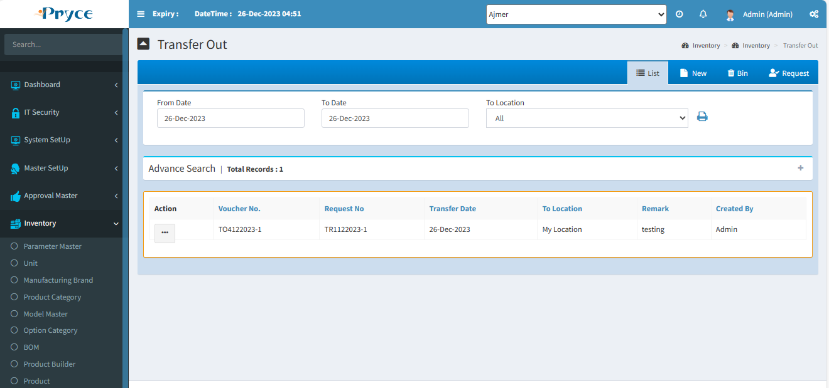

**Sorting**-

You can also sort the record in ascending & descending order after the click on the header of the list record(which is underlined).



**Search Criteria –**



Here you can search according to the field of Voucher No.,Transfer Date,Request No.,Created By then you will get a list of related requests.

**Search-**  After that click on the search button and you get records according to search criteria in a record list.

**Refresh-**  After that you want to get again all records, then click on the refresh button.

**Request-**

In this tab you will get the all transfer requests from another location.

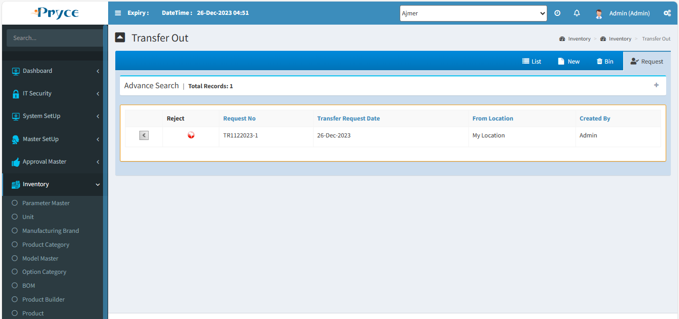

Here you can choose the request like this:-

**Request Button-**

Here you can click on request button, then the record will show in new tab.

**New-**

In this tab record comes from the request Tab.

First of all select the request from request tab,Here you fulfill the out quantity according to request quantity.

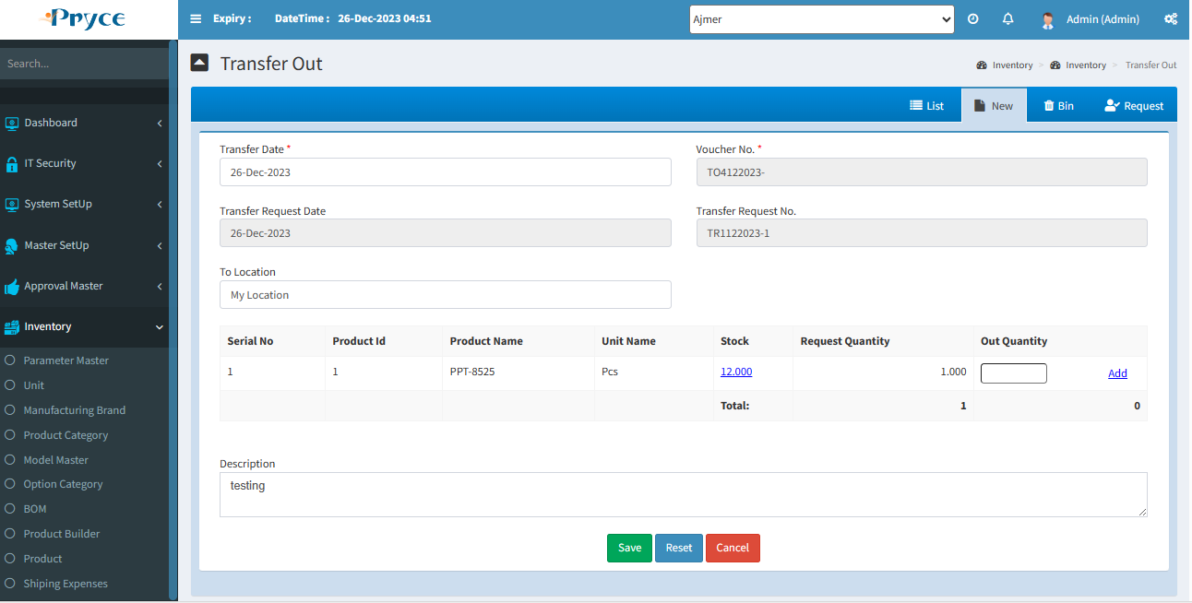

Here you can update the out quantity against the request quantity.

**For out quantity,First you have also stock of products. Than fulfil the out quantity.**

**Save-** Click on save button for new record add and save in the list.

**Reset-** By this “Reset” the record or clear the record.

**Cancel-**When you click on cancel button, then you will get in List tab and all fields will be reset.

**Edit-** 

You can edit the record using edit button on list tab.

When will you click on this button the record of releted button will show in the entry form and New Tab is converted into edit tab.

Here you can edit or update the out quantity against the request quantity.

**Delete-**

When you want to delete any record than click on delete button.

**Bin-**

* In this tab you will get all deleted records from list,where you can again restore record.
* **Select all-**  In this you can select all records by clicking select all button.
* **Restore button- ** In this you can restore selected record by clicking on restore button and again add record in list or grid.
* In this you can also able to select the record individually by checked in the check box.
* Also, you search the particular record in the search window and when you want to restore, then checked and click on the restore button.

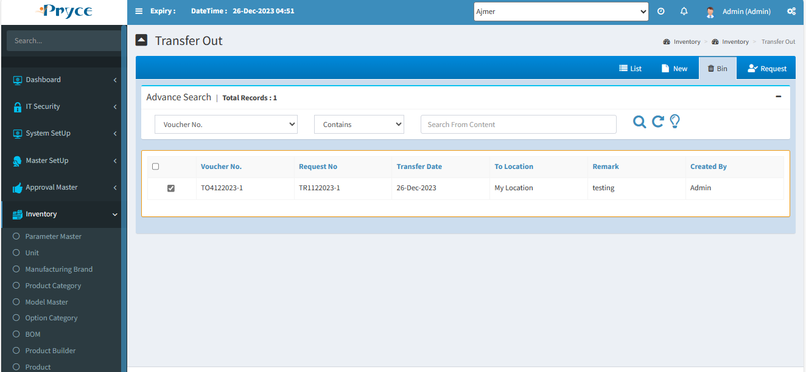

# 1.21 Physical Inventory:-

This page is used for finding the difference between the system quantity and the actual quantity (physical quantity in stock) of product.

**Note:- To use this page the all transaction should be stopped and you can not open those pages which will affect the stock just like as purchase good receive, purchase return, sales invoice, sales return.**

There are 3 tabs-

* List
* New
* Bin

**List-**

In this tab you will get all saved physical inventory and you can search the record, according to the search criteria and also edit and delete. And also you can create a new physical inventory.

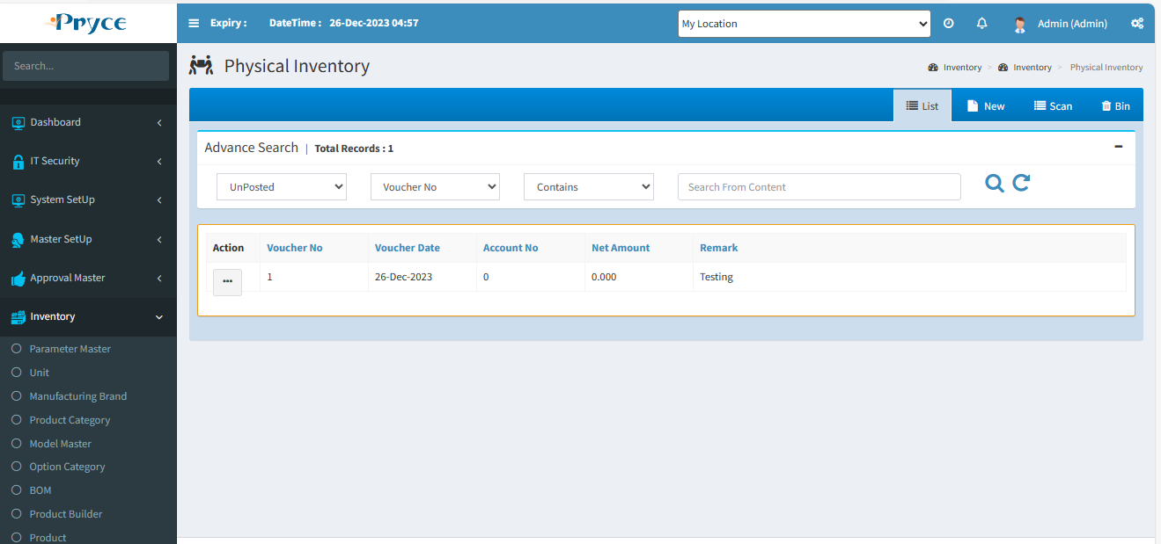

**Sorting**-

You can also sort the record in ascending & descending order after the click on the header of the list record(which is underlined).

**Search Criteria –**



Here you can search according to the field of Voucher No.,Voucher Date,Account No.,Net Amount than you will get a list of related requests.

**Search-**  After that click on the search button and you get records according to search criteria in a record list.

**Refresh-**  After that you want to get again all record, then click on the refresh button.

**Edit**- 

If you want to edit the record, then click on the edit button.

After that edit record page open in edit tab.

Here you can edit the record and save or if you want to post, then click on the post button. Posted record again, not open for edited.

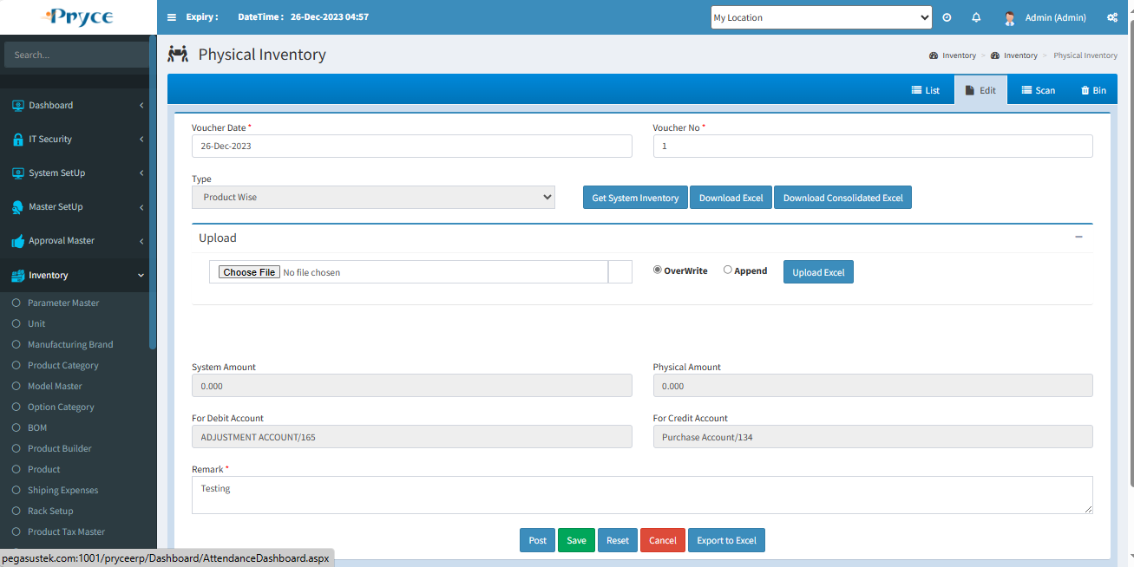

**Delete-**

When you want to delete any record than click on delete button.

**New-**

Here you will get all text box is enabled until you stop the transaction.

**Save-** Click on save button for new record add and save in the list.

**Reset-** By this “Reset” the record or clear the record.

**Cancel-**When you click on cancel button, then you will get in List tab and all fields will be reset.

**Post-** After post the record you can’t edit and delete the record.

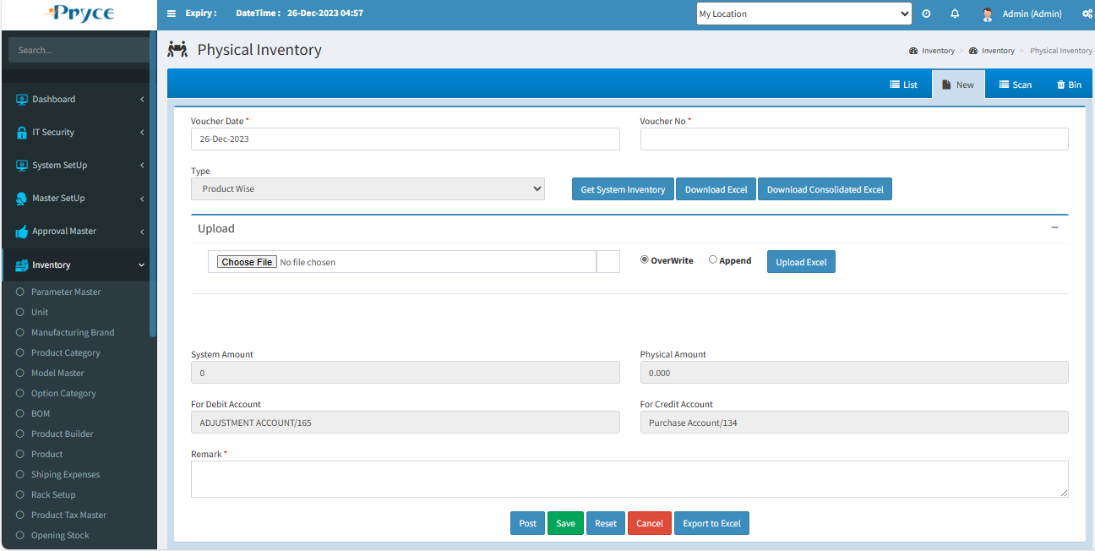

**Bin-**

* In this tab you will get all deleted records from list,where you can again restore record.
* **Select all-**  In this you can select all records by clicking select all button.
* **Restore button- ** In this you can restore selected record by clicking on restore button and again add record in list or grid.
* In this you can also able to select the record individually by checked in the check box.
* Also, you search the particular record in the search window and when you want to restore,then checked and click on the restore button.

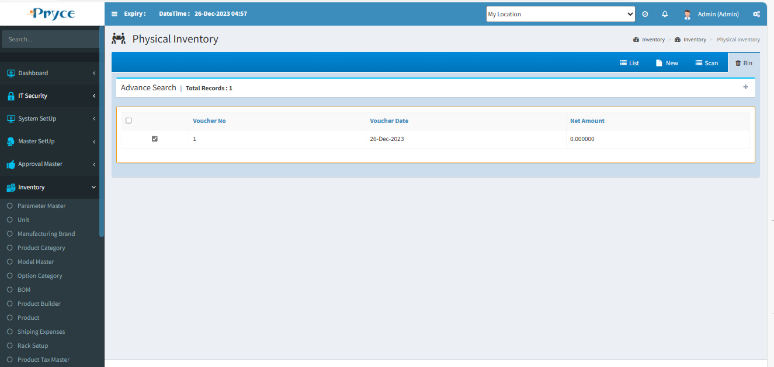

# 1.22 Stock Adjustment:-

In this page you can adjust the stock of a particular product for the same location.

There are Two tabs-

* List
* New

**List-**

In this tab you will get all saved stock adjustment records and you can search the record, according to the search criteria and also edit and delete.

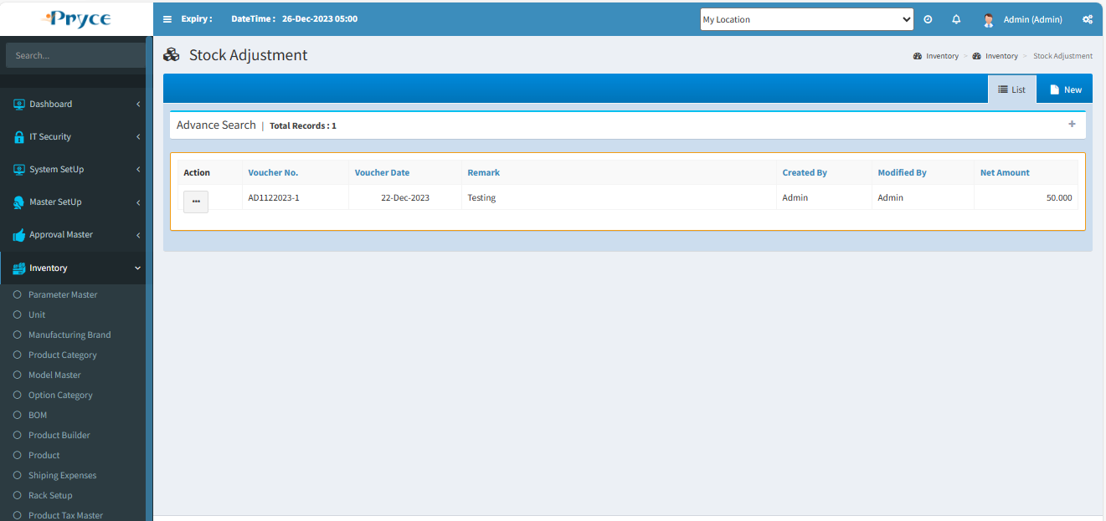

**Sorting**-

You can also sort the record in ascending & descending order after the click on the header of the list record(which is underlined).

**Search Criteria –**



Here you can search according to the field of Voucher No.,Voucher Date,Net Amount than you will get a list of related requests.

**Search-**  After that click on the search button and you get records according to search criteria in a record list.

**Refresh-**  After that you want to get again all records, then click on the refresh button.

**New-**

In this tab you will get an Entry Form where you can save the stock adjustment record.

Here you can select stock adjust type “In” or “Out”.

**Post-**After post the record you can’t edit and delete the record.

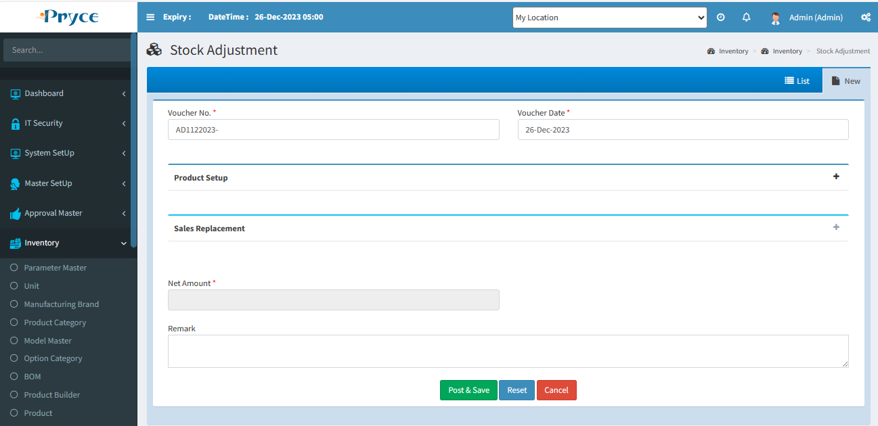

**Save-** Click on save button for new record add and save in the list.

**Reset-** By this “Reset” the record or clear the record.

**Cancel-**When you click on cancel button, then you will get in List tab and all fields will be reset.

# 1.23 Product Ledger:-

In this you can see the movement of every product as opening stock, transfer In or Out,stock adjustment etc.

In this all record, maintain according to those fields-unit,unit cost,In Qty,Out Qty,balance.

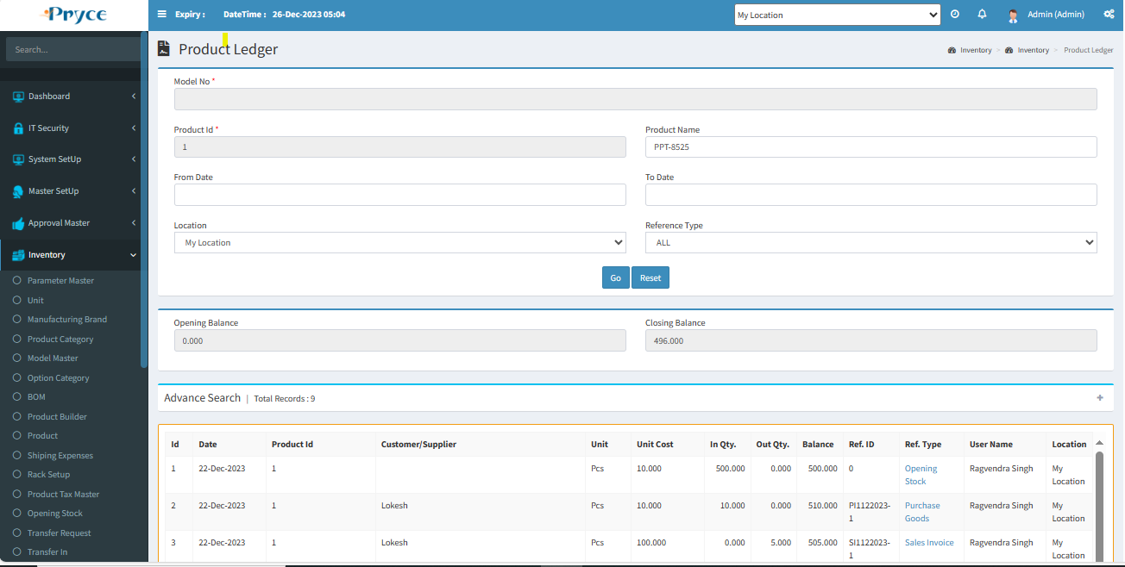

**Filter-**

You can filter records, according your requirement.

When you select From Date - To Date and click on “Go, then you show record according to selected date record.

When you select “Location”, than It’s show location wise record.

When you select “Reference Type” than a record show, according to the reference type.



**Search Criteria –**



Here you can search according to the field of Product Id,Product Name,Status,Date,Reference Type,User Name,Alternate Id then you will get a list of related requests.

**Search-**  After that click on the search button and you get records, according to search criteria in a record list.

**Refresh-**  After that you want to get again all records, then click on the refresh button.

# 1.24 Product Stock:-

In this you can just view the stock of the product available.

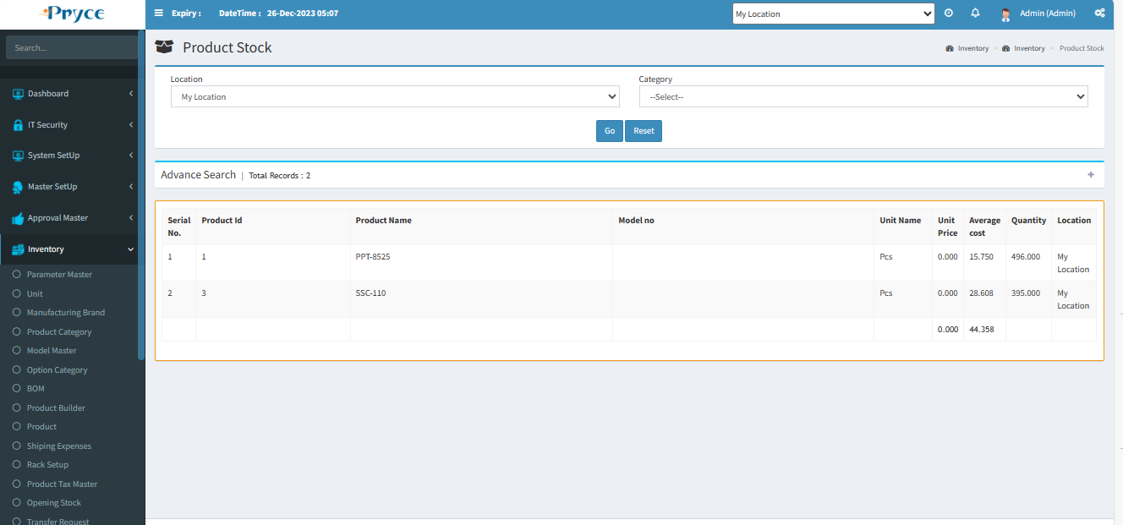

Here you can filter records, according to location selection or category wise,And click on “Go”button.Also you print the filter record.

**Search Criteria –**

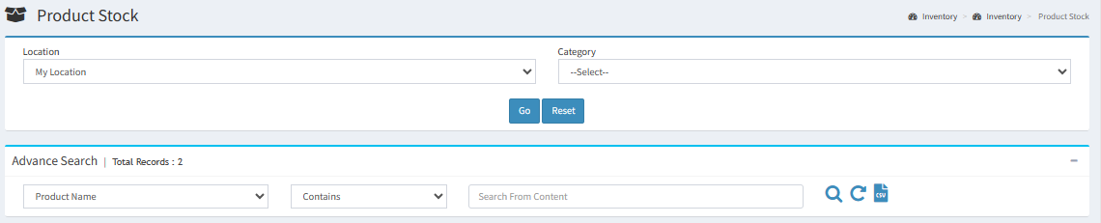

Here you can search according to the field of Product Id,Product Name,Quantity than you will get a list of related requests.

**Search-**  After that click on the search button and you get records according to search criteria in a record list.

**Refresh-**  After that you want to get again all records, then click on the refresh button.

# 1.25 Serial Movement:-

In this all detail there for product serial number,Which location have this product “In” or “out” also show “Reference Type”. In this you can check cycle of product In or Out status based.

Here you can product search by “Product Id” & “Serial no.” and get details of product serial number.

If you want to sort the product detail, then you can.

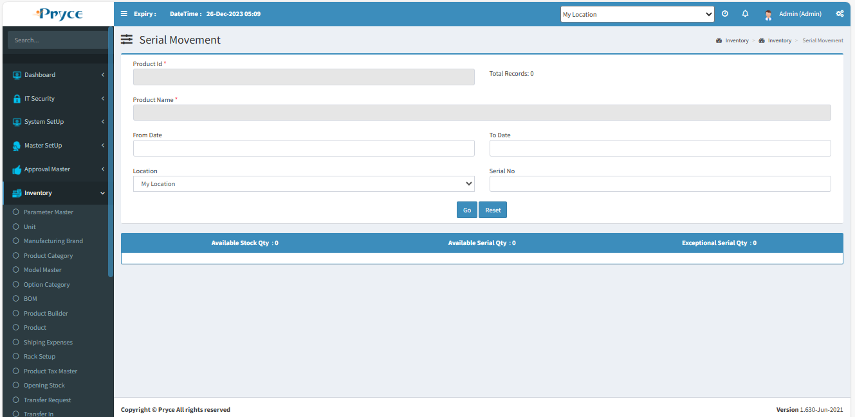

# 2.Purchase

The action of buying something.A buyer-generated document that authorizes a purchase transaction. When accepted by the seller, it becomes a contract binding on both parties.

# 2.1 Purchase Request:-

In this page, purchase department requests to the admin department to purchase the product from the supplier.

There are three tabs-

* List
* New
* Bin

**List-**

In this tab you will get the all saved purchase request records.Here you can edit and delete the record.and also sort & search the record.

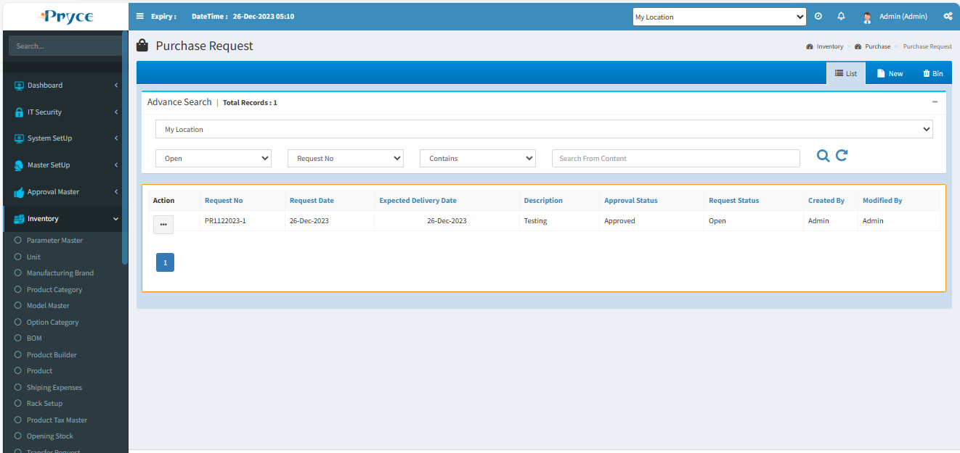

**Status-** Here show status of purchase request.Those statuses come from employee approval master.When “Purchase Request Approval” master select false,Than required approval.

* **Approved-** This request is approved by the department.
* **Rejected-**This request is rejected by the department.
* **Pending-** No response from the department against this purchase request.

**Note:- You can edit and delete only pending status Purchase request.**

**View-** 

You can view the record using view button.

**Note:-Here you can only view the record.**

On the click of view button related request record page will open.

**Detail Button-**

Here you can see the product description using Detail Button.

When you will over the mouse on this detail button than the description will show.

When you will mouse out from this detail button than description will automatically removed from the panel and it will go into previous position.

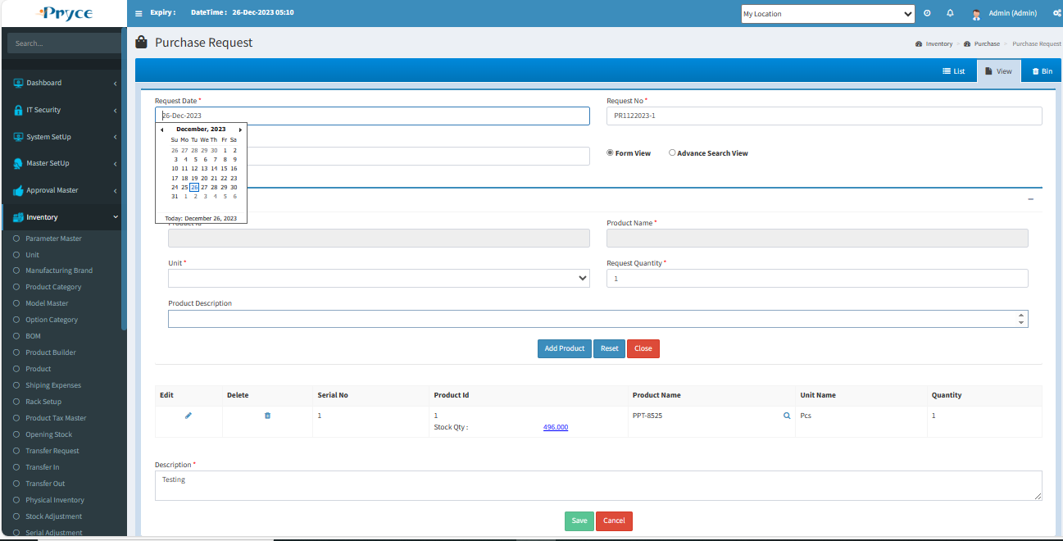

**Edit-** 

You can edit the record using the edit button.

**Note:- You can edit only those records which status is pending.**

When you will click on edit button the new tab is converted in edit and record related to this button is showing in the edit tab.

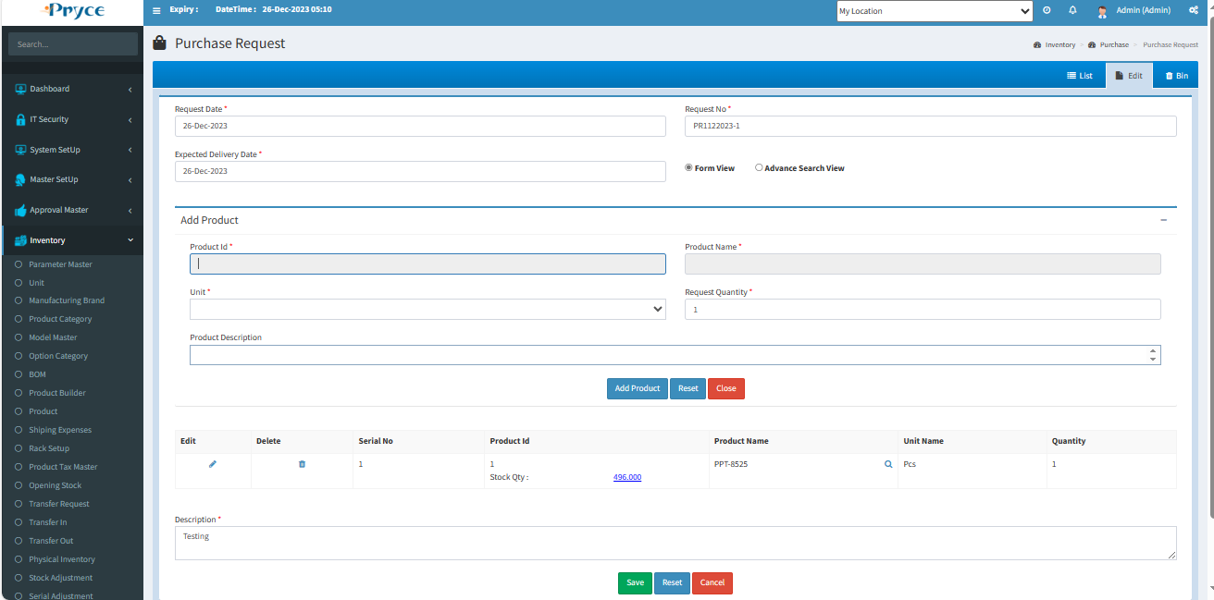

**Delete-**

When you want to delete any records then click on delete button.

**Note:- you can delete only those records in which status is pending.**

After deleting this record this will remove from this list and go in the bin section where you will restore according to your requirement.

**New-**

In this tab you can create the new purchase request.

Here you can add product with “Form view” & “Advance Search View”.

In form view you can add product according to your requirement. & click on add product.

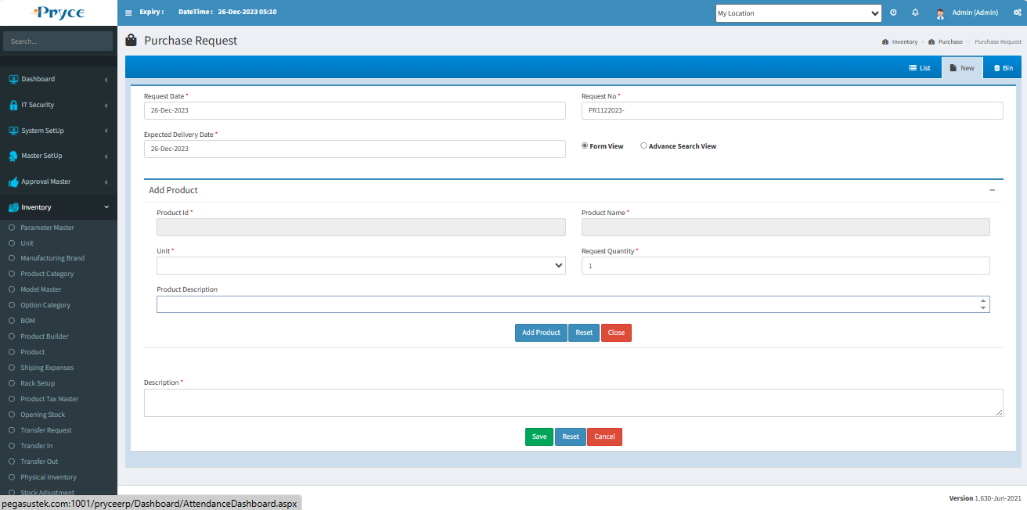

**Advance Search View-**

In this you can add product with advance search,When you click on Advance search radio button,then two more button show-“Add Product List” & ”Fill your product”.

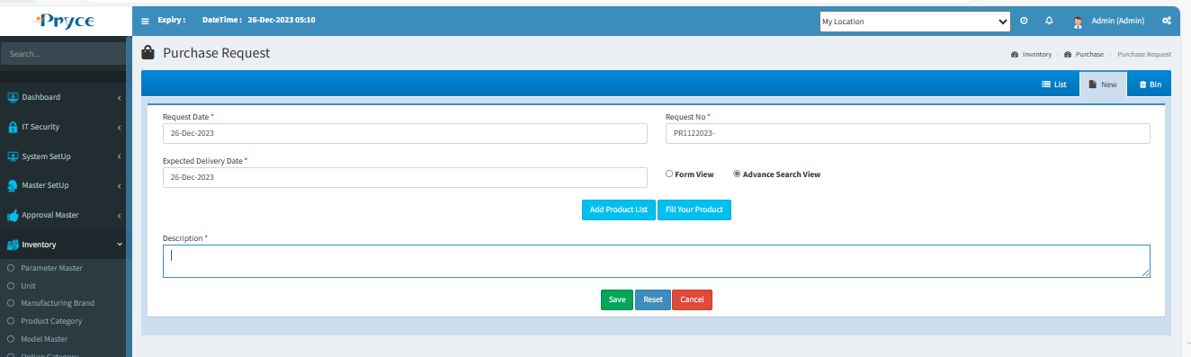

When you click on “Add Product List” than next page show for adds product which you want.

Select check box for adding product & if you want to give quantity then type values in the text box.But first you give value then select the check box.

Selected product show in left side of list & if you want to delete any record than click on delete.

If you want any product and not found, Then you filter the product & search.

After product selection click on “Add To List”.

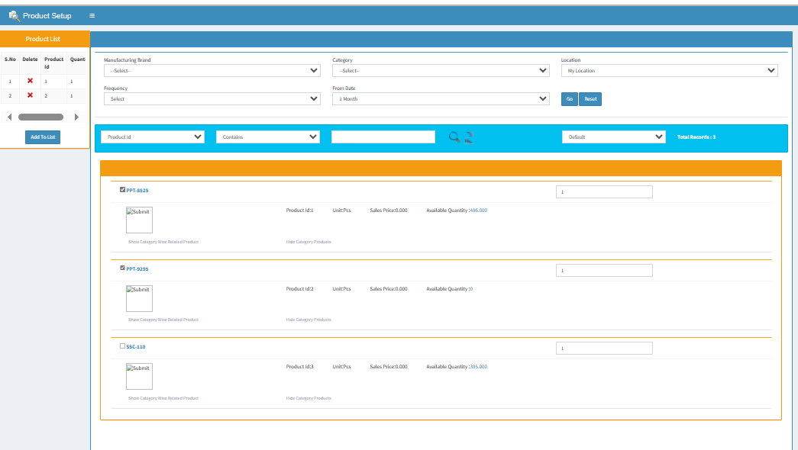

After that click on “Fill Your Product”, Then show all the selected product.

**Description-**You can enter the description of this purchase request.

**Bin-**

* In this tab you will get all deleted records from list, where you can again restore record.
* **Select all-**  In this you can select all records by clicking select all button.
* **Restore button- ** In this you can restore selected record by clicking on restore button and again add record in list or grid.
* In this you can also able to select the record individually by checked in the check box.
* Also, you search the particular record in the search window and when you want to restore, then checked and click on the restore button.

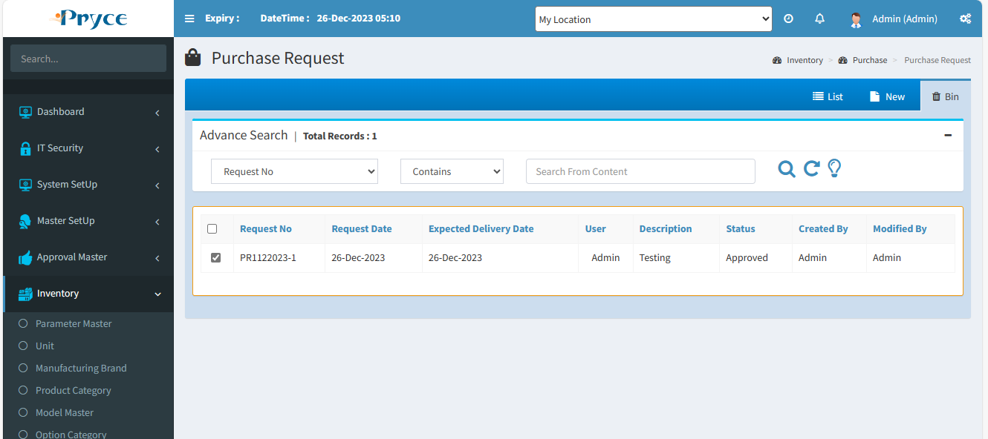

# 2.3 Purchase Inquiry:-

In this page you can make the purchase inquiry for purchase the product.

There are Four tabs-

* List
* New
* Bin
* Request

**List-**

In this tab you will get the all saved purchase inquiry records.Also here you can view, edit, delete & search, at the record.

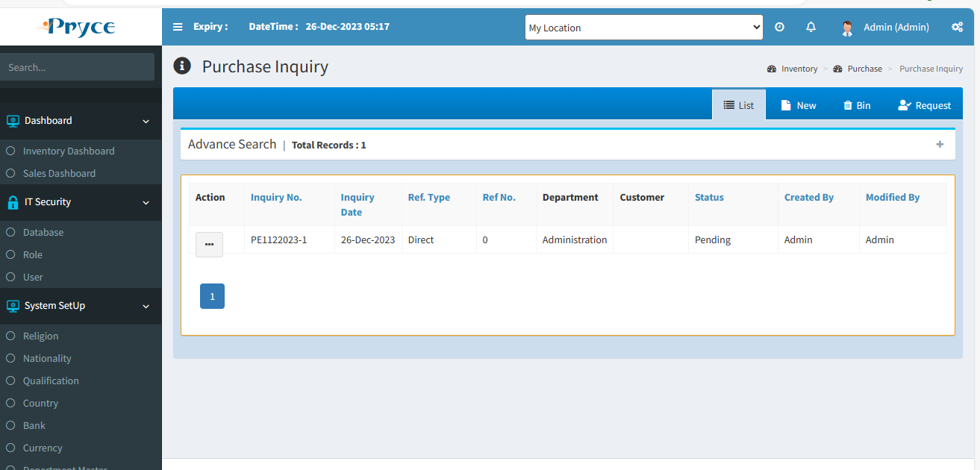

**Sorting**-

You can also sort the record in ascending & descending order after the click on the header of the list record(which is underlined).

**Search Criteria –**

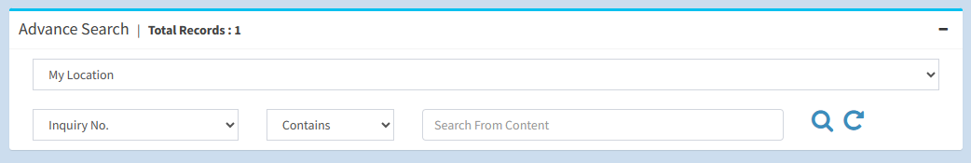

Here you can search according to the field of Inquiry No.,Inquiry Date,Ref.Type,Ref No.,User,Customer,status then you will get a list of related requests.

**Search-**  After that click on the search button and you get records according to search criteria in a record list.

**Refresh-**  After that you want to get again all records, then click on the refresh button.

**View-** 

You can view the record using view button.

**Note:-Here you can only view the record.**

On the click of view button the panel will open with the purchase inquiry record related to this view button.

**Detail Button-**

Here you can see the product description using Detail Button.

When you will over the mouse on this detail button than the description will show.

When you will mouse out from this detail button than description will automatically removed from the panel and it will go into previous position.

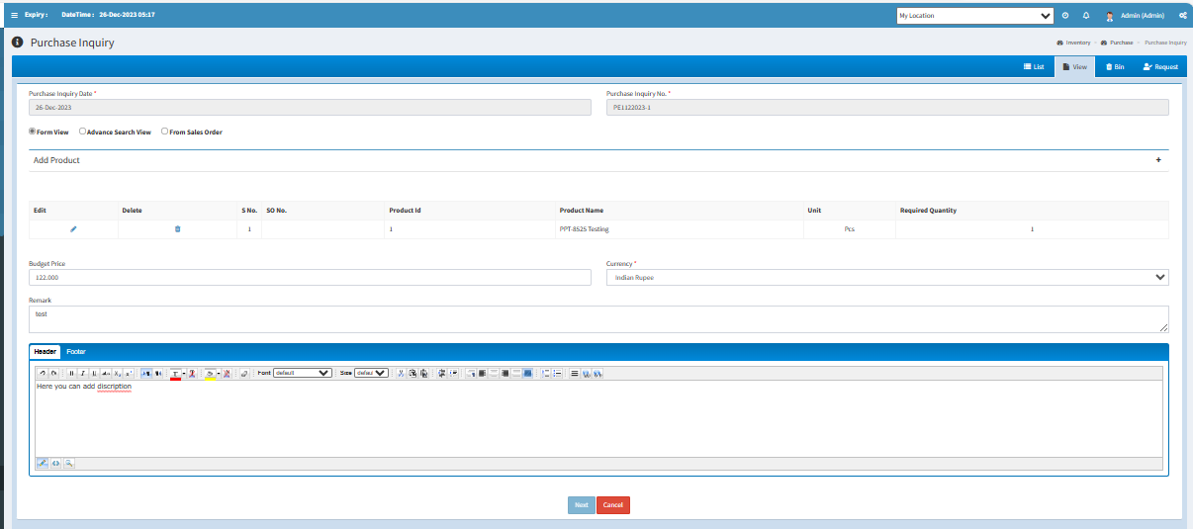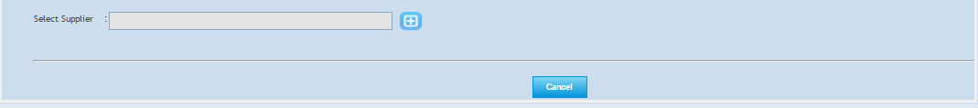

**Edit:-** 

You can edit the record when you click on the edit button.

**Note:- You can edit only those records in which Status is Pending.**

When you will click on edit button the new tab is converted into edit and all records related to this button is showing in the edit tab-

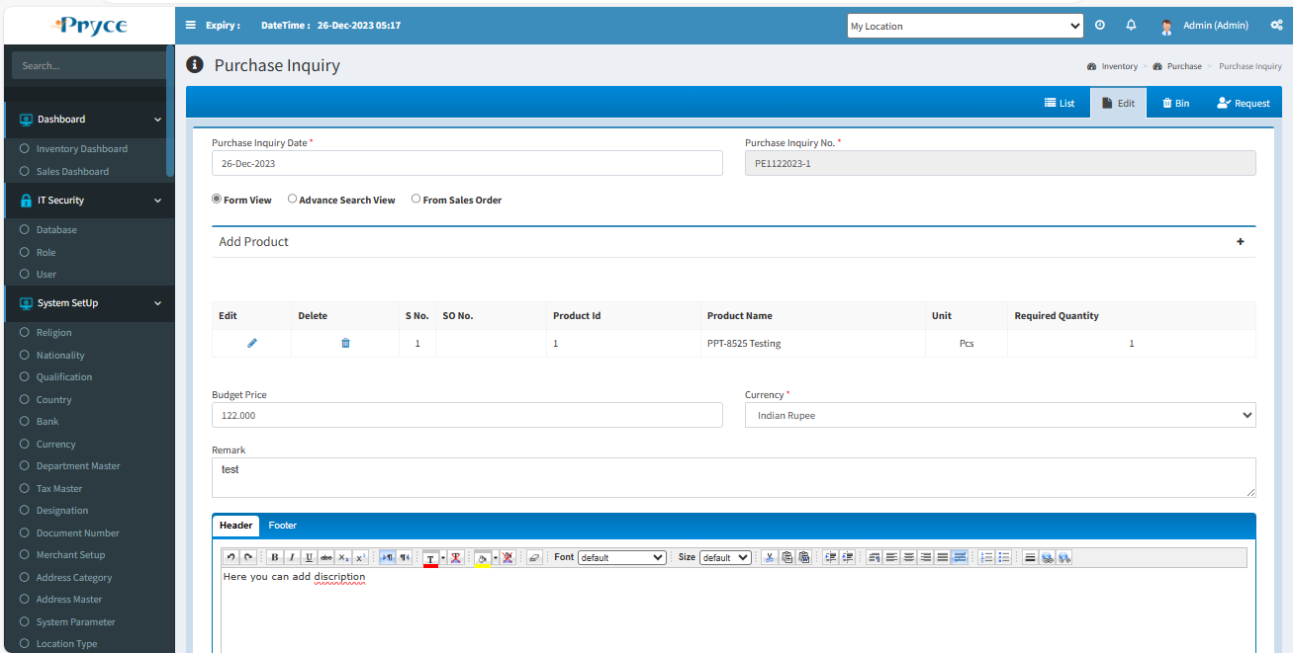

**Next Button-** Here you can click on the next button, then the next page will open for supplier selection,Where you can select the supplier in suggestion list one or more.and also check the check box.Which supplier you want.

Here “Supplier price list”button available when you click on this button than selected supplier price list show. 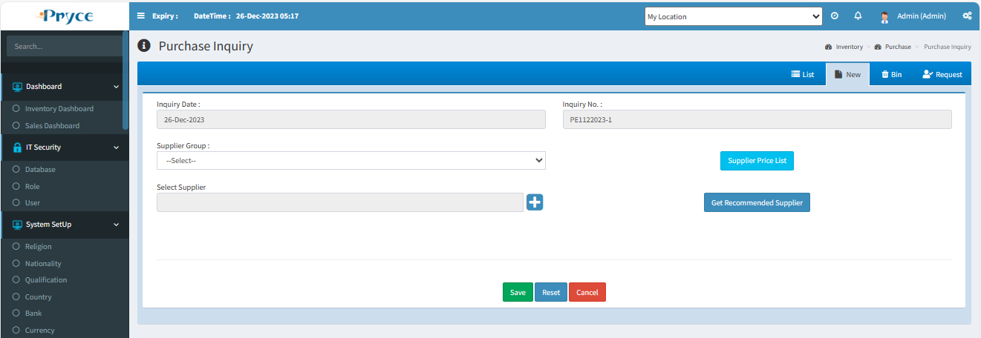

**Delete-**

When you want to delete any record than click on delete button.

**Note:- You can delete only those records in which status is pending.**

After deleting this record this record removes from this list and go into bin section where you will restore according to your requirement.

**New-**

In this tab you can create the new purchase inquiry “Direct”.

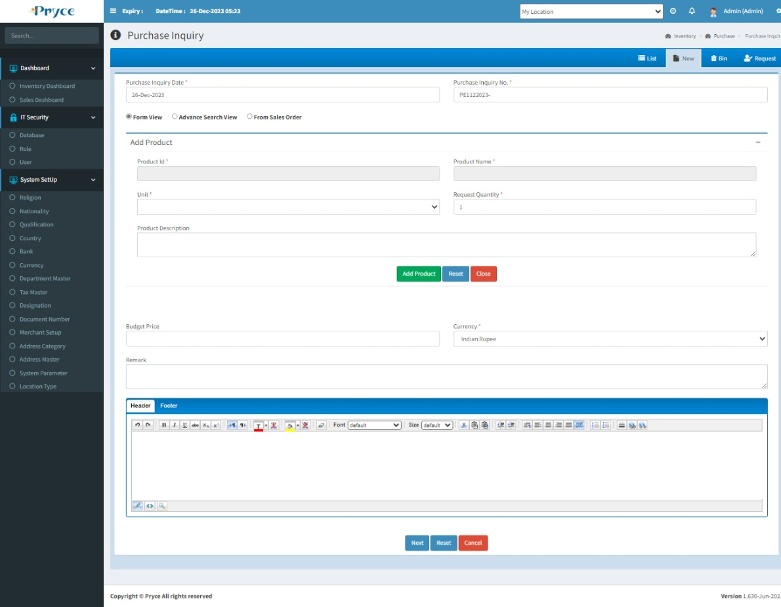

**Next Button-** Here you can click on the next button, then the next page will open for supplier selection,Where you can select the supplier in suggestion list one or more.and also check the check box.Which supplier you want.

Here “Supplier price list”button available when you click on this button than selected supplier price list show.

**Bin-**

* In this tab you will get all deleted records from list,where you can again restore record.
* **Select all-**  In this you can select all records by clicking select all button.
* **Restore button- ** In this you can restore selected record by clicking on restore button and again add record in list or grid.
* In this you can also able to select the record individually by checked in the check box.
* Also, you search the particular record in the search window and when you want to restore, then checked and click on the restore button.

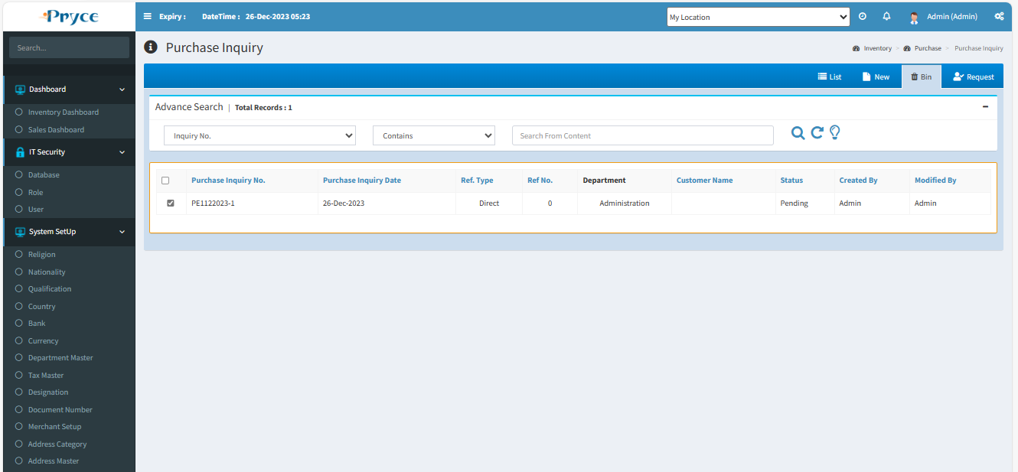

**Request**-

In this tab you can get the list of approved purchase request.

When the purchase request approves from a related department, then you can make the inquiry against this request.

**Request Type:-** Two types of request-

**Purchase Request-** The purchase request comes from purchase department.

**Sales Inquiry**- The sales inquiry comes from the sales department.

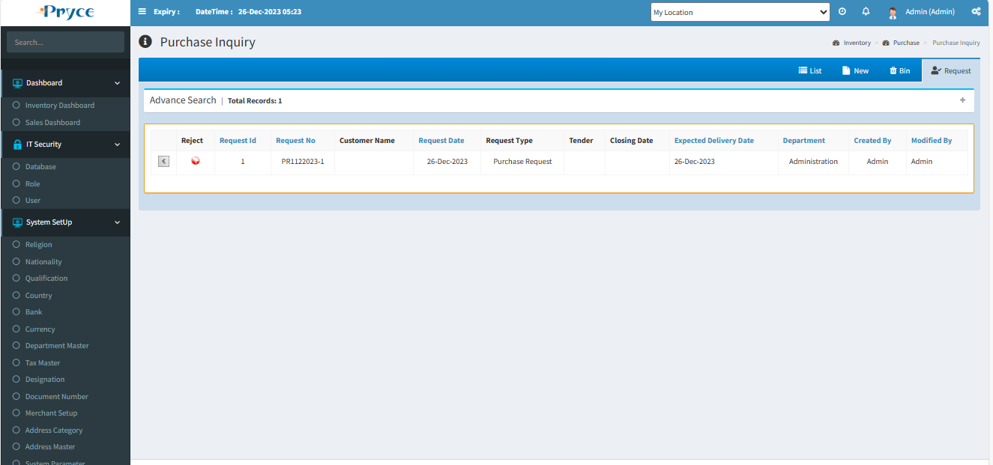

**Request Button-** When you click on request button than the record related to this button is showing in new tab.

Here you can add, the more product in this inquiry using add product button and also delete the product using the delete button.

Then you click on “Next button” for select supplier and add.When supplier add then click on Save. This record shows in List of purchase inquiry.

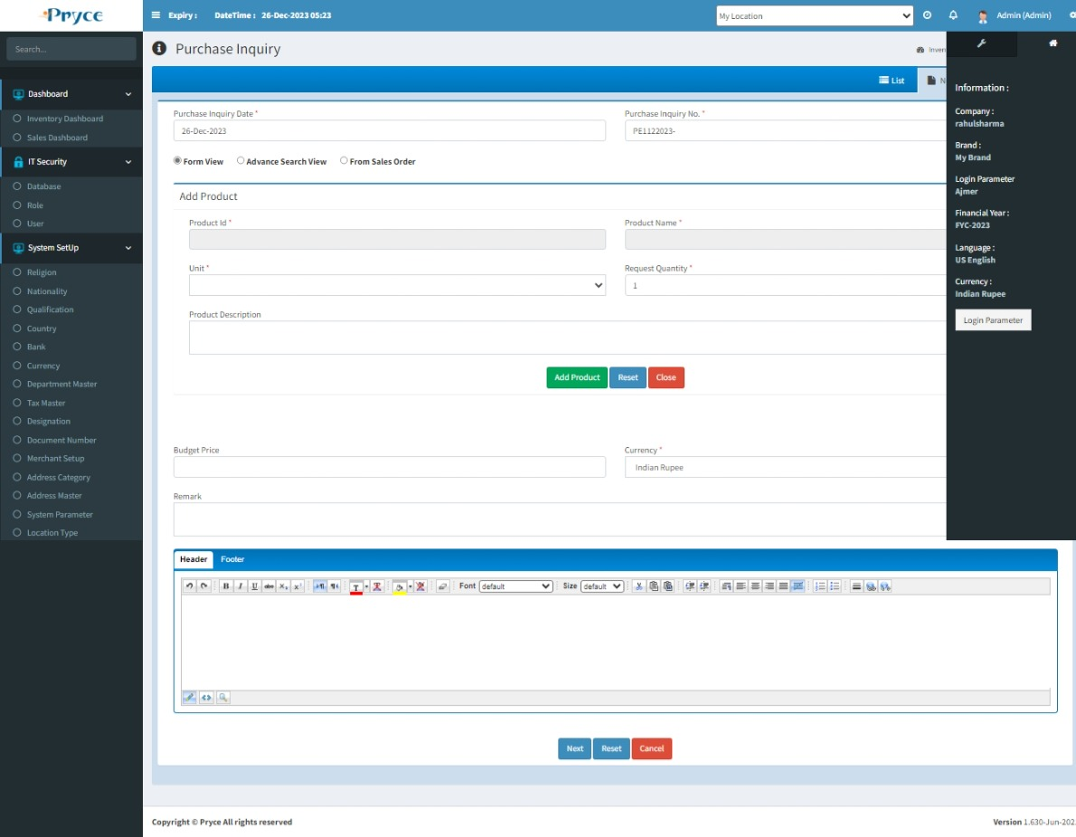

# 2.4 Purchase Quotation:-

In this page you can save the purchase quotation (comes from the supplier) against the purchase inquiry.

There are Four tabs-

* List
* New
* Bin
* Inquiry

**List-**

In this tab you can get the all saved purchase quotation record and here and also you can edit,delete,view,print& sort,search record.

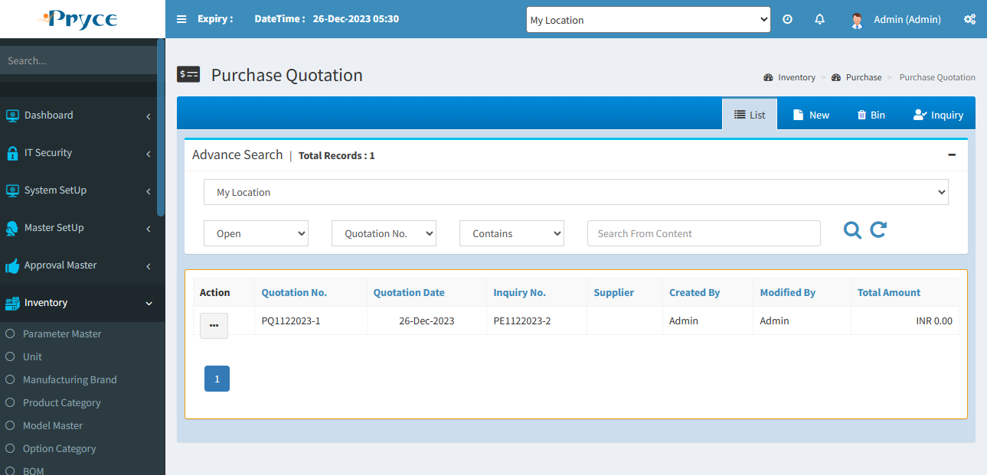

**Sorting**-

You can also sort the record in ascending & descending order after the click on the header of the list record(which is underlined).

**Search Criteria –**

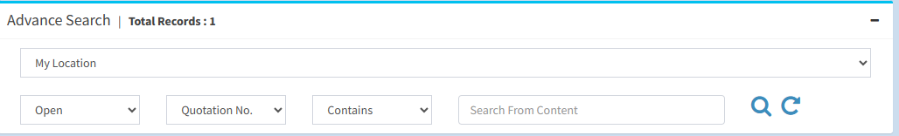

Here you can search according to the field of Quotation No.,Quotation Date,Inquiry no.,supplier name than you will get a list of related Quotation record.

**Search-**  After that click on the search button and you get records according to search criteria in a record list.

**Refresh-**  After that you want to get again all records, then click on the refresh button.

**View-** 

You can view the record using view button.

**Note:-Here you can only view the record.**

On the click of view button the panel will open with the purchase quotation record related to this view button.

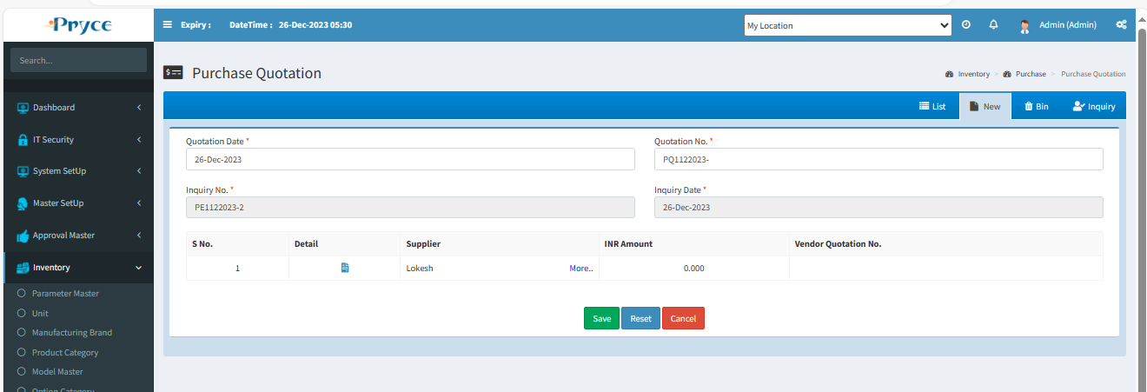

**Edit-** 

You can edit the record when you click on the edit button.

**Note:- You can edit only those records in which purchase order is not made against this quotation.**

When you will click on edit button the new tab is converted into an edit tab and record related to this button is shown in the edit tab.

Here you can update the quotation detail of individually supplier using “Detail” button of each supplier.

**Detail Button-** You can click on detail button to update the quotation detail.



Here you can update the quotation price, vendor quotation no.,referenced product name etc.

Click on the save button after update the record and this page is redirected to again edit tab and total amount is affected according the quoted price of all suppliers.

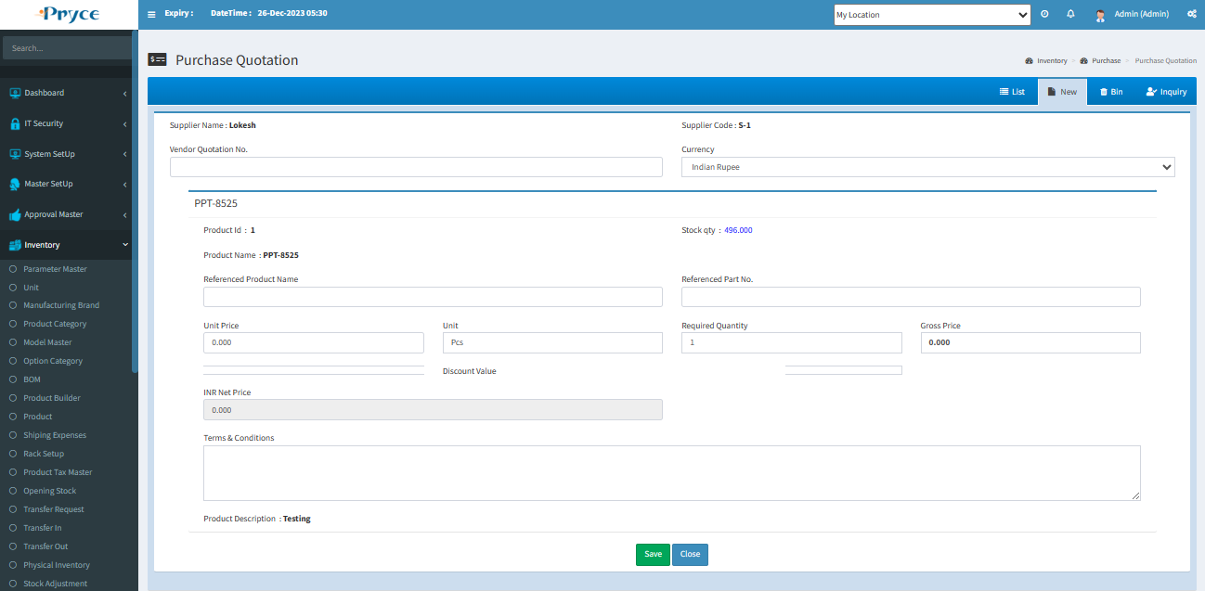

**Delete-**

When you want to delete any record than click on delete button.

**Note:- You can delete only those records in which order is not made against this quotation.**

After deleting a particular record this record removes from this list and go into bin section where you will restore according to your requirement.

**New-**

You can not create quotation without inquiry.

**Note:-Quotation should not create without inquiry so first of all you will go to the inquiry tab, then choose the inquiry than you can create the quotation.**

**Bin-**

* In this tab you will get all deleted records from list,where you can again restore record.
* **Select all-**  In this you can select all records by clicking select all button.
* **Restore button- ** In this you can restore selected record by clicking on restore button and again add record in list or grid.
* In this you can also able to select the record individually by checked in the check box.
* Also, you search the particular record in the search window and when you want to restore, then checked and click on the restore button.

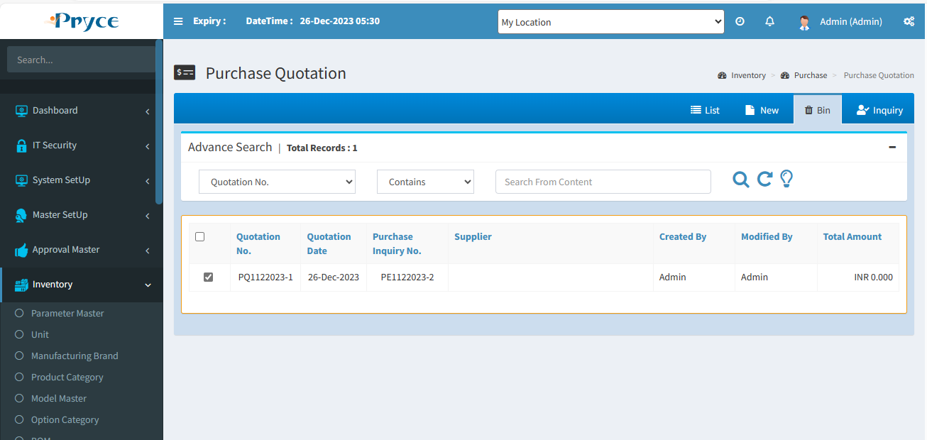

**Inquiry**-

In this tab you can get the list of Purchase Inquiry.

**Request Button-** When you click on request button than the record related to this button is showing in new tab.

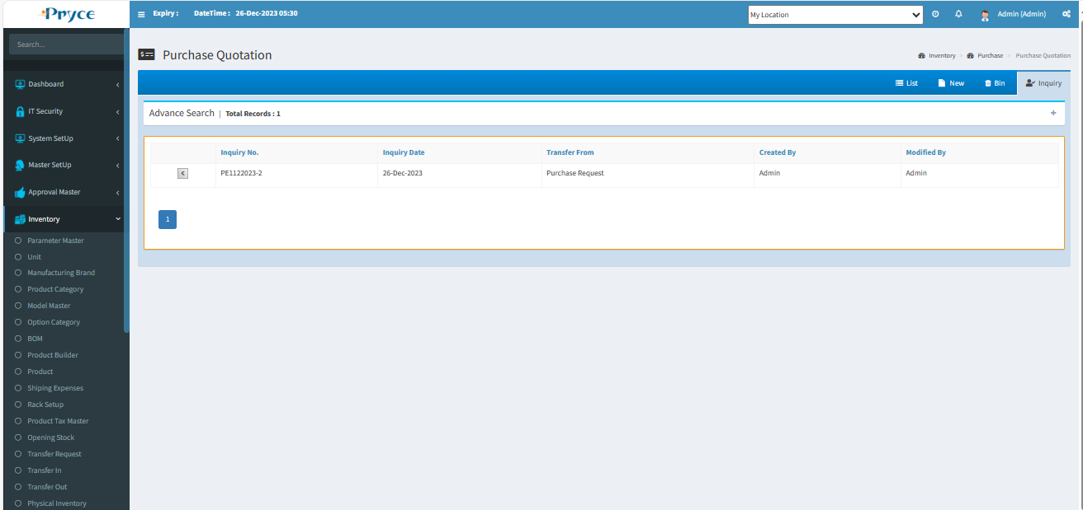

Here you can enter the quotation price (supplier wise) using detail button.

 **Detail Button-** You can click on detail button and enter the quotation price which comes from the supplier.

Click on “Save” button to save the record and this page is redirected to again new tab and total amount is affected according to the sum of the quoted price of all suppliers.



**Note:- When the Purchase Inquiry is made against the sales inquiry than the Purchase quotation has sent the sales price to the sales department which is shown on sales quotation.**

# 2.5 Purchase Order:-

In this page you can save the purchase order (comes from the supplier) against the purchase quotation and directly.

There are Four tabs-

* List
* New
* Bin
* Quotation

**List-**

In this tab you can get the all saved purchase order records and here you can edit,delete,view,print,search & sort.

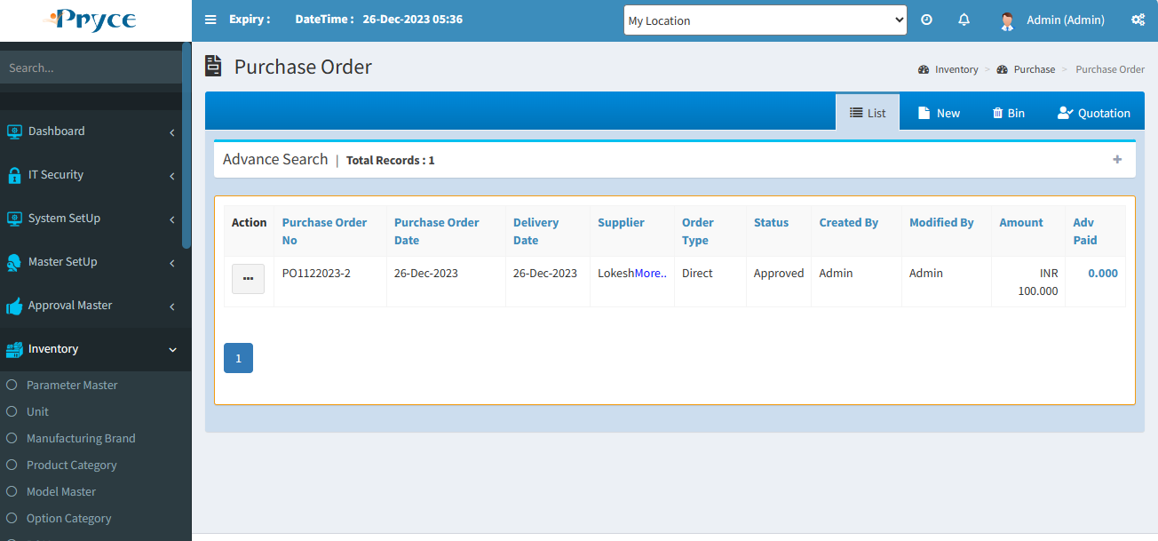

**Order Type-**

When the purchase order is made directly than the order type is **Direct** and when the purchase order is made against the quotation then **By Quotation,**and from the sales department than **By Sales Order.**

**Sorting**-

You can also sort the record in ascending & descending order after the click on the header of the list record(which is underlined).

**Search Criteria –**

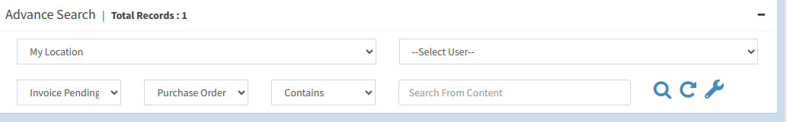

Here you can search according to the field of Purchase order No.,Purchase Order Date,Delivery Date.,Order Type,Status,Supplier than you will get a list of related orders.

**Search-**  After that click on the search button and you get records according to search criteria in a record list.

**Refresh-**  After that you want to get again all records, then click on the refresh button.

**View-** 

You can view the record using view button.

**Note:-Here you can only view the record.**

On the click of view button the panel will open with the purchase order record related to this view button.

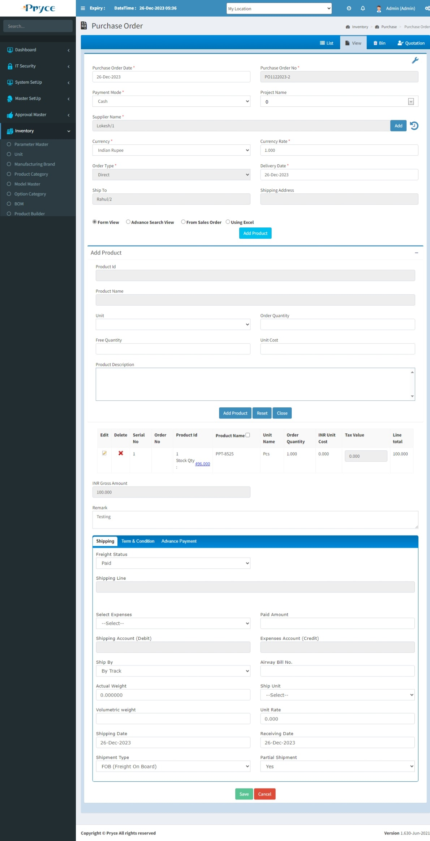

**Edit-** 

You can edit the record using the edit button.

**Note:- You can edit only those records in which purchase invoice is not made against this Purchase Order.**

When you will click on edit button the new tab is converted into edit and all records related to this button is showing in the edit tab.

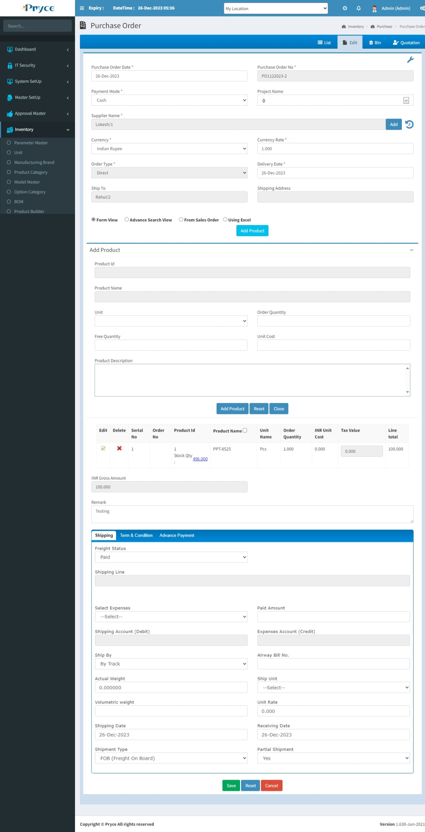

**Add Product-** You can add more product using add product button.But this product who’s there in quotation time.but not selected in quotation to order create.

That time you click on “Add Product”than not selected product show.Here you can check the product which is you require. & click on “Add to order”.

Also, you delete the record, If you not required.

**Delete-**

When you want to delete any record than click on delete button.

**Note:- You can delete only those records in which Invoice is not made against this Purchase Order.**

After deleting a particular record this record removes from this list and go into bin section where you will restore according to your requirement.

**New-**

In this tab you can create the new purchase order.

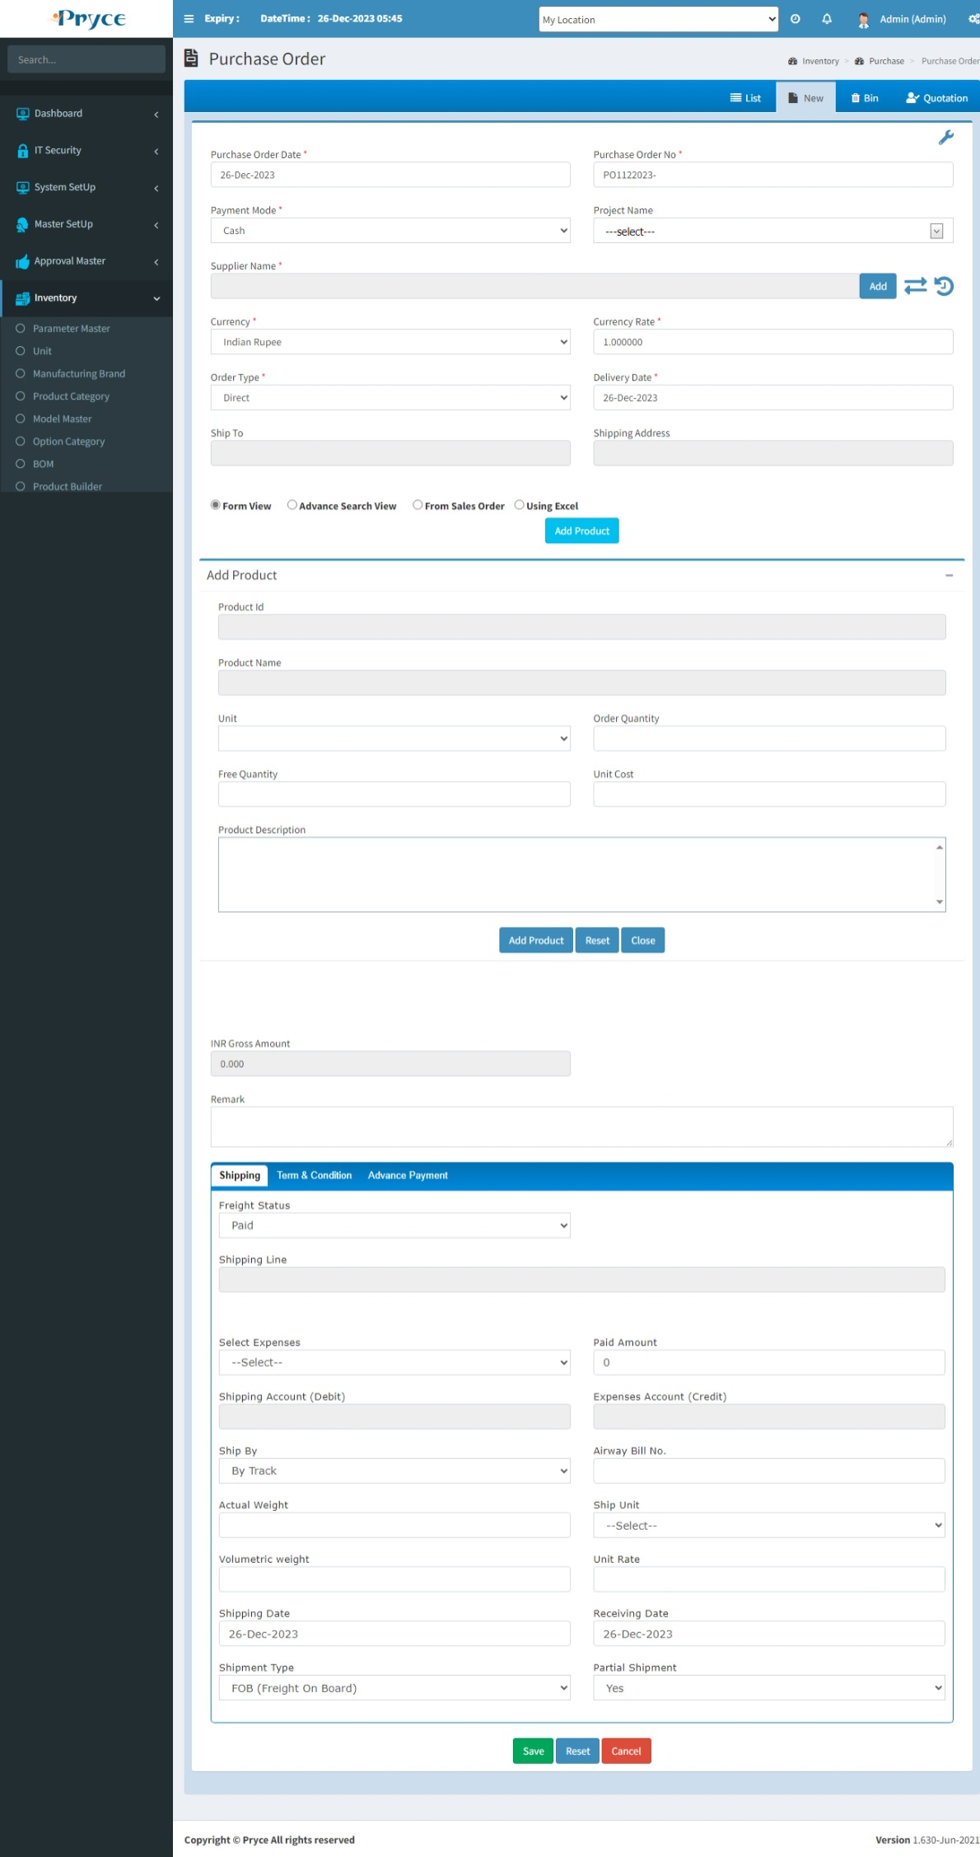

You can create the Purchase Order of following three types:-

1. Directly
2. Purchase Quotation
3. By Sales Order
4. **Directly-**

Using this option you can directly create the purchase order.

First of all you select the order type and then select the Direct option.

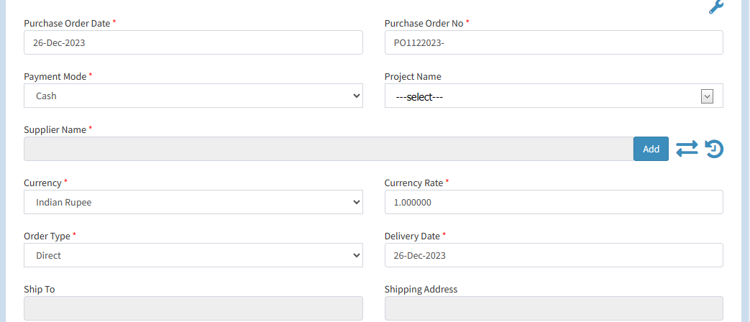

After that you can select the supplier to give the purchase order,you can’t manually type supplier, only just select from the suggestion list.

**Product Add-**

* Form view
* Advance search view

**From View-**

**Unit Cost-** You can enter the unit cost for this particular product.

**Order Quantity:-**In this field you can enter the order quantity of this particular product.

**Free Quantity:**-In this field you can enter the free quantity of this particular product.

**Description:**- Description comes is dynamically according the selected product. & click on “Add Product”.

**Advance search view-**

When you select advance search, view option for product add, then select the radio button.Then you show two more buttons-“ Add Product List”, “Fill Your Product”



When you click on “Add Product List” than next page show for adds product which you want.

Select check box for adding product & if you want to give quantity then type values in the text box.But first you give value then select the check box.

Selected product show in left side of list & if you want to delete any record than click on delete.

If you want any product and not found, Then you filter the product & search.

After product selection click on “Add To List”.

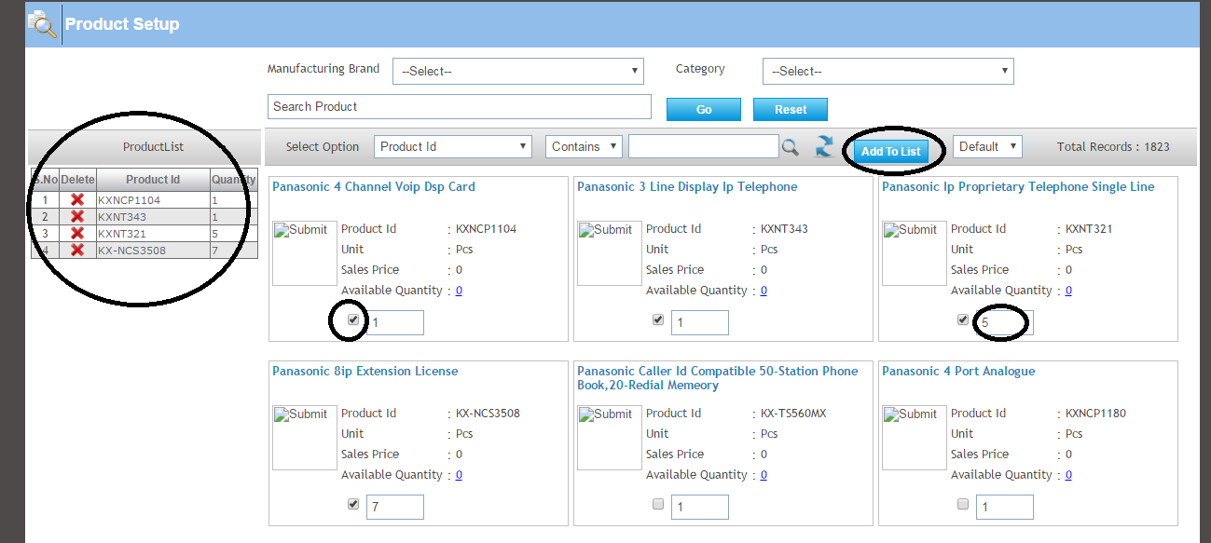

After that click on “Fill Your Product”, Than all selected products will be shown in the list.

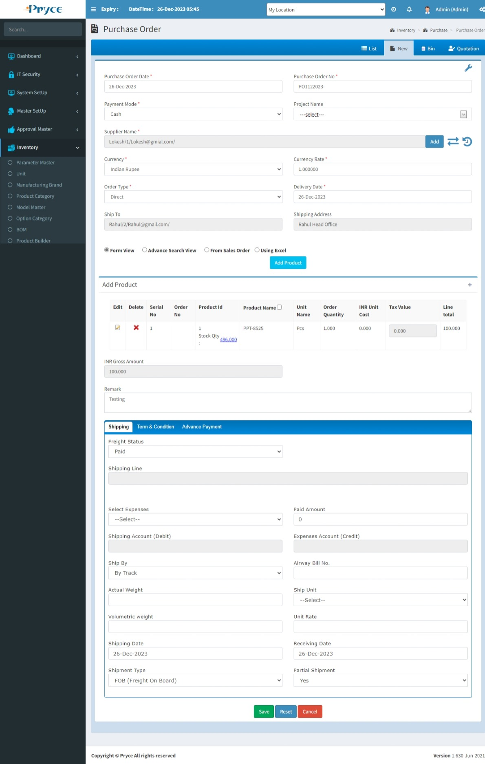

**Shipping-** Here you can give shipping detail of order according your status.

**Term & Conditions-** Here you can give Term & Condition for your order.

**Advance Payment-** Also you can pay the advance,In this have many options for payment.

1. **Purchase Quotation**-

It’s an “Indirect” order type,Which comes from purchase quotation.

1. **Sales Order-**

You can create the purchase order against the sales order when the sales Order is forward in Purchase Order page.

You select the “indirect” option on Order Type.

After that select the “Sales Order” Option in reference type.

After that select the “Sales Order Number” in Reference Number.

When you select the sales Order Number then you can select the supplier in the suggestion list.

That after all the detail of this sales Order will show.Here you can select all product or select randomly according your requirement.

**Bin-**

* In this tab you will get all deleted records from list,where you can again restore record.
* **Select all-**  In this you can select all records by clicking select all button.
* **Restore button- ** In this you can restore selected record by clicking on restore button and again add record in list or grid.
* In this you can also able to select the record individually by checked in the check box.
* Also, you search the particular record in the search window and when you want to restore, then checked and click on the restore button.

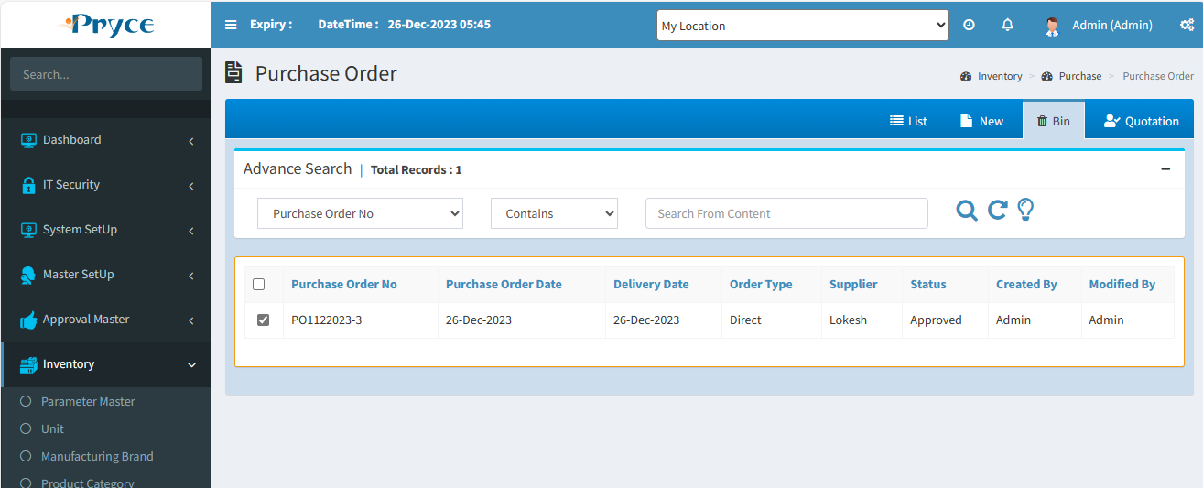

**Quotation**-

In this tab you can get the list of Purchase Quotation.

**Status:-** Is following two types:-

1. Quotation has come from the supplier (belong to sales)- when this quotation belongs to the sales department.
2. The quotation comes from the supplier,When this quotation belongs to the purchase department.

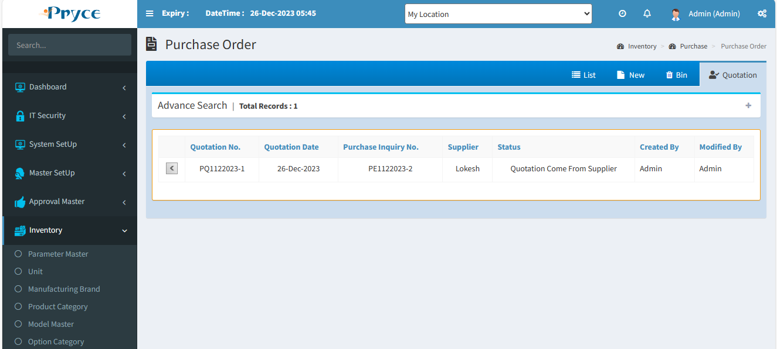

**Request Button-**  When you click on request button than the record related to this button will show.

It’s a quotation comparison page,Here you can select a supplier according product amount.

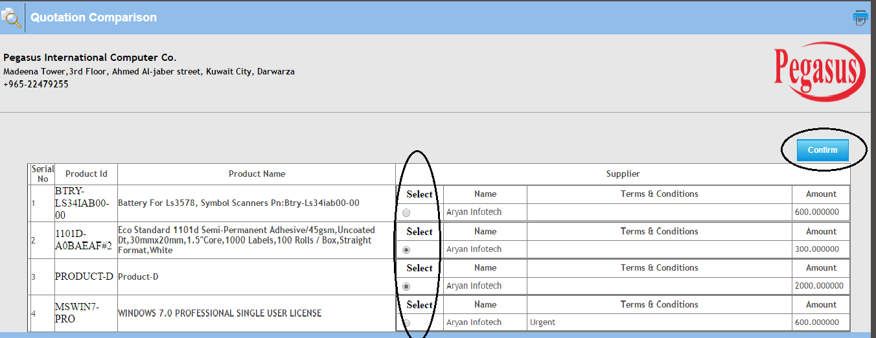

When have **multiple supplier** than product, select according to low amount of supplier.& click on “confirm”button.

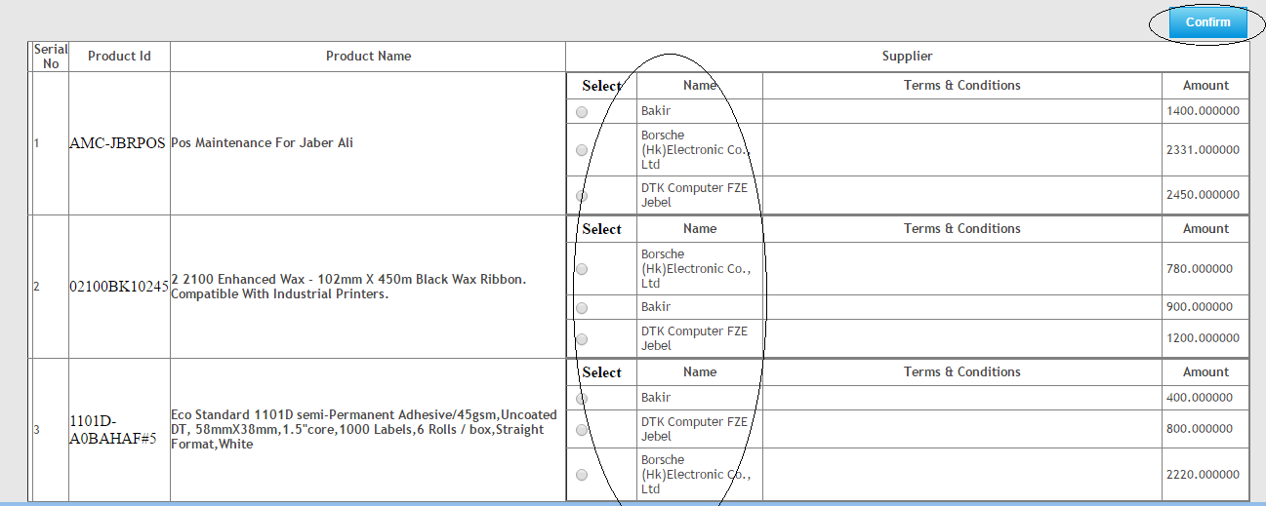

After confirming quotation then again click on Request Button.

**Request Button-**  When you click on request button than the record related to this button will show.

Here you can create the purchase order against the purchase quotation.

Above the supplier Name field,All fields by default generated.

When you select a supplier in the suggestion list.than related product list show.

After that you can select those products in which you want to make an order and enter the free quantity.

Also, you can select the product in a random manner.

For example- Here Four products are there, but you want to make order of only two product then select/check specific product only.

Amount also count according to product selection.Even affected “Duty (%)”,”Net Amount”.

2.6 Purchase Invoice:-

In this page you can save the purchase Invoice against the purchase Order and directly.

There are Three tabs-

* List
* New
* Pending Order

**List-**

In this tab you can get the all saved purchase invoice record and here you can edit,delete,search & sort the record. Also, you can show list according to your selection, search by-“All”,”Posted”,”Unposted”.

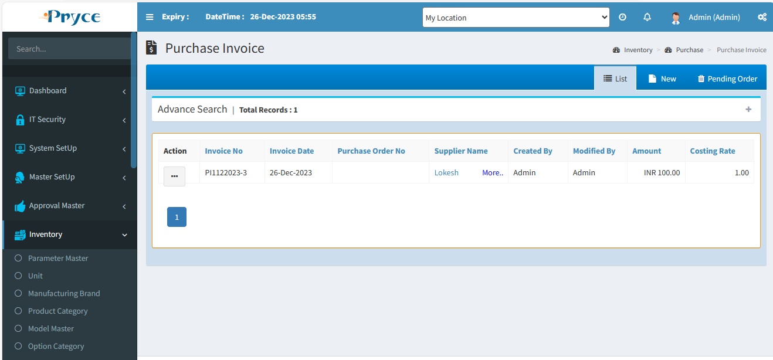

**Sorting**-

You can also sort the record in ascending & descending order after the click on the header of the list record(which is underlined).

**Search Criteria –**

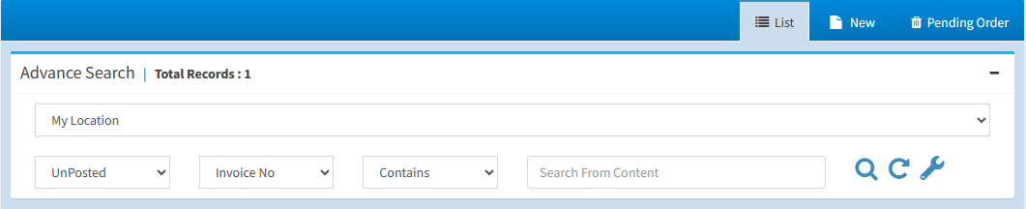

Here you can search according to the field of Invoice No.,Invoice Date,Supplier Invoice No.,Supplier Invoice Date.,Invoice Type,Supplier than you will get a list of related invoices.

**Search-**  After that click on the search button and you get records according to search criteria in a record list.

**Refresh-**  After that you want to get again all records, then click on the refresh button.

**View-** 

You can view the record using view button.

**Note:-Here you can only view the record.**

On the click of view button the panel will open with the purchase invoice record related to this view button.

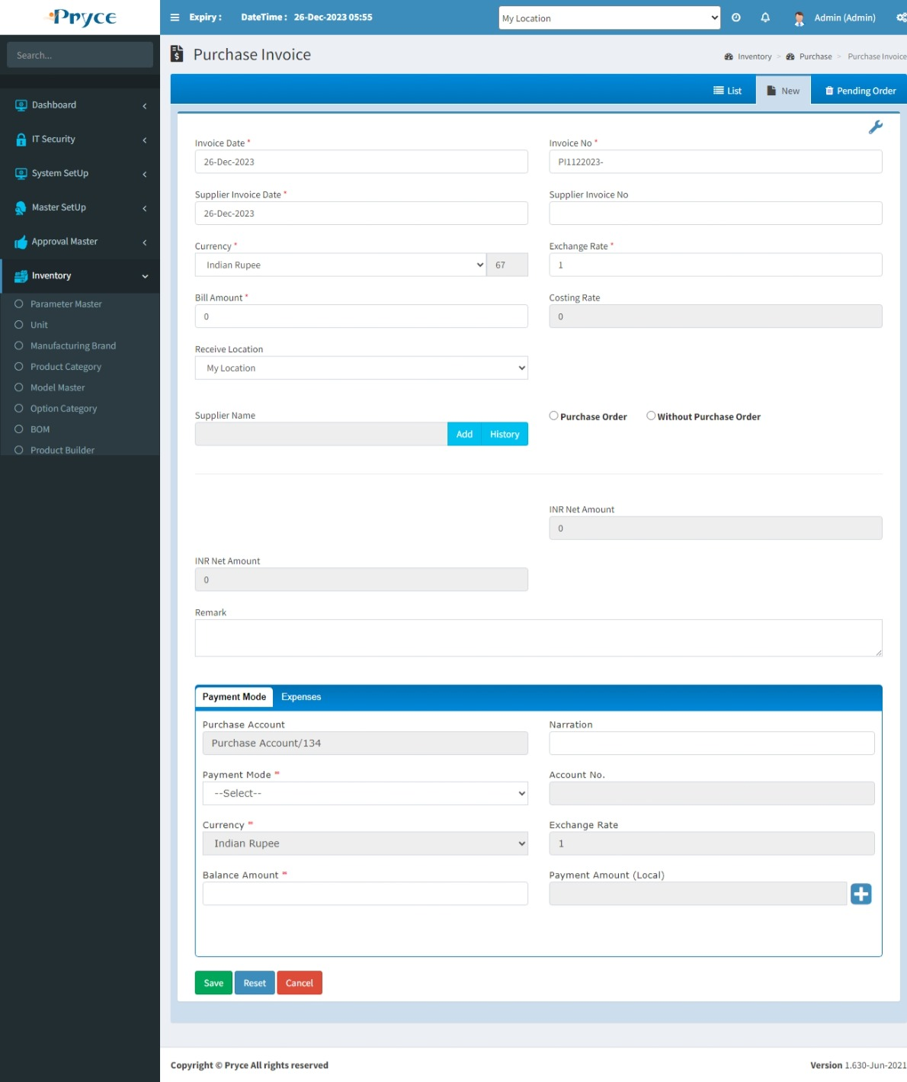

**Edit-** 

You can edit the record when click on the edit button.

**Note:- You can edit only those records in which purchase invoice is not posted.**

When you will click on edit button the new tab is converted into edit and all records related to this button is showing in the edit tab.

Here you can edit Expenses detail,Product deletes If you want and edit the cost,free quantity,invoice quantity.Also tax & discount.

You can select payment mode.

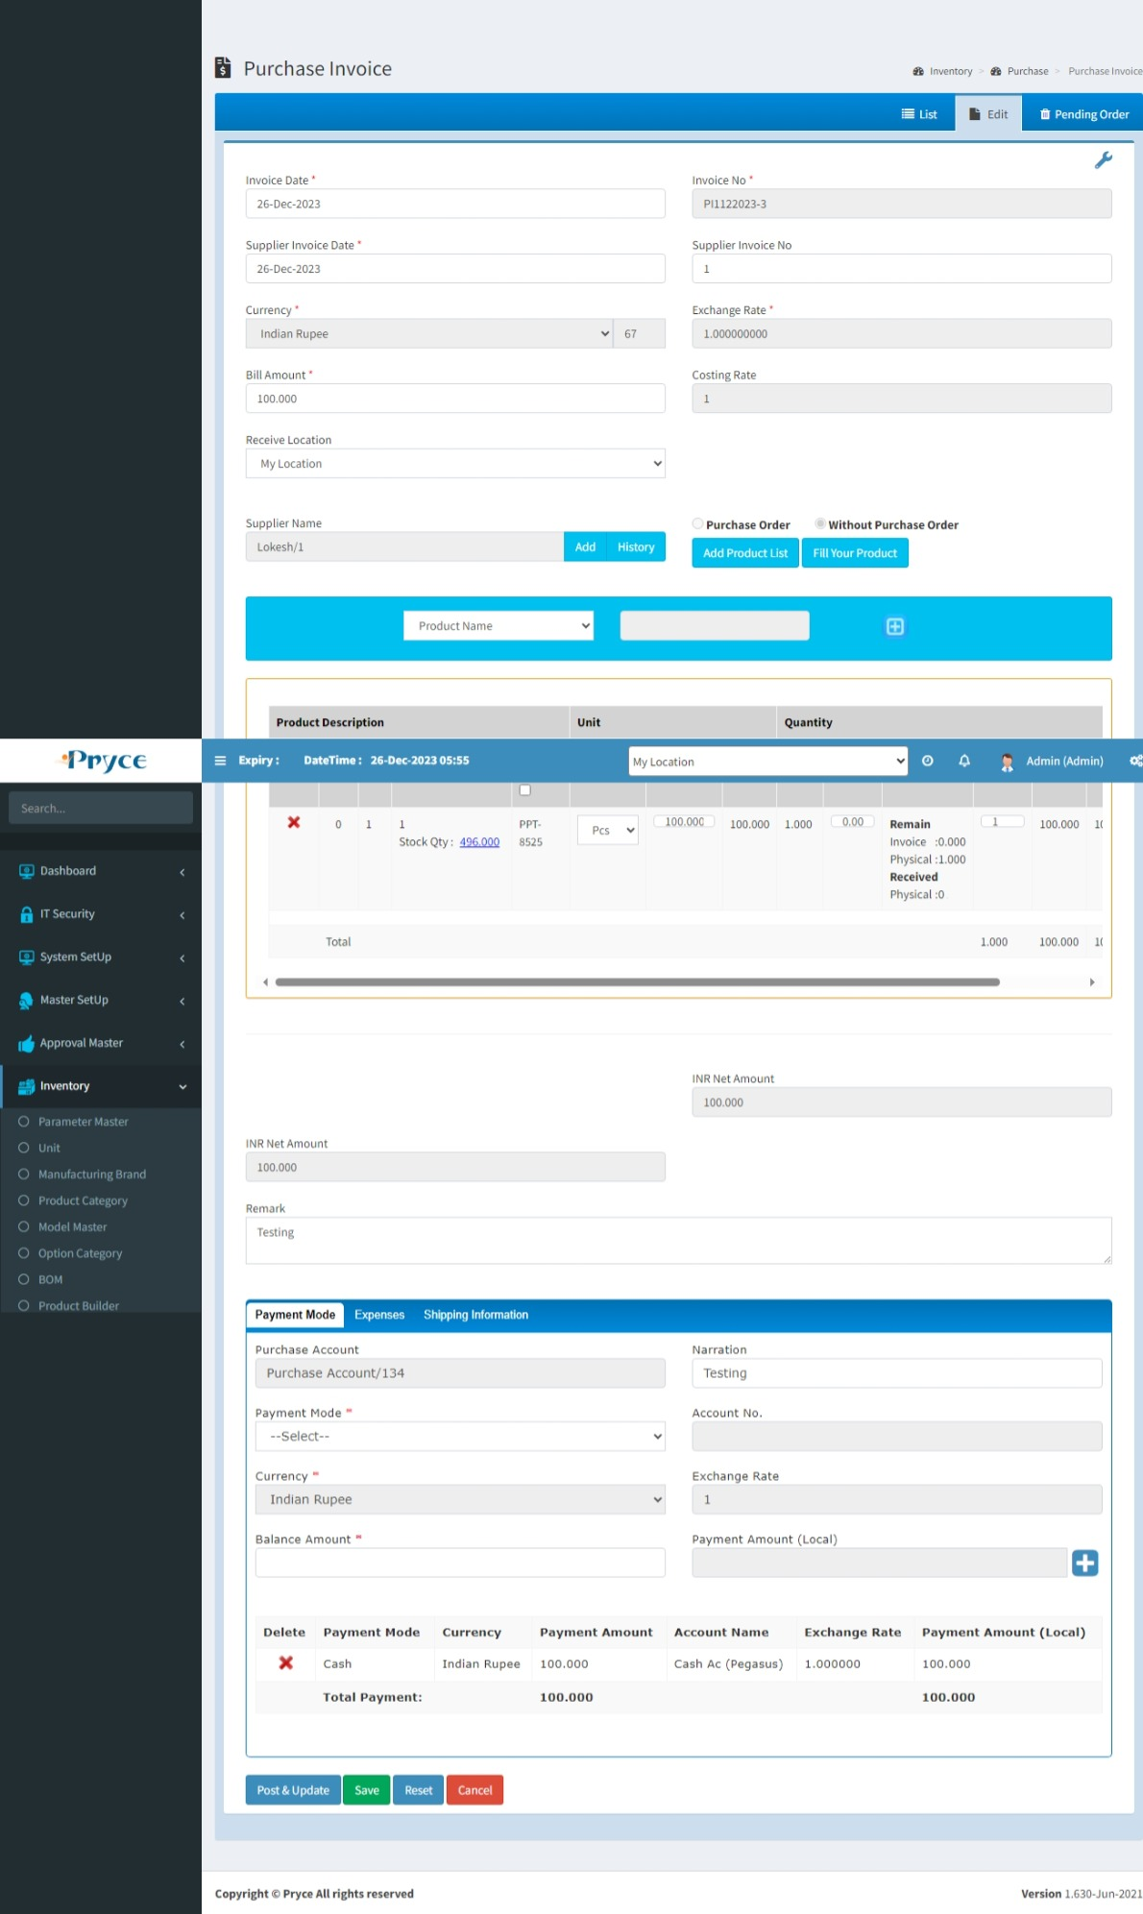

**Delete-**

When you want to delete any record than click on delete button.

**Note:- You can delete only those records in which Invoice is not posted.**

After deleting a particular record this record removes from this list and go into bin section where you will restore according to your requirement.

**New-**

In this tab you can create the new purchase Invoice or direct invoice.

You create the Purchase Invoice by following two types:-

1. Directly
2. Pending Order
3. **Directly-**

You can directly create the purchase invoice.

Some fields are generated by default,and some are not.

Here some are mandatory field, which must fill.

**Expenses**- Here you can enter all the expenses.

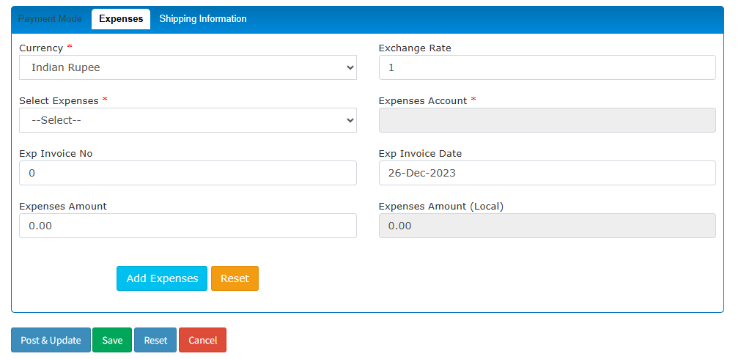

After filling the information in expenses tab, then press on the add button,Than the expenses will save in the list.

Here you can delete the expenses using the delete button.

Here you can select the supplier from the suggestion list,then select radio button “Without purchase order” for direct invoice create.

After that you can select the without purchase Order option, Here you can add product by-Form view, Advance search view.

Here selected product add to list,If you want to delete any product then click on delete .

You can add & edit product details.Also, you give discount & Tax according to your requirement.

The net amount is calculated automatically according the grid total and net tax(%) and net discount(%).

**Payment Mode**- in this tab you can select the payment mode just like as cash ,cheque etc.

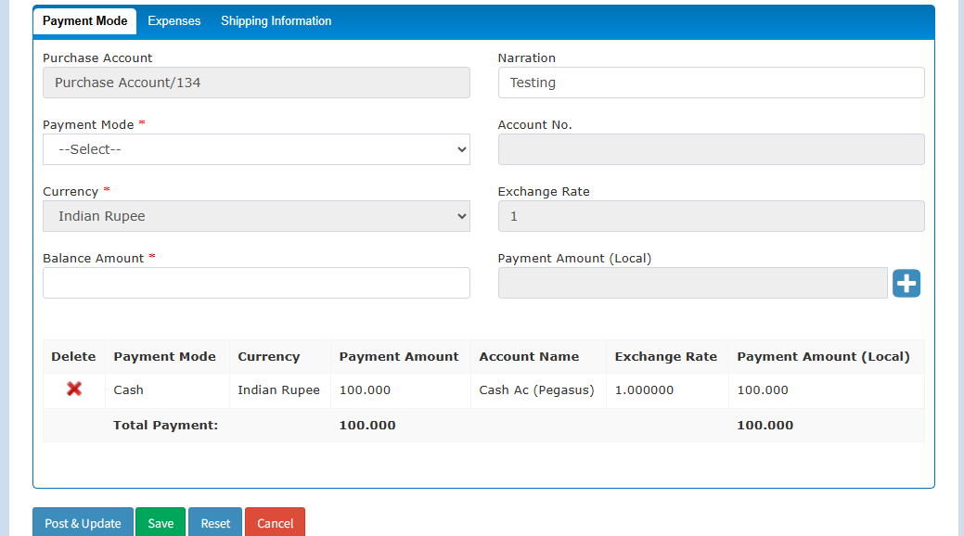

Here you can add payment detail First, you select payment mode,then fill other field and balance amount show automatically in the field.This detail adds by”Add” button.

1. **Pending Order/Indirect invoice-**

You can create the purchase invoice against the purchase order.**But when on parameter master page “Purchase Order Approval-True”, than first order approved by the employee in approval master page.**

Following stage to create Purchase invoice against the order-

**Note- Here you can create the one invoice against the multiple purchase order and also multiple invoice against the one sales order.**

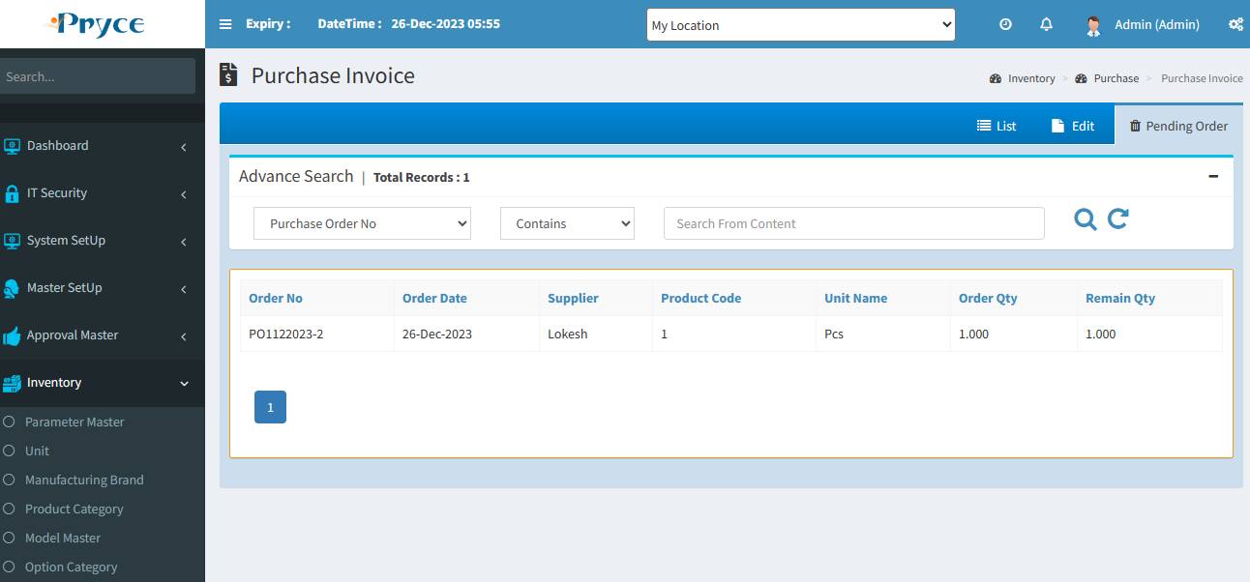

After that you can select the purchase order for creating invoices.

When you click on “View product detail”button (+),Than product detail will show.

You create an invoice against pending order (indirect invoice) go through in “New Tab”.

You select a supplier name from suggestion list, But supplier name same as in purchase/pending order,Then select “Purchase Order” radio button. All product and payment detail show,Here you can add & edit detail then click on save.

You select a supplier name from suggestion list, But supplier name not same as in purchase/pending order, Then select “Without Purchase Order” radio button. Then you can add product by-Form view,Advance search view.

You can give here discount, tax, remarks etc.

Also, you can add here payment detail.

# 2.7 Purchase Back Order:-

In this you can do purchase back order, those all records comes from “purchase order”.

When “Partial Shipment” option “Yes” then you can create **purchase invoice** with **invoice quantity** less than or equal to the **physical quantity**. If you enter invoice quantity less than physical quantity, then in Back Order panel remaining quantity of order show also unchecked product will show. Here you can do back order of those remaining orders.

When “Partial Shipment” option “No” then you can create **purchase invoice** with **invoice quantity** less than or equal to the **physical quantity**. If you enter invoice quantity less than physical quantity, then in Back Order panel remaining quantity of order not show only unchecked product will show. Here you can do back order of only unchecked order.

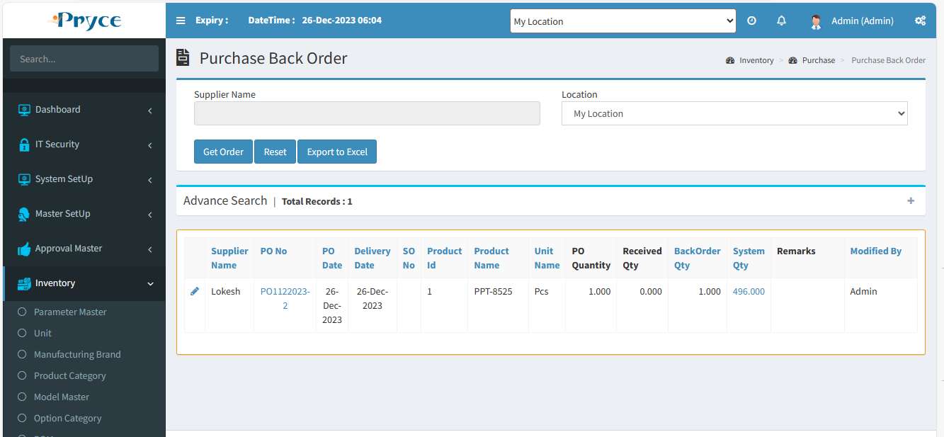

**Sorting**-

You can also sort the record in ascending & descending order after the click on the header of the list record(which is underlined).

**Search Criteria –**



Here you can search according to the field of Order No.,Order Date,Supplier name,Product Id, Product Name,Unit name,quantity than you will get a list of related back order record.

**Search-**  After that click on the search button and you get records according to search criteria in a record list.

**Refresh-**  After that you want to get again all records, then click on the refresh button.

**Edit-** 

You can edit the record when click on the edit button.

When you click on the edit button,then open the related record for editing.Here you can only save the record for back order.When you save the record, Then recorded remove from the list.

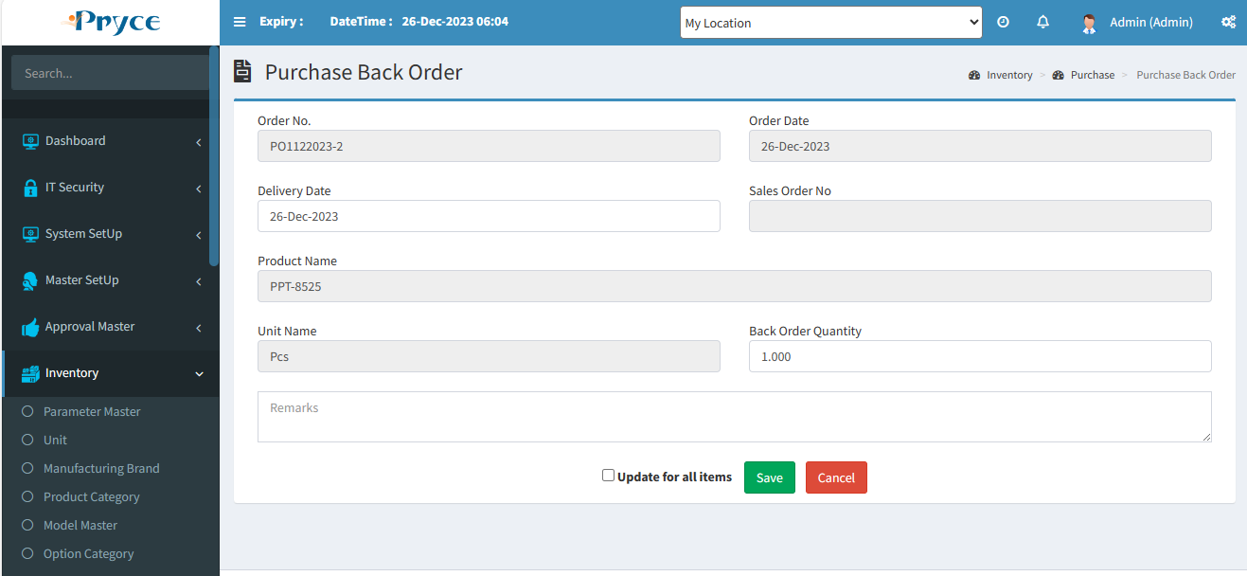

# 2.8 Purchase Good Receive:-

In this page you can save a record when you will receive the product from the supplier.

In this page you can got the all saved good received record and Here you can edit,view,print the record also you search & sort.

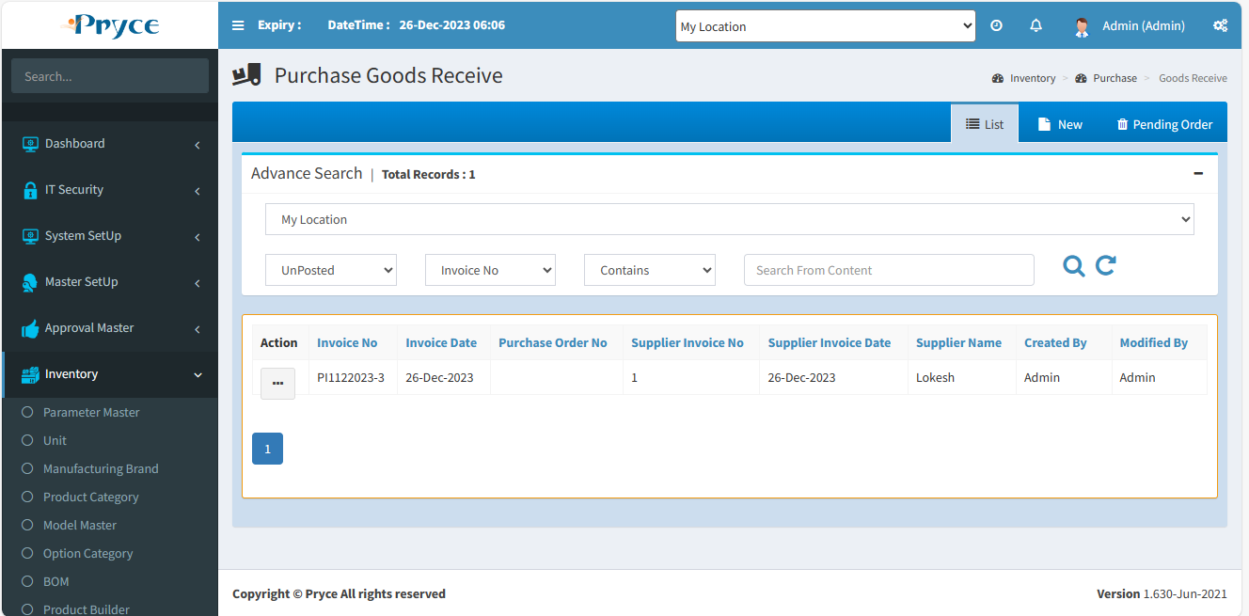

**Sorting**-

You can also sort the record in ascending & descending order after the click on the header of the list record(which is underlined).

**Search Criteria –**

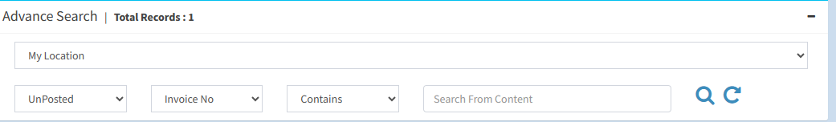

Here you can search according to the field of Invoice No.,Invoice Date,Supplier Invoice No.,Supplier Invoice Date.,Supplier than you will get a list of related purchase goods receive.

**Search-**  After that click on the search button and you get records according to search criteria in a record list.

**Refresh-**  After that you want to get again all records, then click on the refresh button.

**View-** 

You can view the record using view button.

**Note:-Here you can only view the record.**

On the click of view button the panel will open with the purchase goods receive record related to this view button.

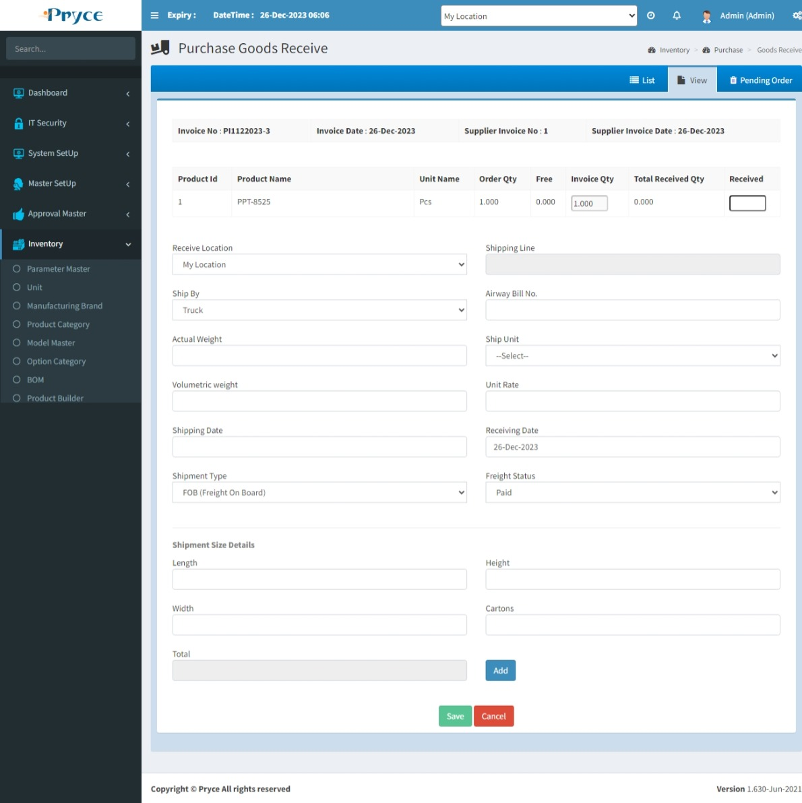

**Edit-** 

You can edit the record when you click on the edit button.

When you will click on edit button the new tab is converted into edit and all records related to this button.

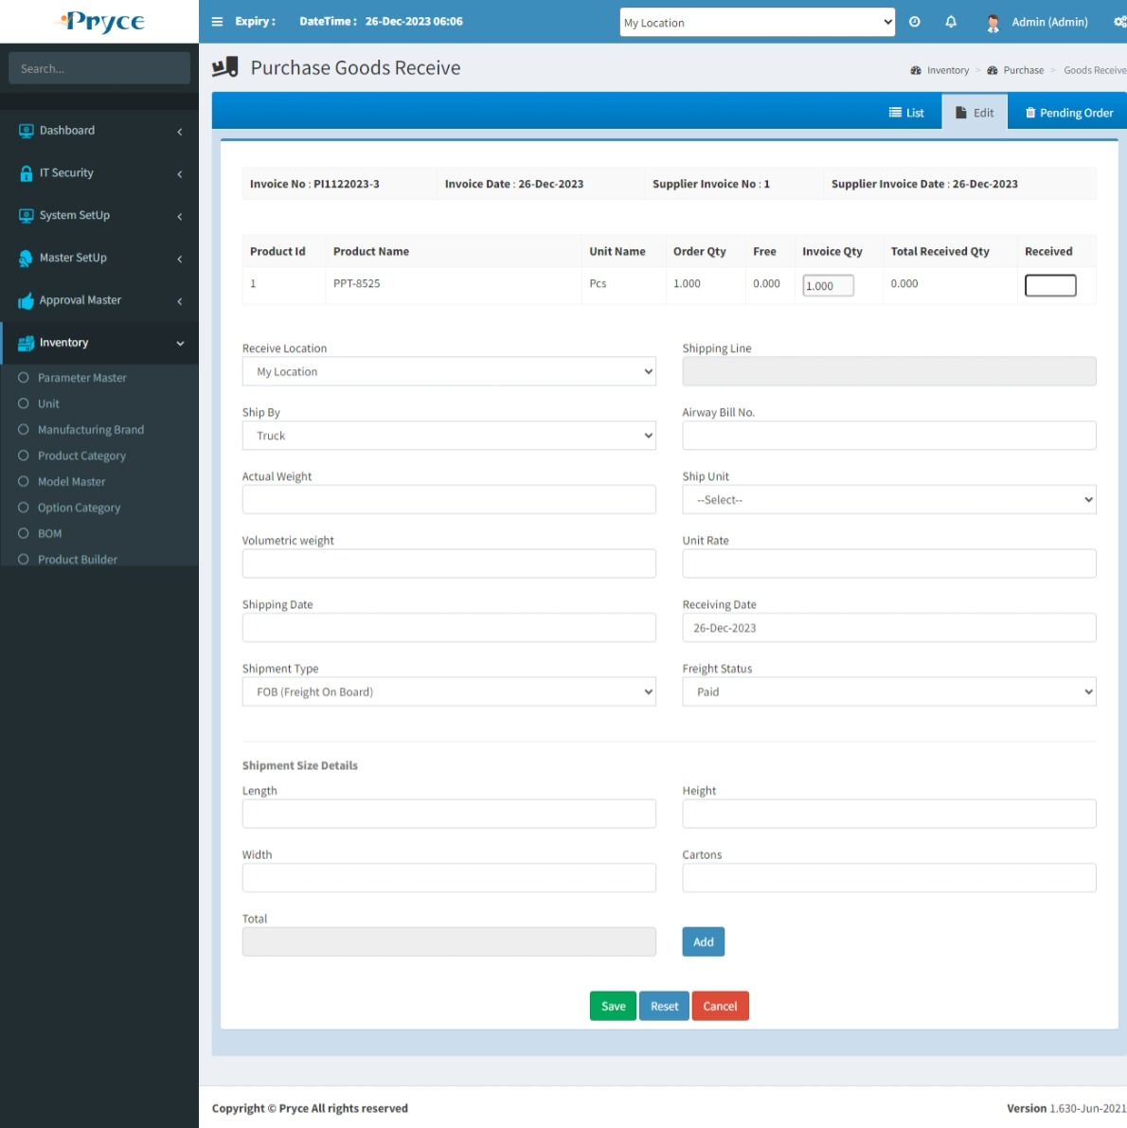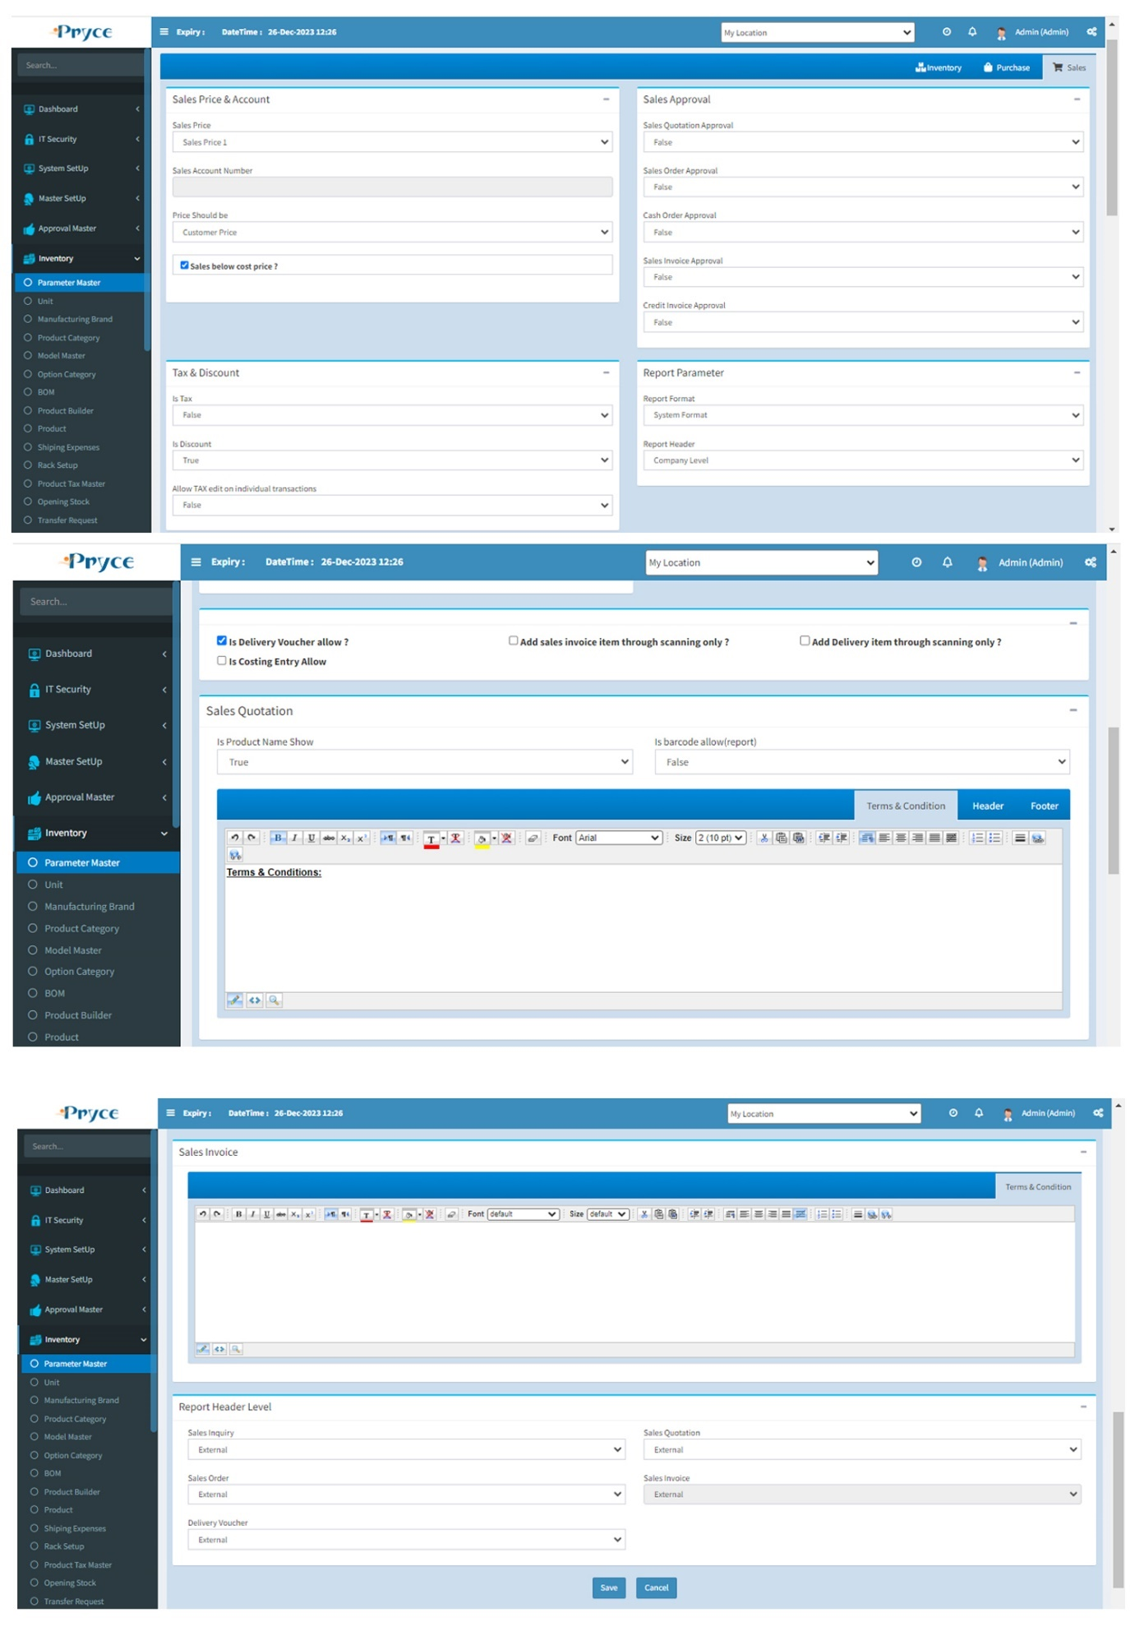

You can enter the received quantity by adding the serial number using the add button

When you click on add button than the serial no. panel is open.

If you want to enter the barcode, then choose the barcode option.

This is Serial no.panel,Here you can add quantity according to serial wise. Also, you can Load the no. when click on “Load” button.

Also, you can upload the file.

Serial no. select by barcode or manually type and click on save & close.If you want to delete the record then click on delete.

Here you can enter the receive quantity,with manufacturing date. And add one or more quantity with a click on the add button,Also delete the record. & save.

You can add the serial number as per your requirement, then click on save button than the received quantity is filled according to the serial number.or date wise.

**Note:- Duplicate serial number will not accept.**

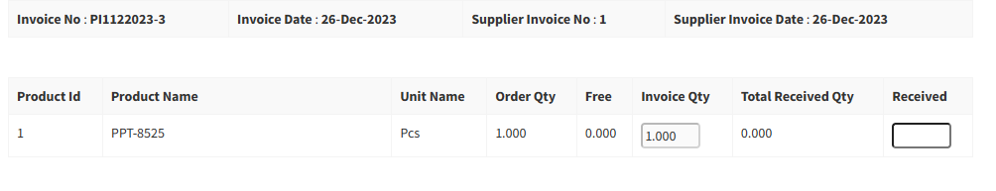

**New-**

This tab use for pending order create.Here you can’t create any new record. It’s created against only pending order.

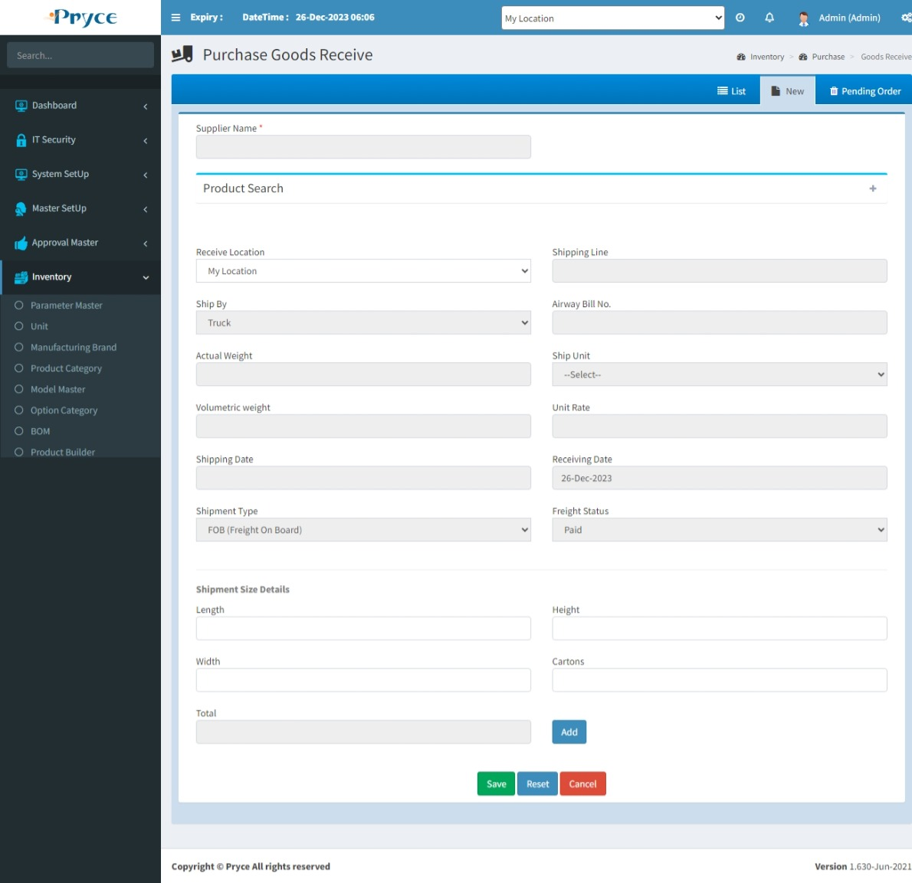

**Pending Order-**

In this have pending order record,Here you can see only purchase order detail.when you click on “view product detail”.

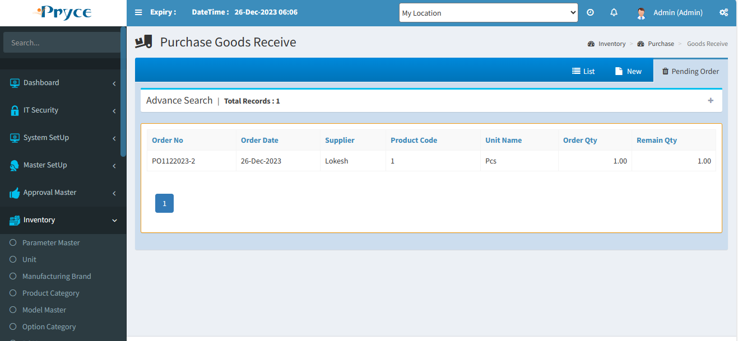

The pending order creates when you select a supplier name from the suggestion list.But supplier name same as a purchase order supplier name.When you select a supplier name than product list show.

Product list shows, according to selected supplier name.also you checked required product for goods receive.If you want to delete than delete.

Received quantity also manually fill in text box.Here “Add” button not show because in Product Master,This product select “Manage Inventory” option “Quantity”.

**When you click on the product grid received “Add button”Than serial no.page show.Here you enter serial no. or select with barcode, Save & close.**

# 2.9 Purchase Return:-

In this page you can return product against the goods receive.

There are Three tabs-

* List
* New
* Bin

**List-**

In this tab you can get the all saved purchase return record and Here you can edit,delete,view the record & also search & sort the record.

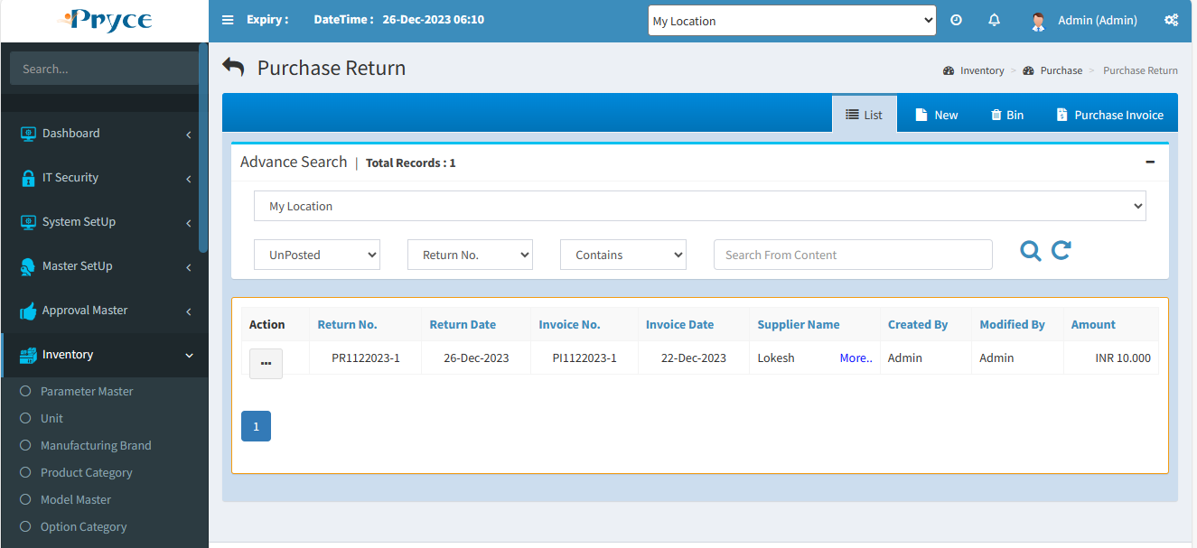

**Sorting**-

You can also sort the record in ascending & descending order after the click on the header of the list record(which is Bold heading).

**Search Criteria –**

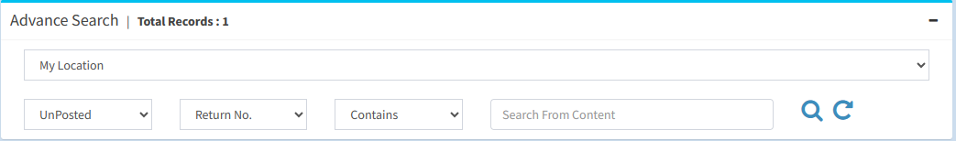

Here you can search according to the field of Return Id, Return No.,Return Date, Invoice No. then you will get a list of related purchase return.

**Search-**  After that click on the search button and you get records according to search criteria in a record list.

**Refresh-**  After that you want to get again all records, then click on the refresh button.

**View-** 

You can view the record using view button.

**Note:-Here you can only view the record.**

On the click of view button the panel will open with the purchase goods receive record related to this view button.

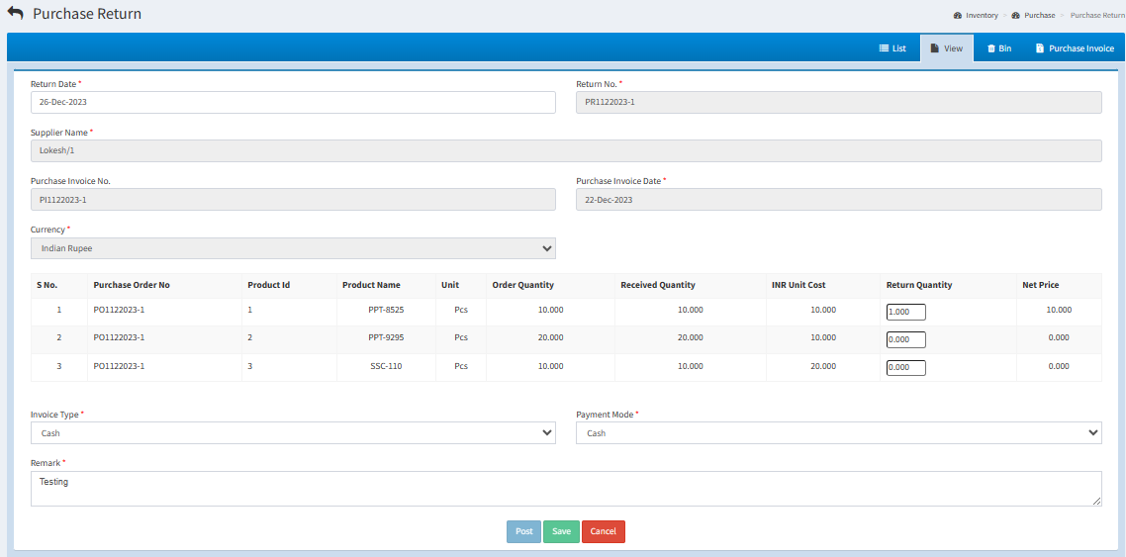

**Edit-** 

You can edit the record when click on the edit button.

When you will click on edit button the new tab is converted into edit and all records related to this button is showing in the edit tab.When edit the detail then click on the Post or Save.

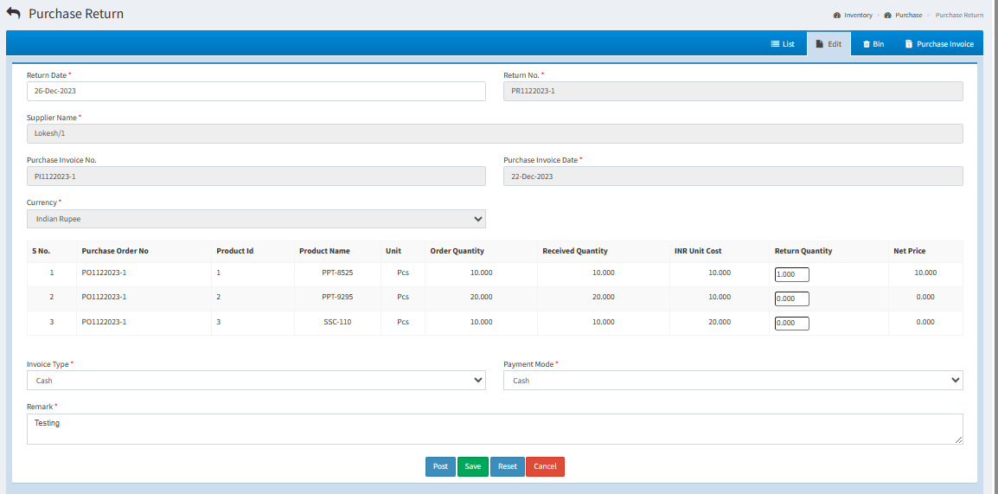

**Delete-**

When you want to delete any record than click on delete button.

After deleting the record, the record will be removed in list tab and go in bin tab where you can restore using restore button.

**New–**

In this tab you can return the quantity against the receive quantity.

**Follow the following steps to return the quantity-**

First of all select the “Purchase Invoice No.”When you select invoice no. than all fields fill according to selected invoice no.

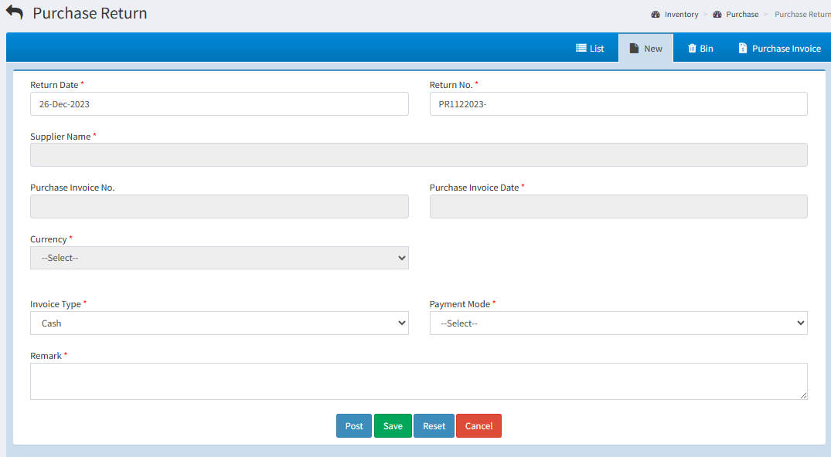

Here show all detail of selected invoice no.,you can add return quantity.

You can select an invoice type-credit or cash.

Also, you can select payment mode option. & give a remark for purchase return.

You can enter the return quantity by adding the serial number using the “Add” button.

When you click on add button than the serial, panel will open.

If you want to enter the barcode, then choose the barcode option.

Here you give the return quantity.

You can add the serial number as per your requirement,then click on save button than the return quantity is filled according the number of serial numbers.

**Note:- Duplicate serial number will not accept**

**Bin-**

* In this tab you will get all deleted records from list, where you can again restore record.
* **Select all-**  In this you can select all records by clicking select all button.
* **Restore button- ** In this you can restore selected record by clicking on restore button and again add record in list or grid.
* In this you can also able to select the record individually by checked in the check box.
* Also, you search the particular record in the search window and when you want to restore, then checked and click on the restore button.

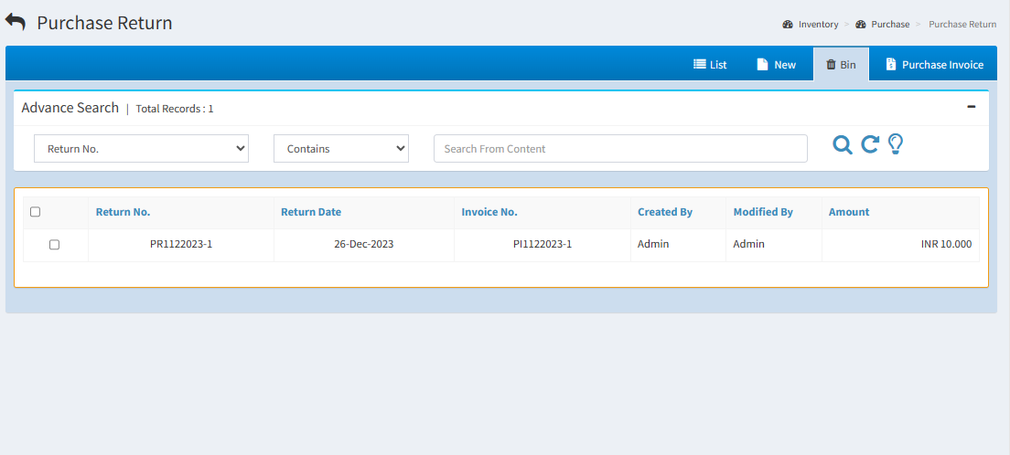

# 3.Sales

The act of selling something. A transaction between two parties where the buyer receives tangible goods, services and/or assets in exchange for money.

# 3.1 Sales Opportunity:-

In this page you can create the Sales Opportunity for Sales the product.

There are Four tabs-

* List
* New
* Bin
* Customer Call

**List-**

In this tab you will get the all saved Sales Opportunity record and here you edit,delete,view,print the record,Also search & sort the record.

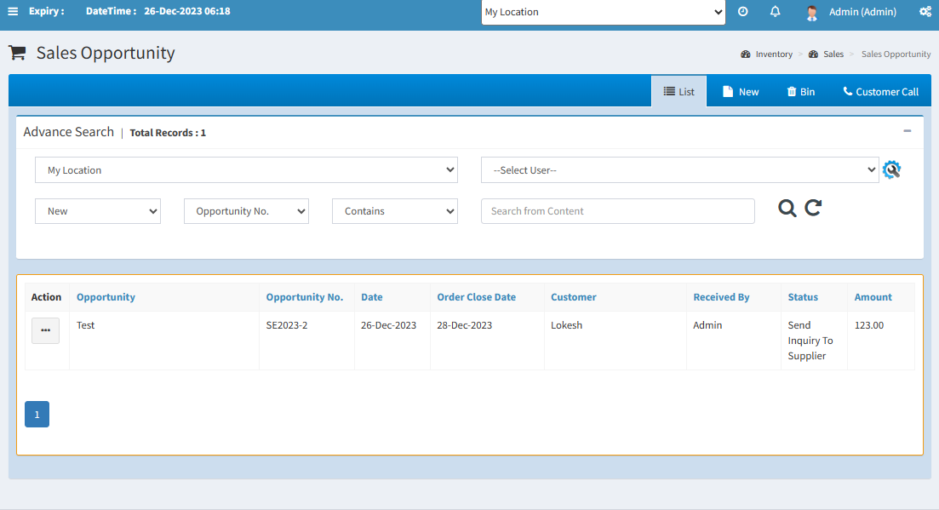

**Sorting**-

You can also sort the record in ascending & descending order after the click on the header of the list record (which is Bold Heading).

**Search Criteria –**

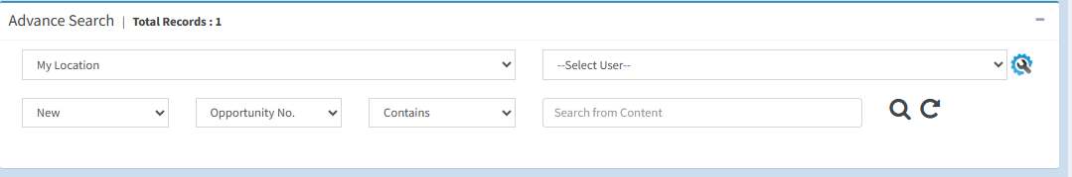

Here you can search according to the field of Inquiry Id, Inquiry No.,Inquiry Date,Received Employee,Handled Employee,Customer Name than you will get a list of related sales inquiry.

**Search-**  After that click on the search button and you get records according to search criteria in a record list.

**Refresh-**  After that you want to get again all records, then click on the refresh button.

**View-** 

You can view the record using view button.

**Note:-Here you can only view the record.**

On the click of view button the panel will open with the purchase goods receive record related to this view button.

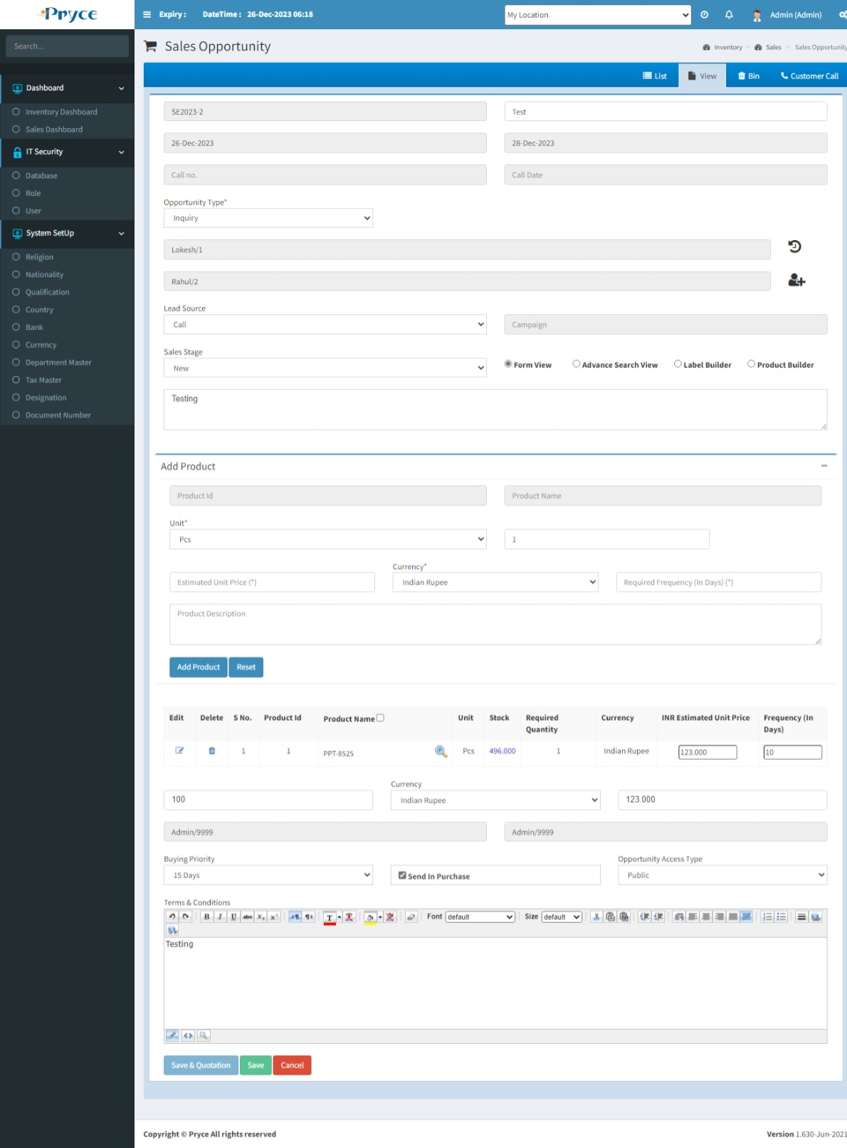

**Detail Button-**

Here you can see the product description using Detail Button.

When you will over the mouse on this detail button than the description will show.

**Edit-** 

You can edit the record when click on the edit button.

**Note:- You can edit an only unposted record.**

When you will click on edit button the new tab is converted into an edit and record related to this button is showing in edit tab.

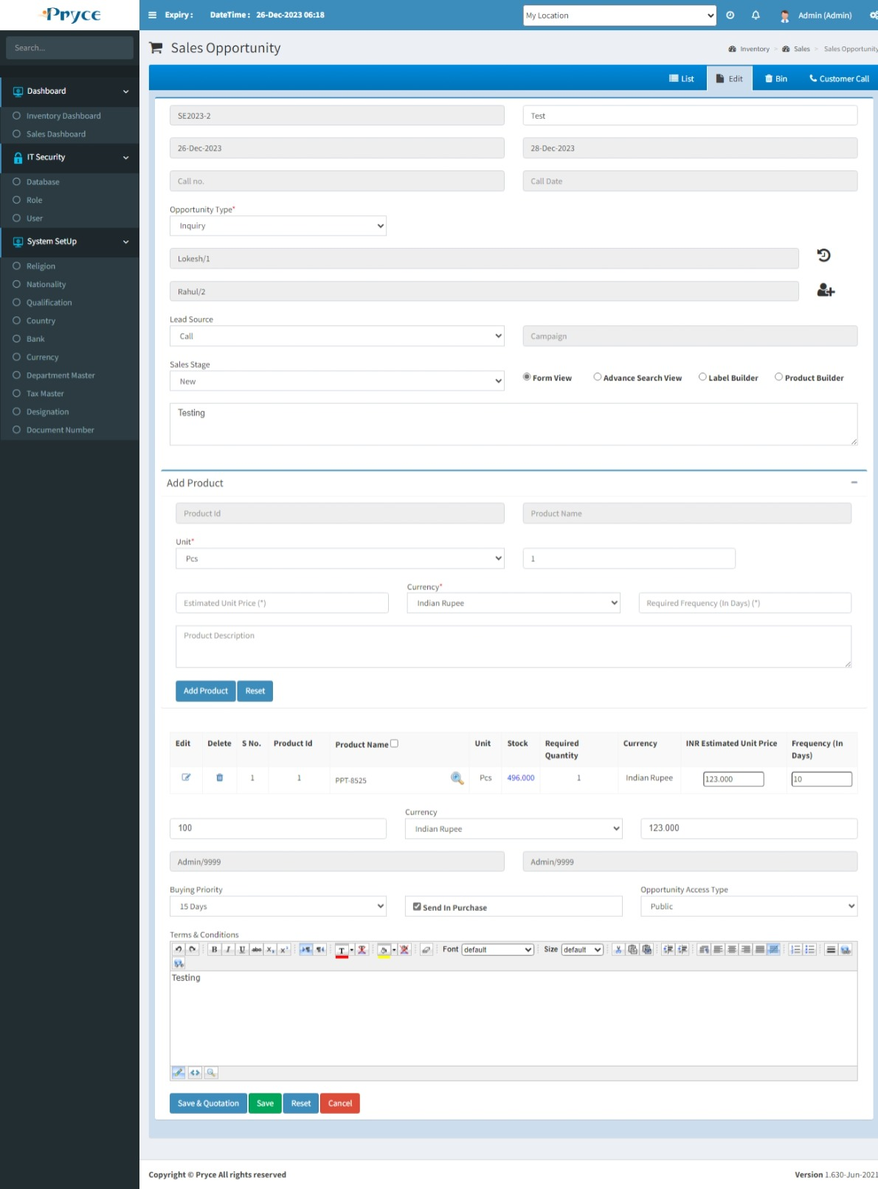

Following option to select in sales inquiries:-

**1 Send Email:-** If you want to send the email to customer than select the send email option.

**2 Post:-** If your sales inquiry is final and you do not want to any updation, then select the post option because after post the option you can not delete and edit the record.

**3 Send In purchase:-** If you want to send this inquiry to the purchase department, then select the send in purchase option.

**4 Save & Quotation:-** By thisrecord saved and also open directly quotation page for creating quotation.

**Delete-**

When you want to delete any record than click on delete button.

**Note:- You can delete an only unposted record.**

After deleting this record this will remove from this list and go in the bin section where you will restore according to your requirement.

**New-**

In this tab the customer can inquire about any product he just needs to enter the description for the product.

Here different fields are there for creating sales inquiry.

**Customer Name-** Customer name needed for sales inquiry create.Here you can select customer name from the suggestion list.

Also, you can add new customers,Just click on “Add” button. When you click on “Add” button, then “Contact Master” page is open.Here you can give details of contact & click on “Next” then select Group option “Customer” , company & brand.

**Contact Name-** Select in suggestion list.

**Currency-** You can select the currency in the drop down list.

**Inquiry Type-** You can select the type of inquiry.

**Add Product-** You can add product according to “Form View”,”Advance Search View”.

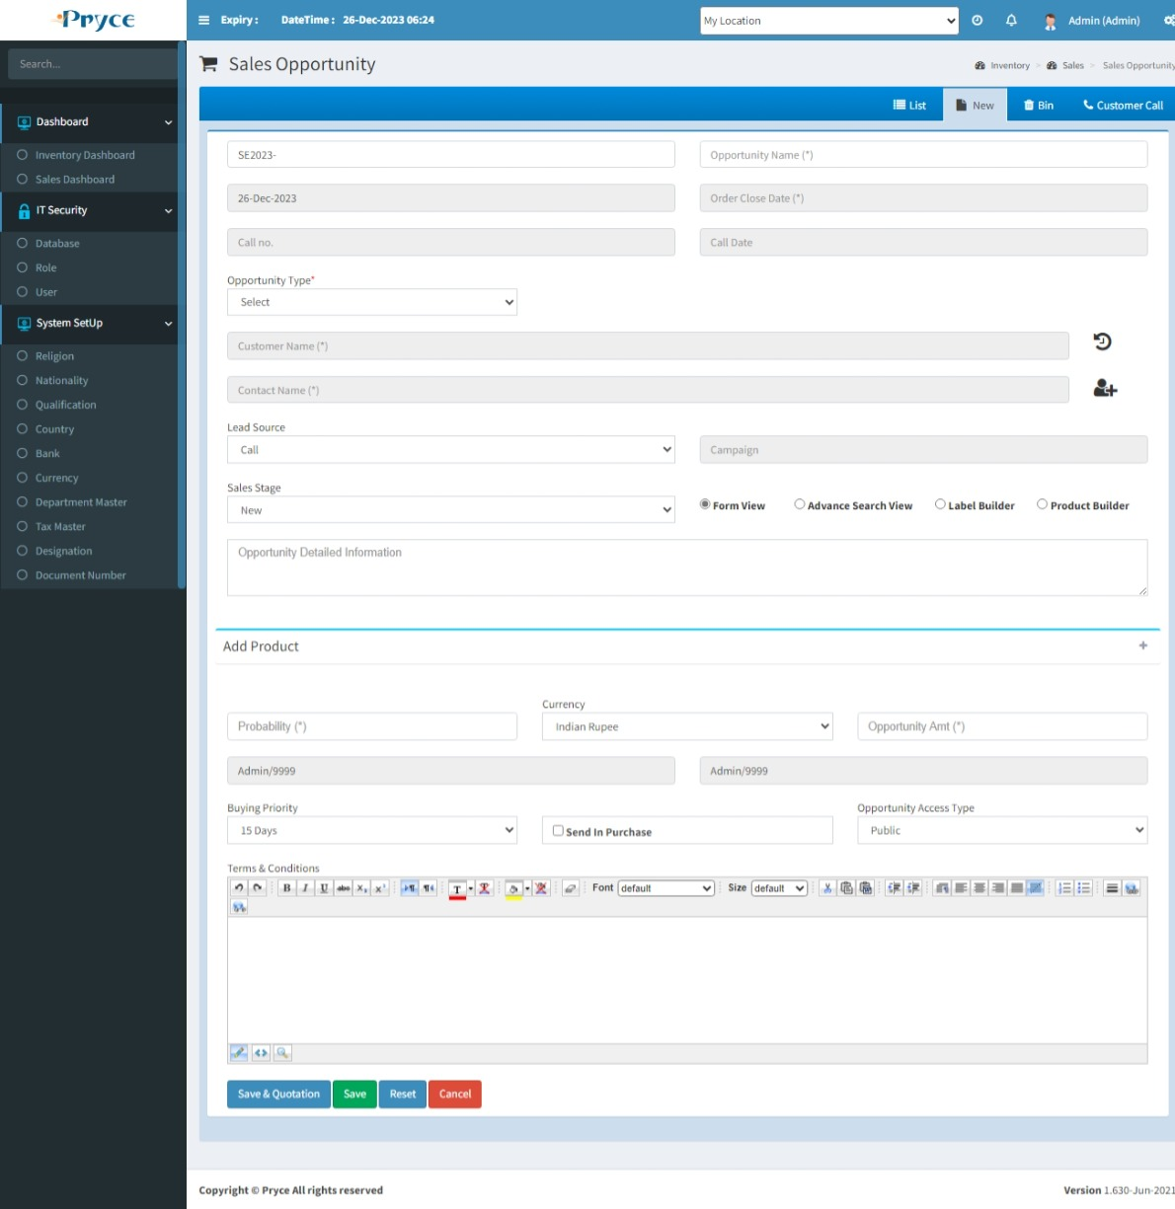

Here you have a product builder option to get the maximum possible part number of this selected product.

When you will click on product builder link button than the product builder page is open in new tab and you can get the all possible part numbers of this product.

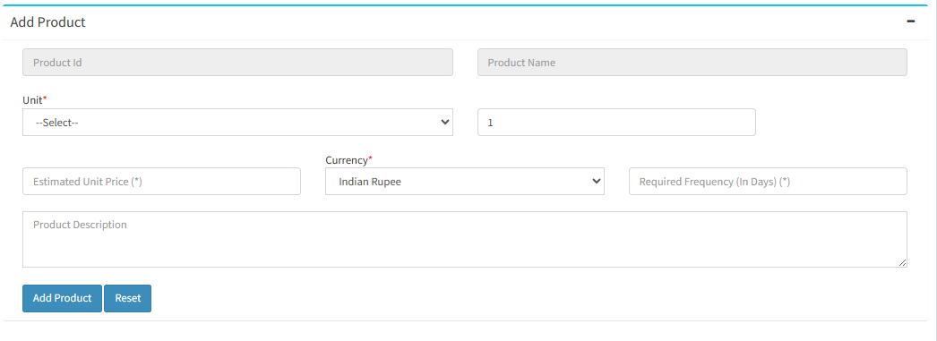

**Unit-** You can select here unit or when you select a product than unit show according to product.

**Required Quanity-** You can enter the number of required quantities.

**Estimated unit price-** You can enter the estimated unit price according to the customer requirement.

**Currency:-** You can select the currency in the drop down list.

**Product Description**- It can come dynamically (according to selected product).

**Remark-** You can give the remark for this sales inquiry.

**Received Employee-** Sales inquiry received an employee name.Here you can select from the suggestion list.Or by default show.

**Handled Employee**-Sales inquiry handled employee name,It’s by default show or select from the suggestion list.

**Buying Priority**-This inquiry fulfills duration show like-urgent, 10 days, 15 days etc.

**Send Email-** If you want to send the email to customer than select the send email option.

**Send In purchase-** If you want to send this inquiry to the purchase department to get the price(In the case you have not particular product according to the customer requirement) of this product then select the send in purchase option.

**Save & Quotation:-** By thisrecord saved and also open directly quotation page for creating quotation.

**Save-** You can save the record using save button.

**Reset-** You can clear the record using the reset button.

**Cancel-**You can clear and redirect in list tab using cancel button.

**Bin-**

* In this tab you will get all deleted records from list,where you can again restore record.
* **Select all-**  In this you can select all records by clicking select all button.
* **Restore button- ** In this you can restore selected record by clicking on restore button and again add record in list or grid.
* In this you can also able to select the record individually by checked in the check box.
* Also, you search the particular record in the search window and when you want to restore then checked and click on the restore button.

# 3.2 Sales Quotation:-

In this page you can save the sales quotation (send to customer) against the Sales inquiry.

There are Four tabs-

* List
* New
* Bin
* Inquiry

**List-**

In this tab you will get the all saved sales quotation record and Here you can edit,delete,view,print also sort & search the record.

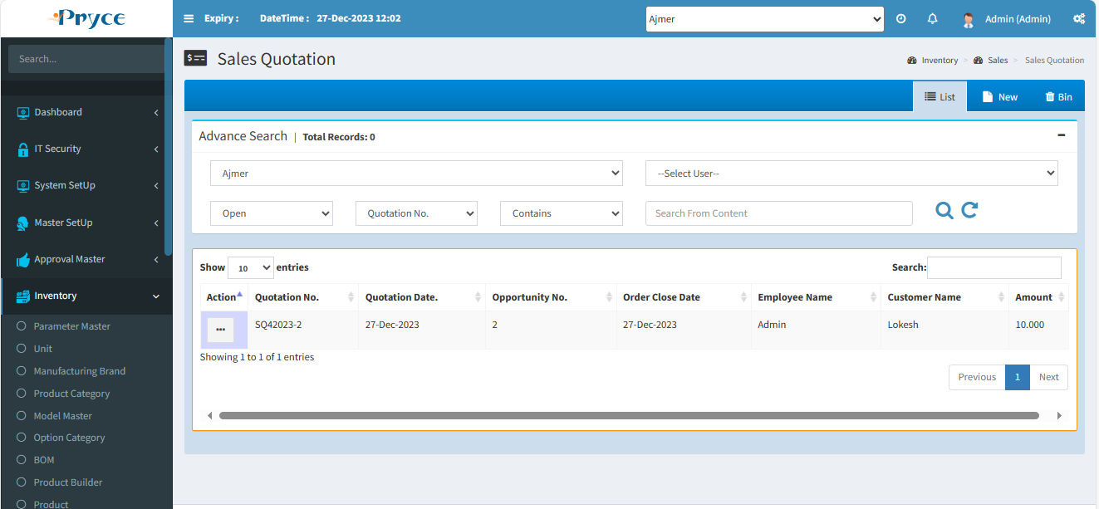

**Sorting-**

You can sort the record in ascending and descending order according to the column header in the grid (which is bold Heading).

**Search Criteria –**

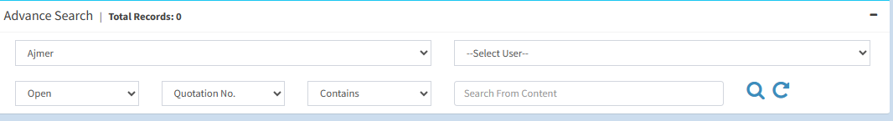

Here you can search according to the field of Quotation Id, Quotation No.,Quotation Date, Follow Up Date,Employee Name,Customer Name than you will get a list of related sales quotation.

**Search-**  After that click on the search button and you get records according to search criteria in a record list.

**Refresh-**  After that you want to get again all records, then click on the refresh button.

**View-** 

You can view the record using view button.

**Note:-Here you can only view the record.**

On the click of view button the panel will open with the sales quotation record related to this view button.

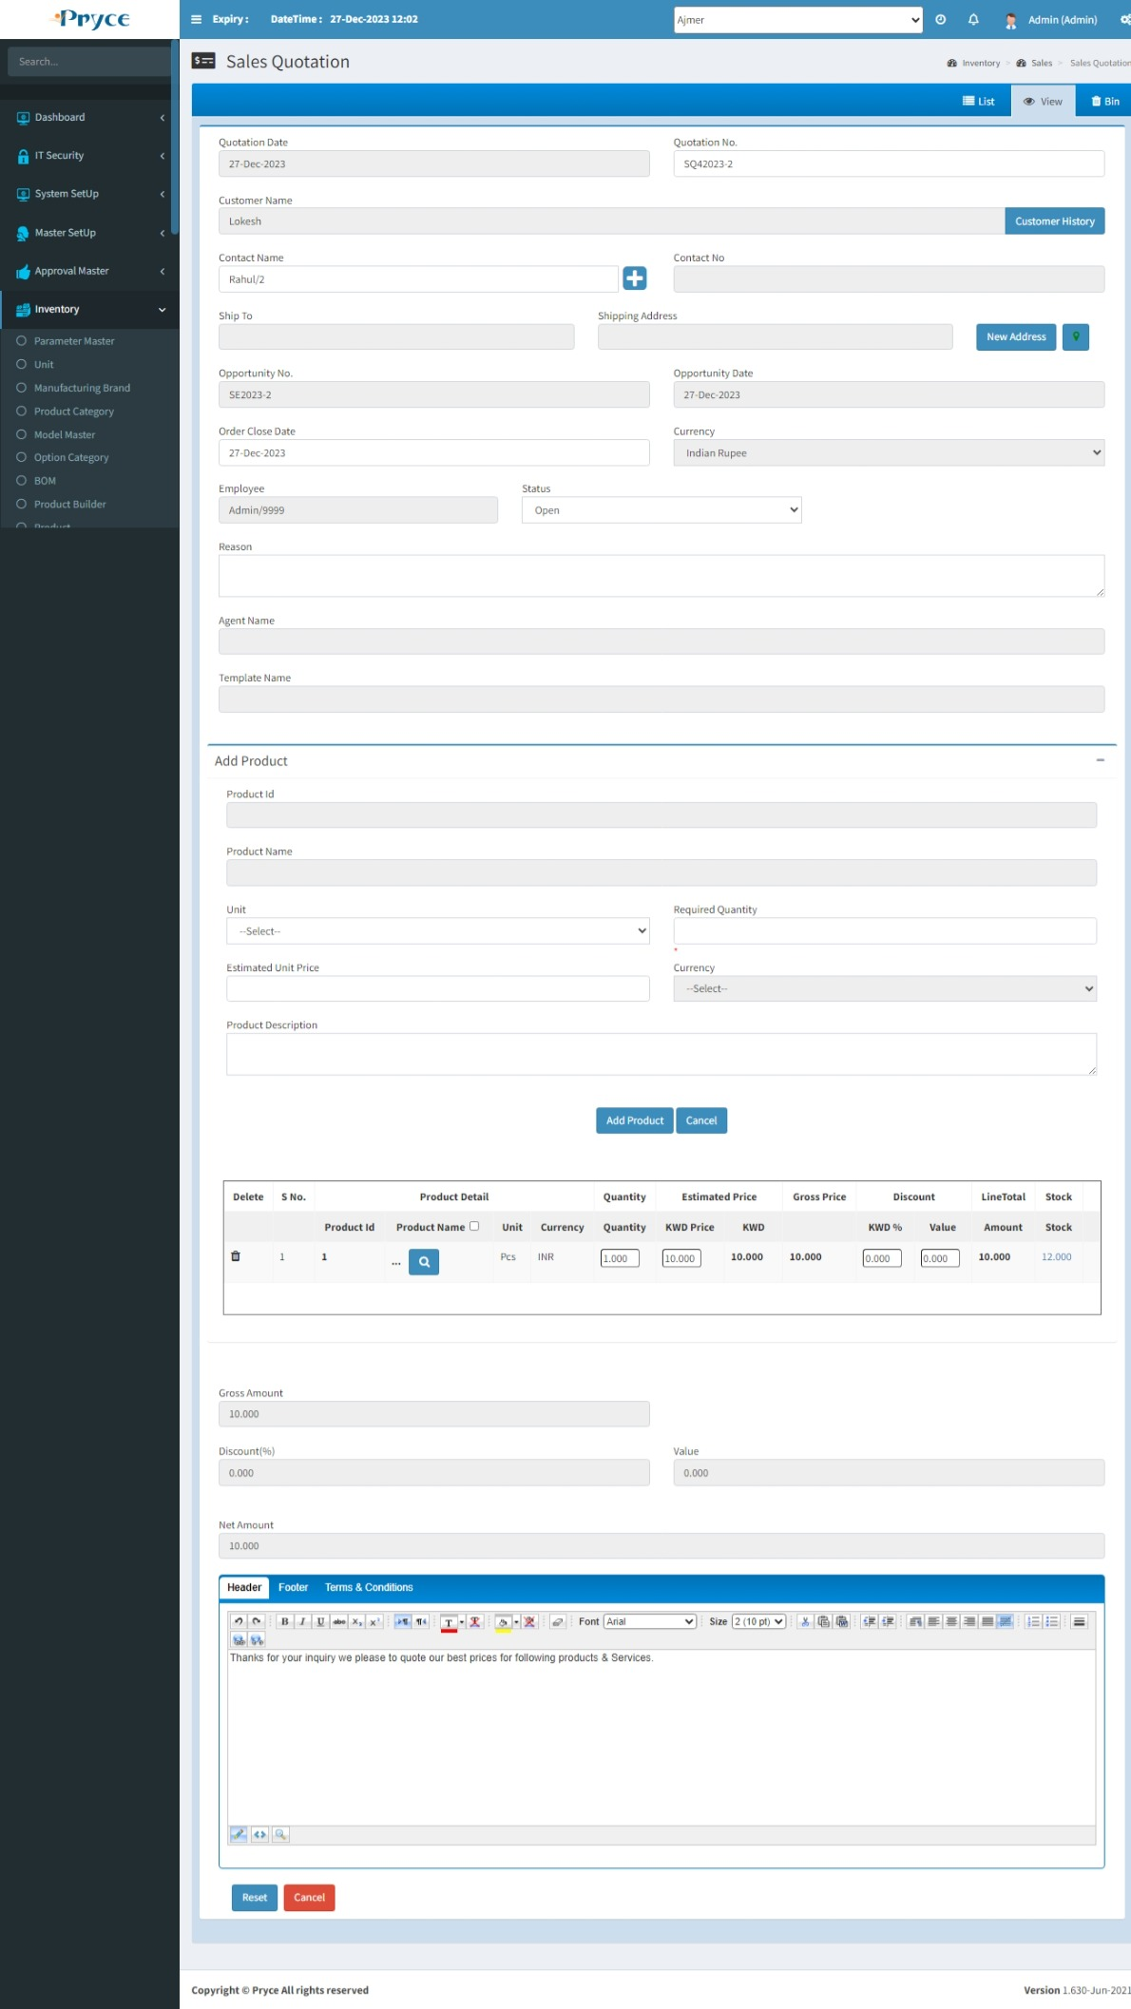

**Edit-**

You can edit the record using the edit button.

**Note- You can edit only those records which sales order is not made against,This sales quotation.**

When you will click on edit button the new tab is converted into edit and all records related to this button is showing in the edit tab.

Here you can edit the unit price according the estimated price,tax and discount.

Quantity price will calculated according the unit price and quantity,then you can enter the tax and discount than you got the total price of a particular product.

Amount value will update according to the total price of all products.

Then you can enter the tax and discount on the amount value.

Then finally you can get the Net amount.

After date you can edit detail of header,footer,Terms & conditions,Follow Up. And save or save & print.

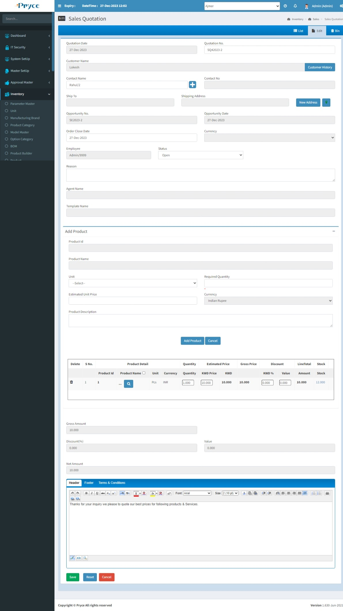

**Delete-**

When you want to delete any record than click on delete button.

**Note:- You can delete only those records in which sales order is not made against this sales quotation.**

After deleting this record this will remove from this list and go in the bin section where you will restore according to your requirement.

**New-**

You can not create sales quotation without sales inquiry.

**Note:-Sales quotation can’t create without sales inquiry so first of all you will go to the inquiry tab, then choose the inquiry than you can create the sales quotation.**

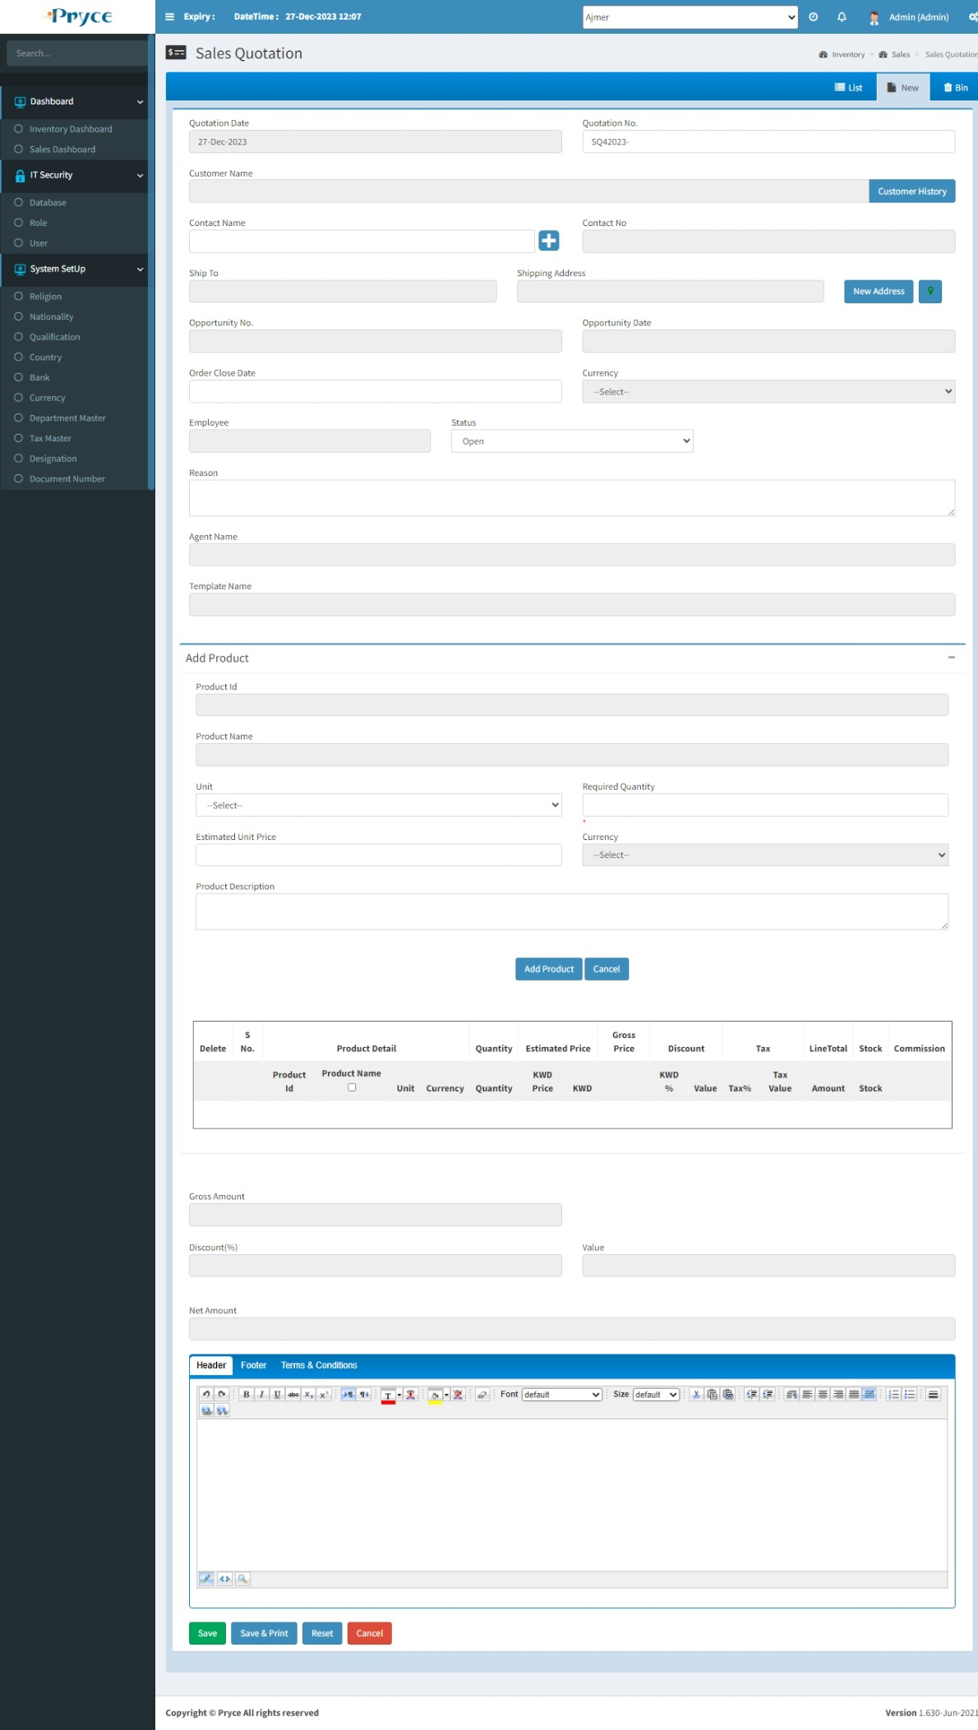

**Bin-**

* In this tab you will get all deleted records from list, where you can again restore record.
* **Select all-**  In this you can select all records by clicking select all button.
* **Restore button- ** In this you can restore selected record by clicking on restore button and again add record in list or grid.
* In this you can also able to select the record individually by checked in the check box.
* Also, you search the particular record in the search window and when you want to restore, then checked and click on the restore button.



# 3.3 Predesign Sales Quotation:-

Predesign sales quotation is used in only sales quotation.Here you can create a template,in this template you can add one or more product,Which is used in sales quotation.It’s a collection of product.

There are Three tabs-

* List
* New
* Bin

**List-**

In this list have saved record of predesign sales quotation(Templates),Here you can edit,delete,sort & search the record.

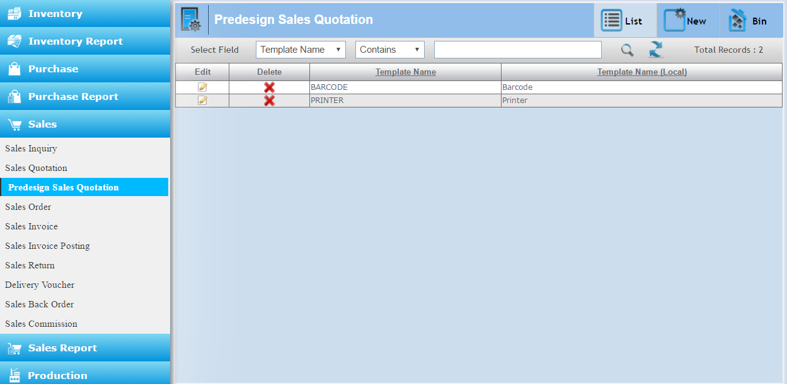

**Sorting-**

You can sort the record in ascending and descending order according to the column header in the grid (which is underlined).

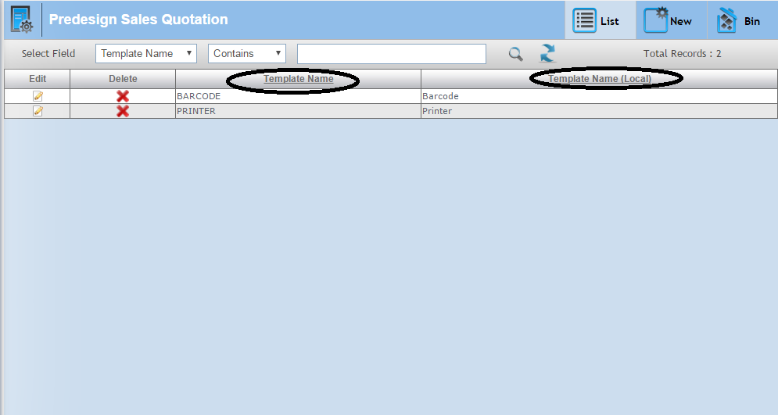

**Search Criteria –**



Here you can search according to the field of Template Name than you will get a list of related predesign sales quotation.

**Search-**  After that click on the search button and you get records according to search criteria in a record list.

**Refresh-**  After that you want to get again all records, then click on the refresh button.

**Edit-**

You can edit the record using the edit button.

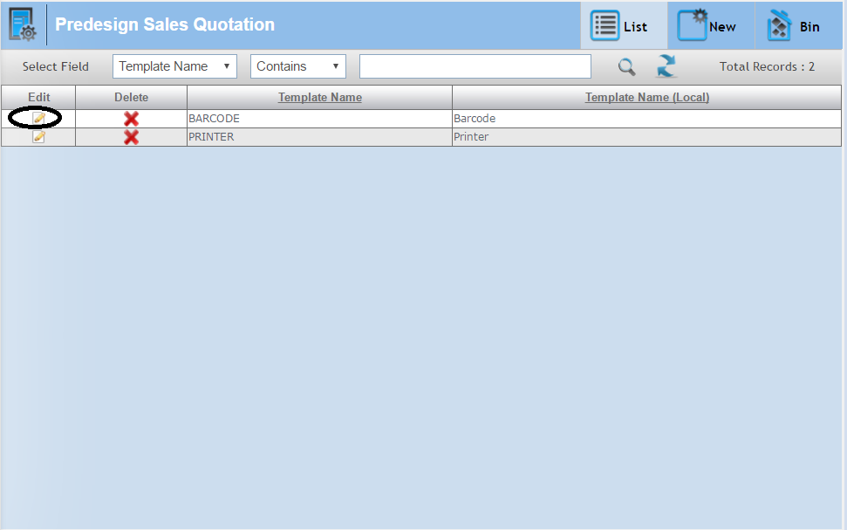

When you will click on edit button the new tab is converted into edit and all records related to this button is showing in edit tab.

Here you can edit the record, according your requirement.And then click to save to update the record.

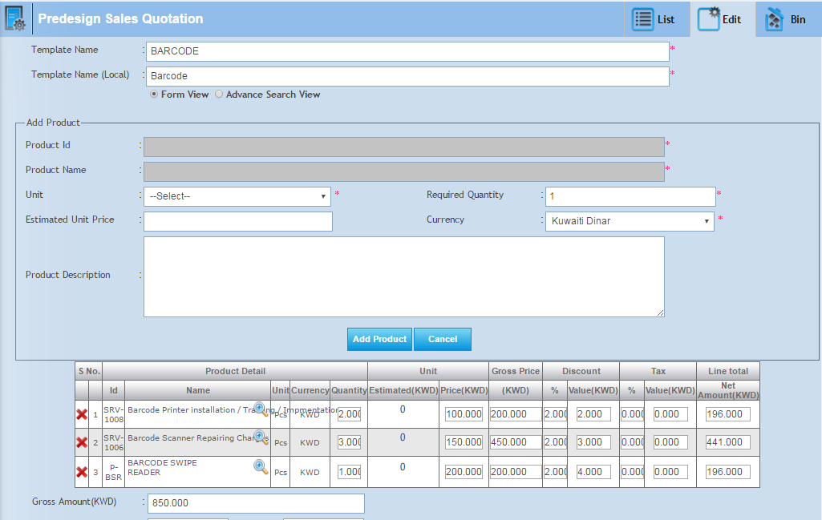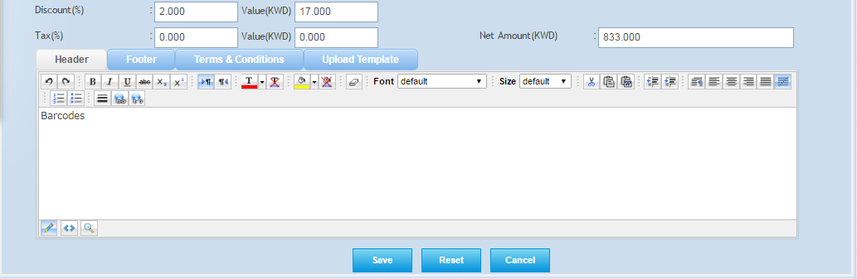

**Delete-**

When you want to delete any record than click on delete button.

After deleting this record, This will remove from this list and go in the bin section where you will restore according to your requirement.

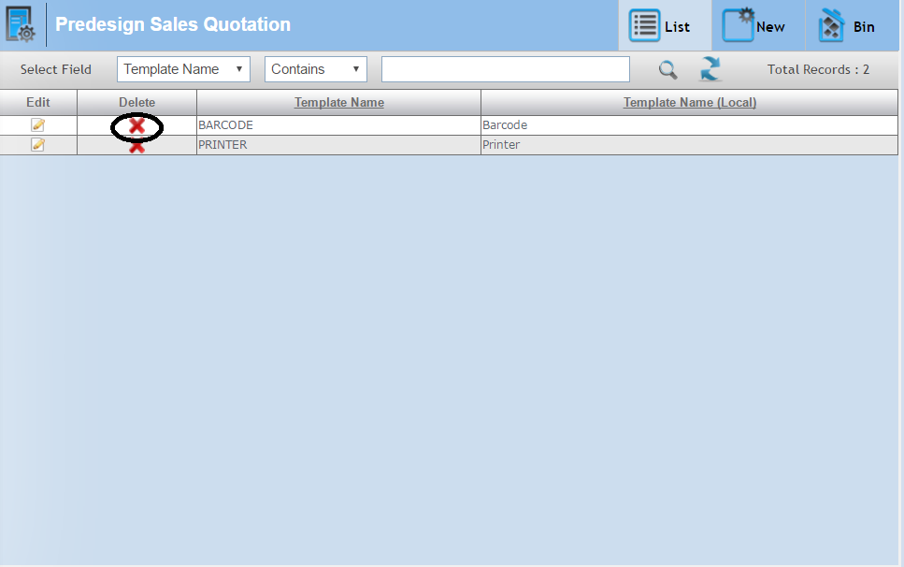

**New-**

In this you can create a new record of predesign sales quotation.Those predesign sales quotation used in sales quotation.

Here need to type the template name for selection in sales quotation.

Then you can add product according to your requirement & template name.Here you can add product by Form View & Advance Search View.

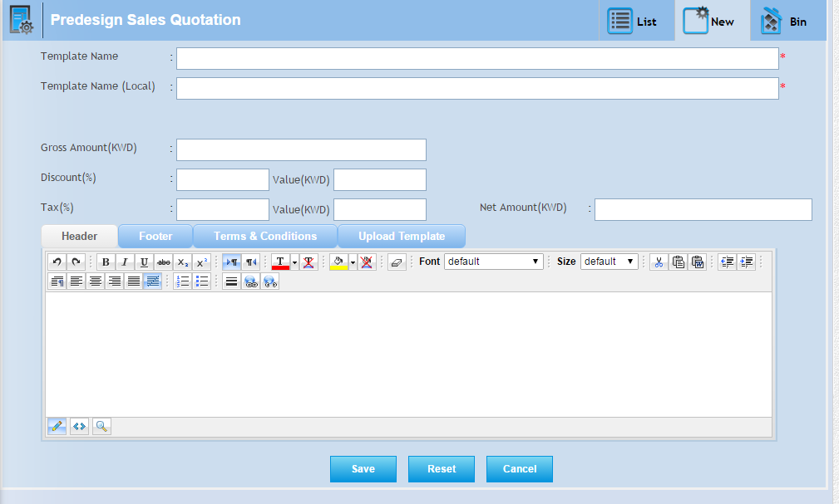

**Bin-**

* In this tab you will get all deleted records from list, where you can again restore record.
* **Select all-**  In this you can select all records by clicking select all button.
* **Restore button- ** In this you can restore selected record by clicking on restore button and again add record in list or grid.
* In this you can also able to select the record individually by checked in the check box.
* Also, you search the particular record in the search window and when you want to restore, then checked and click on the restore button.

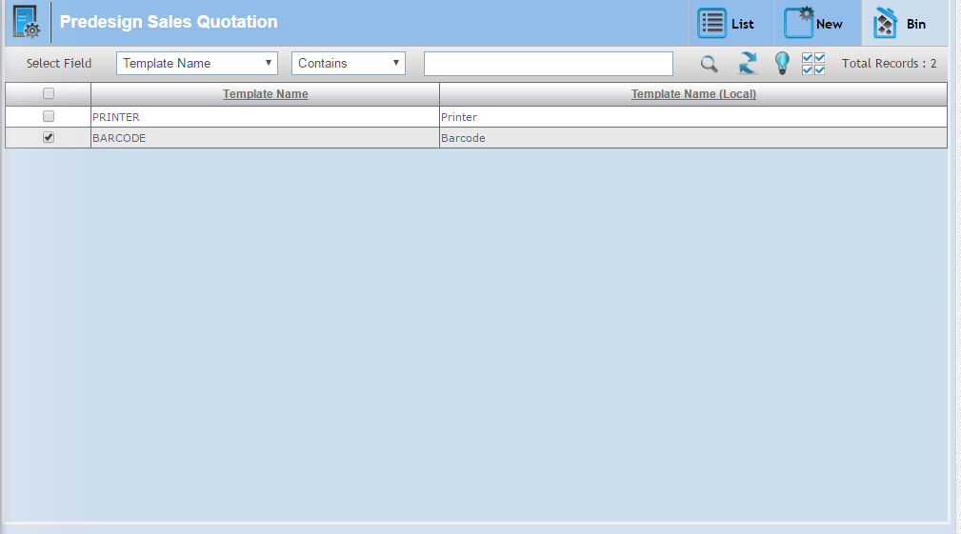

# 3.4 Sales Order:-

In this page you can save the Sales order (comes from the customer) against the sales quotation and directly.

There are Four tabs-

* List
* New
* Bin
* Quotation

**List-**

In this tab you will get all save sales order record and here you can edit,delete,view,print and also sort & save the record.

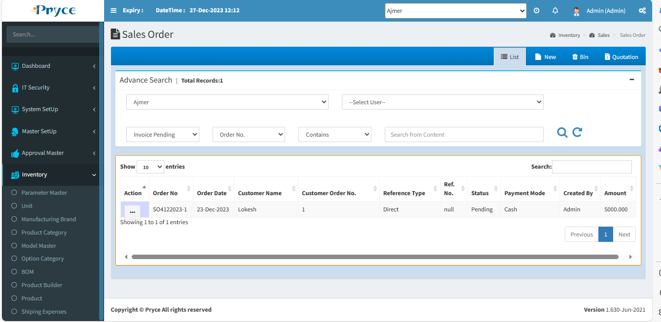

**Sorting-**

You can sort the record in ascending and descending order according to the column header in the grid (which is Bold Heading).

**Search Criteria –**

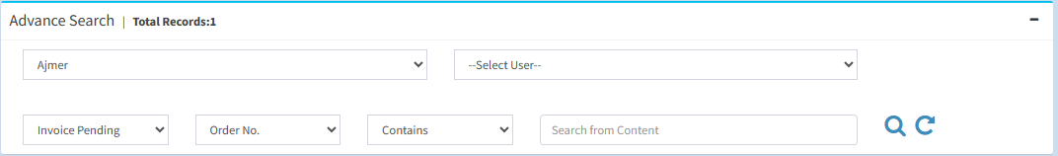

Here you can search according to the field of Order No.,Order Date, Customer Name, Transfer type,Transfer No.,Status,Amount than you will get a list of related sales order.

**Search-**  After that click on the search button and you get records according to search criteria in a record list.

**Refresh-**  After that you want to get again all records, then click on the refresh button.

**View-** 

You can view the record using view button.

**Note:-Here you can only view the record.**

On the click of view button the panel will open with the sales order record related to this view button.

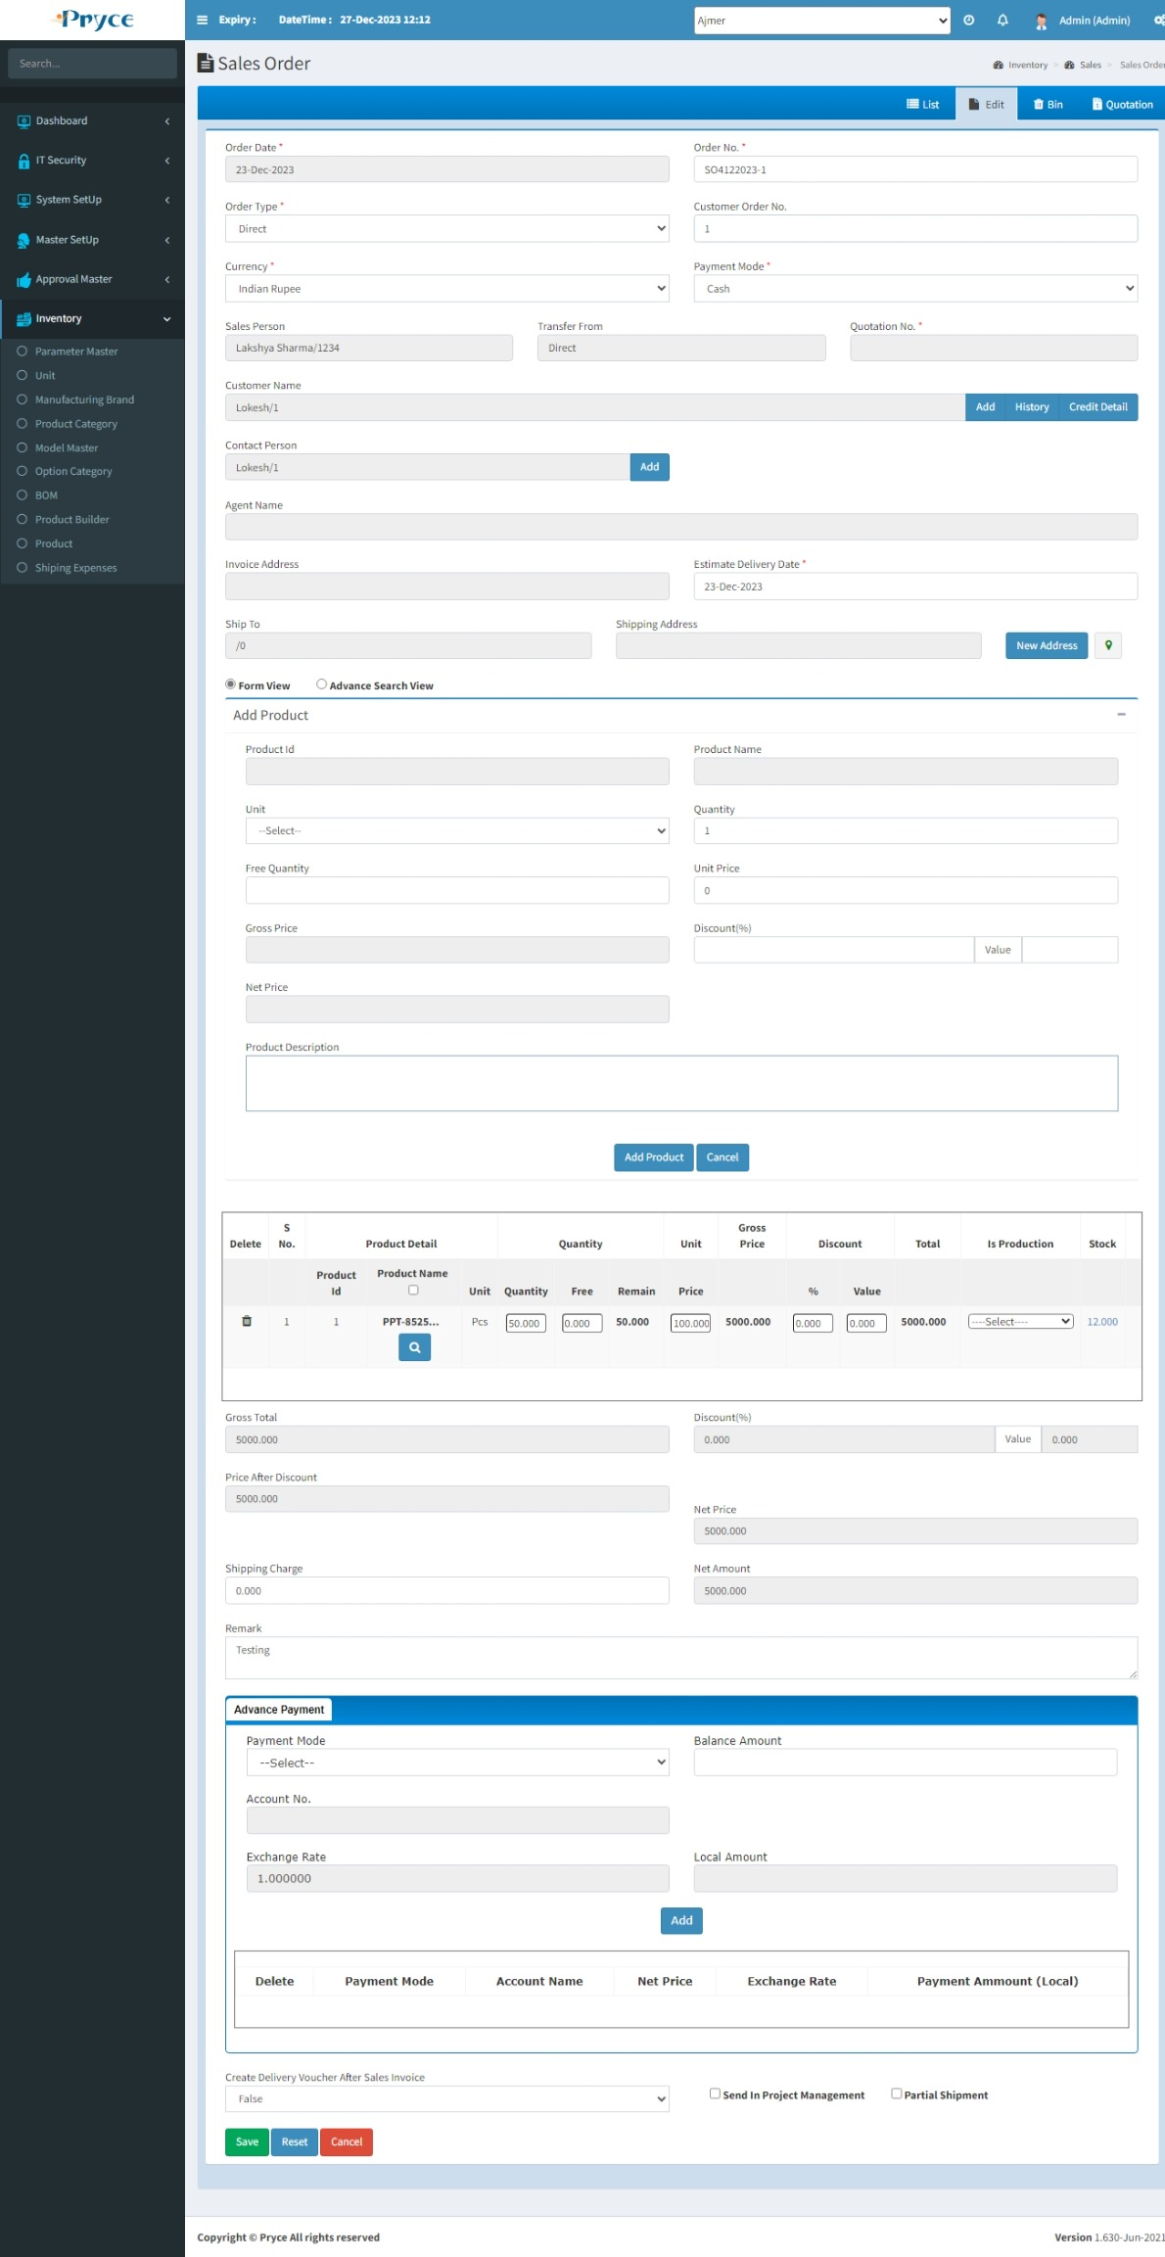

**Edit-** 

You can edit the record using the edit button.

**Note:- You can edit an only unposted record.**

When you will click on edit button the new tab is converted into edit and all records related to this button is showing in edit tab.

You can update the unit price ,tax(%),discount(%) than total will be updated according to tax & discount.

Amount and total amount,net amount are affected, according the total of all products.

You can also update the shipping charge than net amount will be updated.



**Delete-**

When you want to delete any record than click on delete button.

After deleting this record, This will remove from this list and go in the bin section where you will restore according to your requirement.

**Note:- You can delete an only unposted record.**

**New-**

In this tab you can create the new sales order.

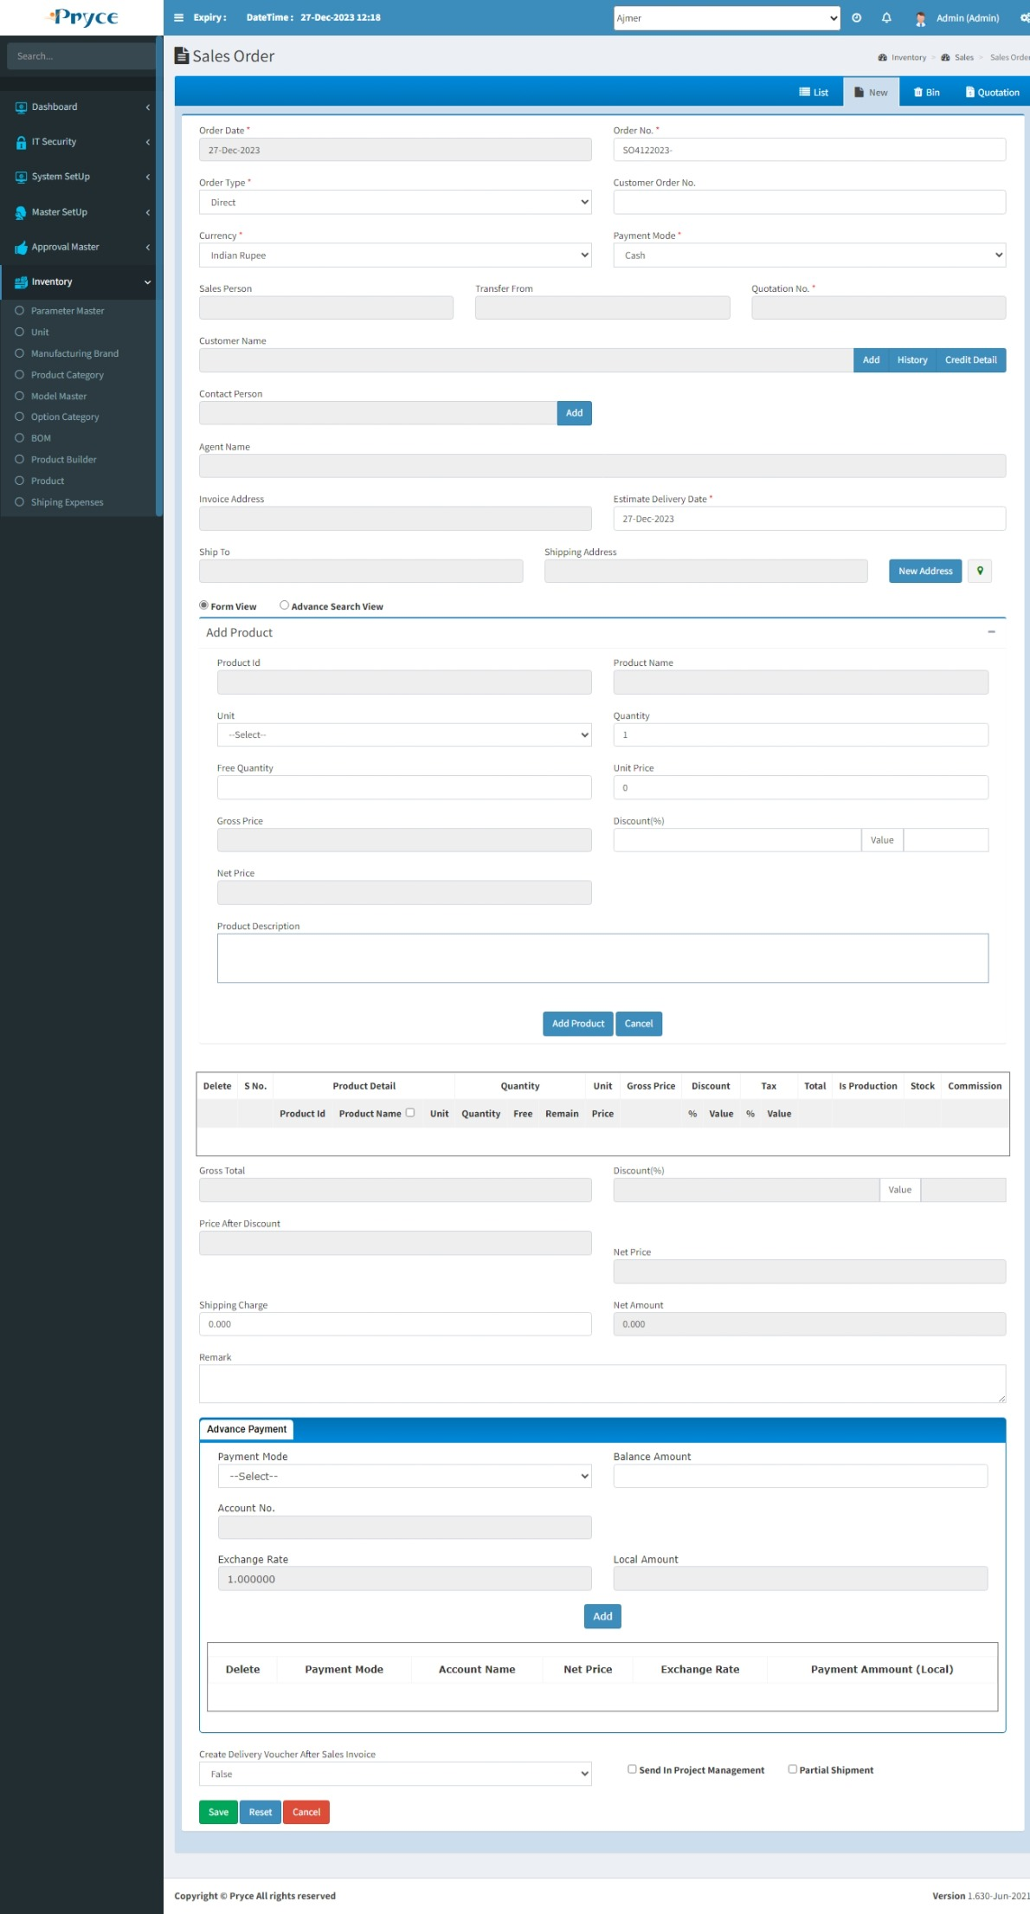

You create the sales order following two types:-

1. Directly
2. Sales Quotation
3. **Directly:-**

Using this option you can directly create the sales order.When you click on New tab.

First of all you select the direct option in the order type list.

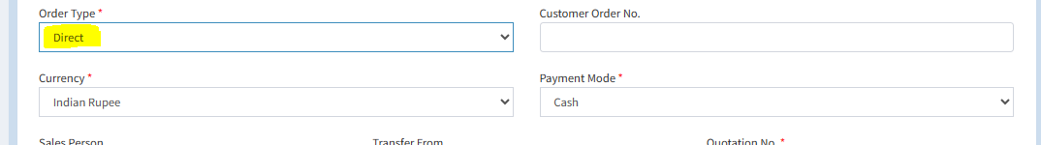

After that you can select the customer from the suggestion list. When you want to add new contact, then click on “Add” button.

When you select customer name from the suggestion list than “Invoice Address”,”Ship To” field automatically filled according selected customer.

Then you can select the “Estimate Delivery Date”.

You can select the “Shipping Address” in the search list.

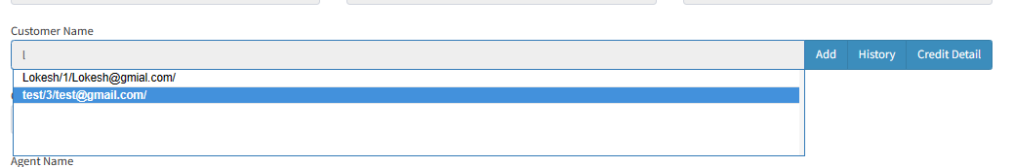

You can add product from “Form view” & “Advance Search View”.

**Product Name-**  You can search the product in search list extender by type the first one or two character of this product.

**Unit-** You can select the unit of this product.or by default show when in product master,Unit price given this product.

**Quantity-** You can enter the quantity of this particular product.

**Free Quantity**- In this field you can enter the free quantity of this particular product.

**Unit Price**- In this field you can give the unit price for this particular product.

**Net Price:**- It’s automatically calculated according the unit price and quantity.

**Discount(%)-** Here you can give discounts in percent & according percent value count automatically.

**Description:**- Description will come dynamically according the selected product.

You can enter the tax,discount & shipping charges as per the requirement and the price affected after tax,discount & shipping charge and also total amount will affect.

You can select the **send in purchase order option,** then this sales order will forward in purchase order page.

When you select “**Delivery Voucher”** option **“True”** than it’s require voucher create or this order forward in “delivery voucher”.

When the select “**Partial Shipment”** option **“True”** than order, arrange in partial shipment form or product wise show.

When you select **“Send In Production”** than this order forward in production master page. Here show which location to transfer the record.

1. **Sales Quotation:-**

You can create the sales order against the sales quotation.

Following stage to create sales order against the quotation.

Select the **by quotation option** in “order type” drop down list. Or also select from “Quotation” tab.

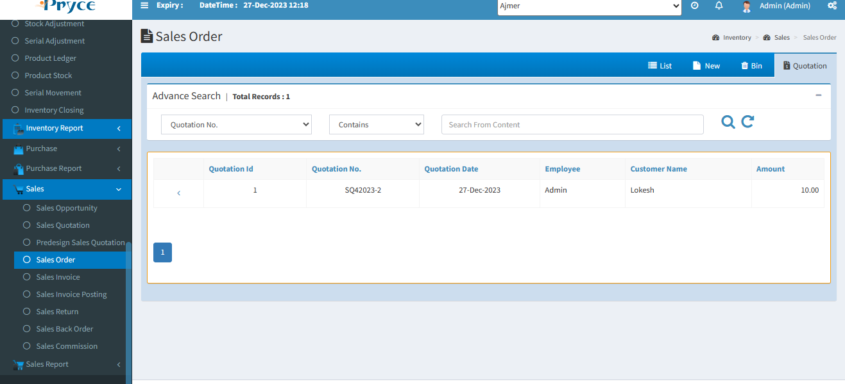

Select the quotation number in which quotation against you want to create the sales order. Or click on the Arrow button (<),When you click on this button than in “New” tab sales quotation detail open,Here you can edit the record for creates the sales order.

**Save-** You can save the record using save button.

**Reset-** You can clear the record using the reset button.

**Cancel-** You can redirect in list tab using cancel button.

**Bin-**

* In this tab you will get all deleted records from list, where you can again restore record.
* **Select all-**  In this you can select all records by clicking select all button.
* **Restore button- ** In this you can restore selected record by clicking on restore button and again add record in list or grid.
* In this you can also able to select the record individually by checked in the check box.
* Also, you search the particular record in the search window and when you want to restore, then checked and click on the restore button.

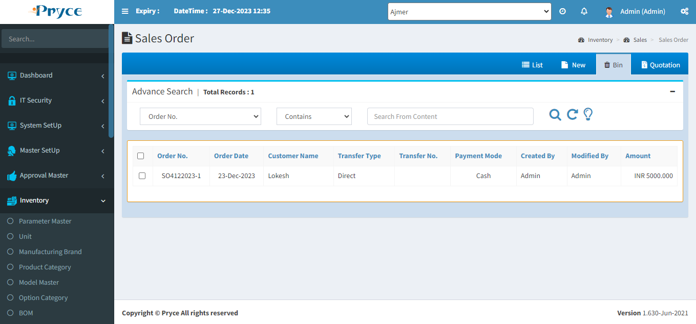

# 3.5 Sales Invoice:-

In this page you can save the sales Invoice against the sales Order and directly.

There are four tabs-

* List
* New
* Bin
* Pending Order

**List-**

In this tab you will get the all saved sales Invoice records and here you can edit,delete,view,print & also search, sort the record.

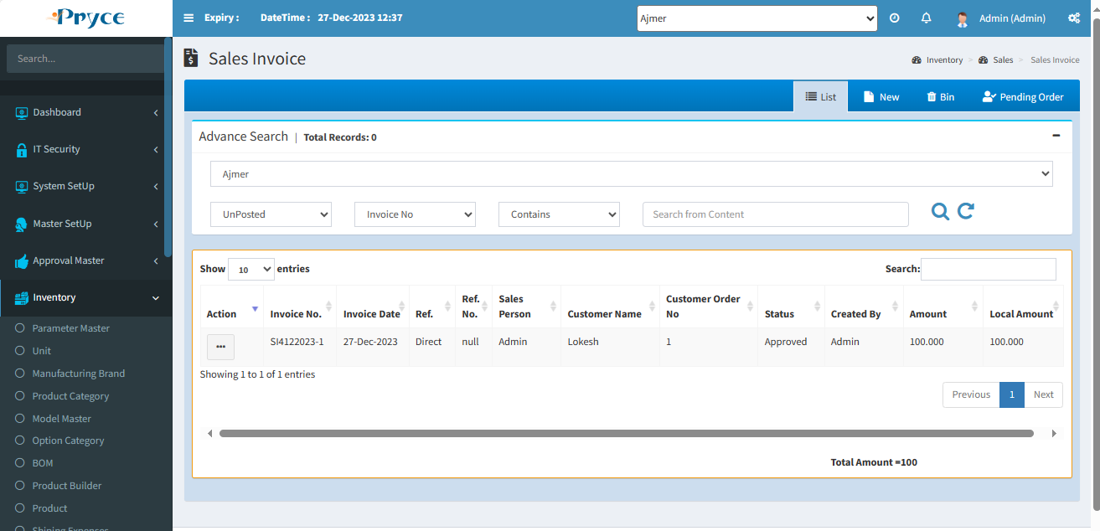

**Sorting-**

You can sort the record in ascending and descending order according to the column header in the grid (which is bold heading).

**Search Criteria –**

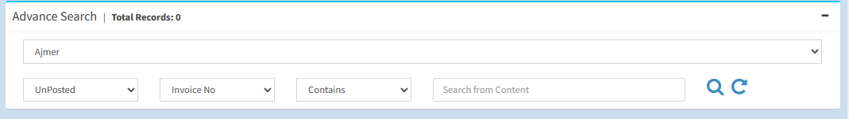

Here you can search according to the field of Invoice Id,Invoice No.,Order No.,Invoice Date, Sales Person,Customer Name,Status,Created By.,Amount than you will get a list of related sales invoice.

**Search-**  After that click on the search button and you get records according to search criteria in a record list.

**Refresh-**  After that you want to get again all records, then click on the refresh button.

**View-** 

You can view the record using view button.

**Note:-Here you can only view the record.**

On the click of view button the panel will open with the sales invoice record related to this view button.

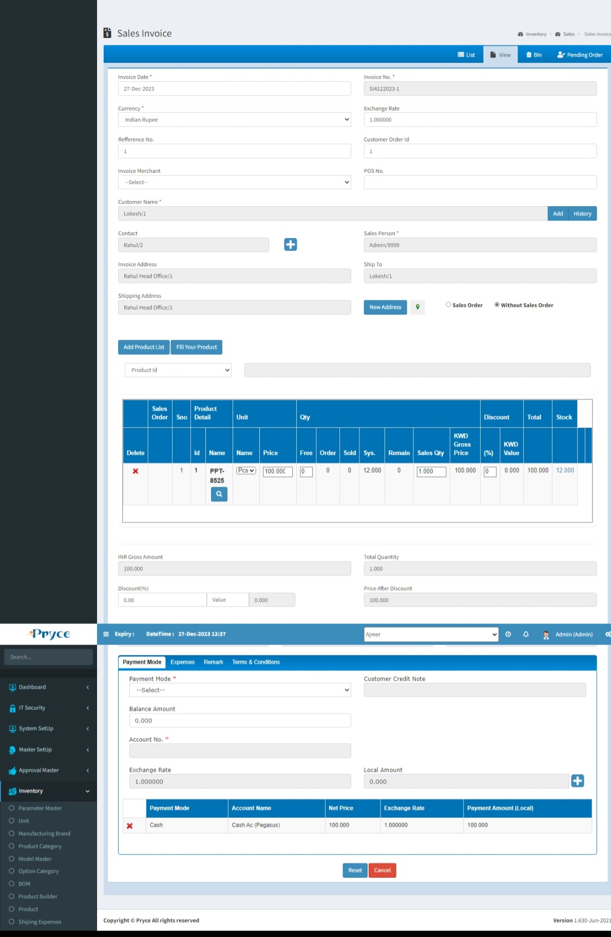

**Edit-** 

You can edit the record using the edit button.

**Note:- You can edit an only unposted record.**

When you will click on edit button the new tab is converted into edit and all records related to this button is showing in edit tab.

You can update the price, sales quantity, tax(%), discount(%) than total will be updated according to tax & discount.

Amount and total amount,net amount are affected, according the total of all products.

You can also update the expense charge than net amount will be updated.

Here you can delete the product in grid of product, and also delete & edit the payment mode.

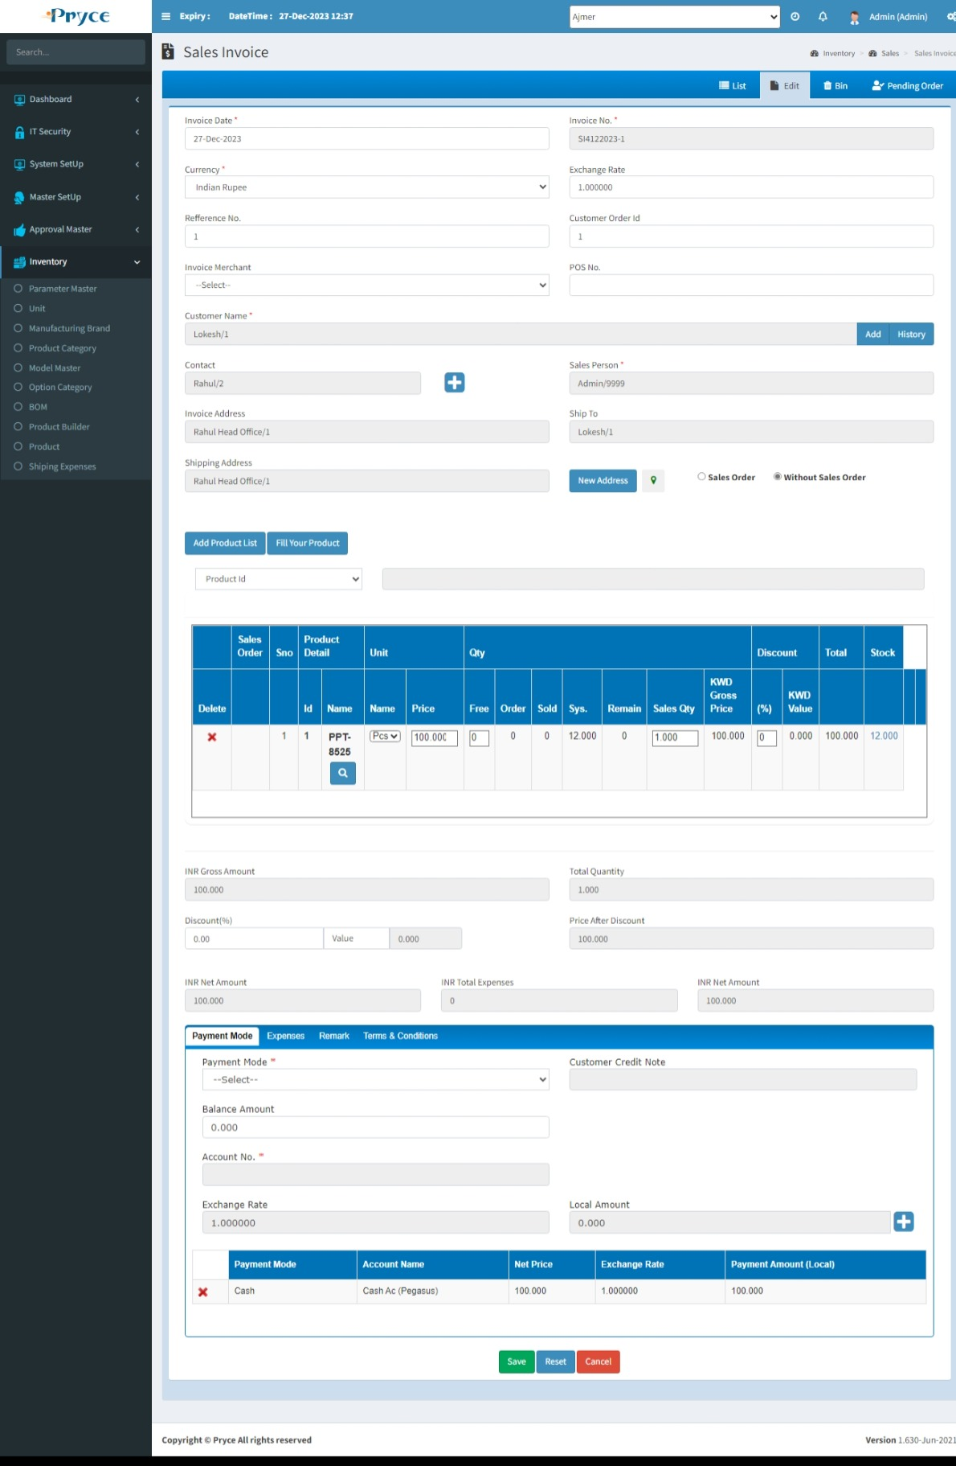

**Delete-**

When you want to delete any record than click on delete button.

After deleting this record, This will remove from this list and go in the bin section.

**Note:- You can delete an only unposted record.**

**New-**

In this tab you can create the new sales Invoice.

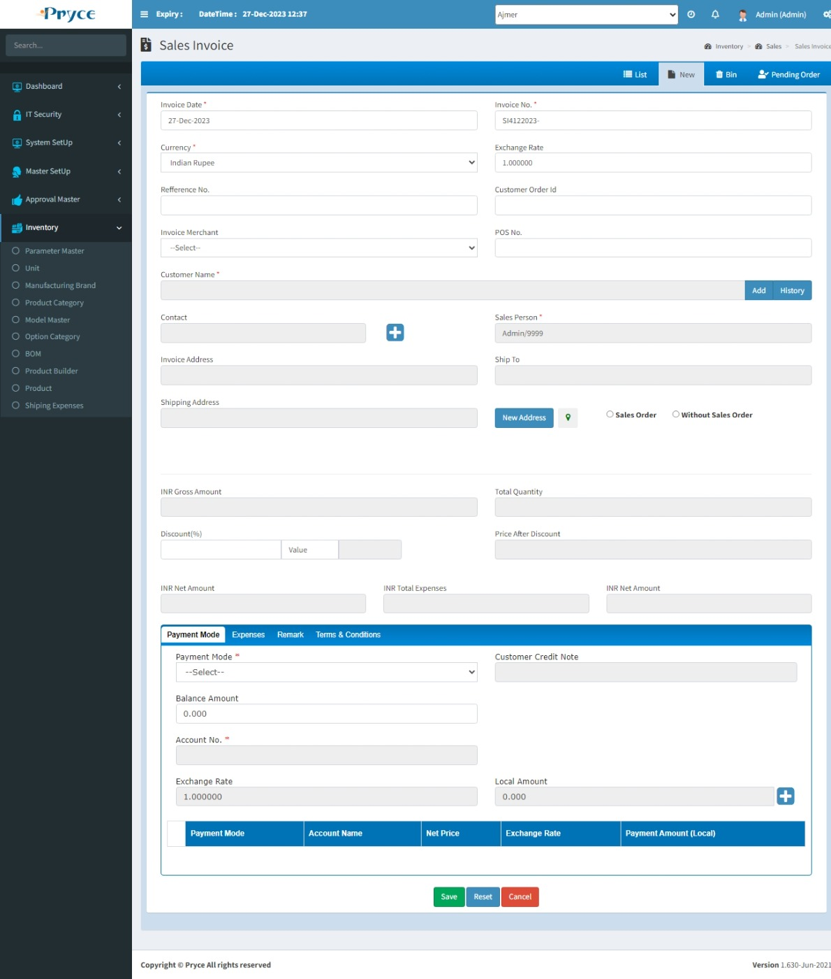

You create the sales Invoice by following two types:-

1. Directly
2. Pending Order/With Sales Order
3. **Directly-**

You can directly create the sales invoice.

First of all you select the “Customer Name” from the suggestion list.When you select a customer name, then “Invoice Address”, “Ship To”, “Shipping Address” field fill automatically according customer name.All detail comes from “Contact Master”.

After that select “Without Sales Order” option for direct sales invoice creation.

You can add product from “Form view” & “Advance Search View”.

Here you can add or update unit price,sales quantity. Also delete the product from the product list.

If you want to give Discount, Tax then gives in percent (%).

Net amount is calculated automatically according the grid total and net tax(%) and net discount(%).

Here you can add “Expenses” charge detail.

You can select payment mode for paying the amount.also you delete this payment record,If you want. Here “Net Price” must be equal to “Invoice Amount”.

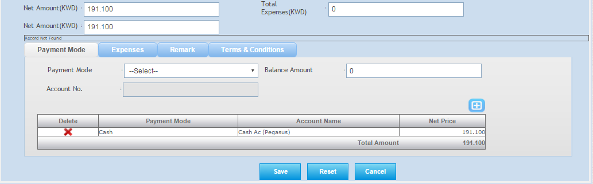

**Add Quantity-**You can add the quantity by adding a serial number using add button.

**How to add the serial number-** When you click on add button than serial panel will open.

You can enter the barcode of the selected product using the barcode option

Here set the focus in the text box and then scan the product from barcode scanner than serial number will be in serial panel.

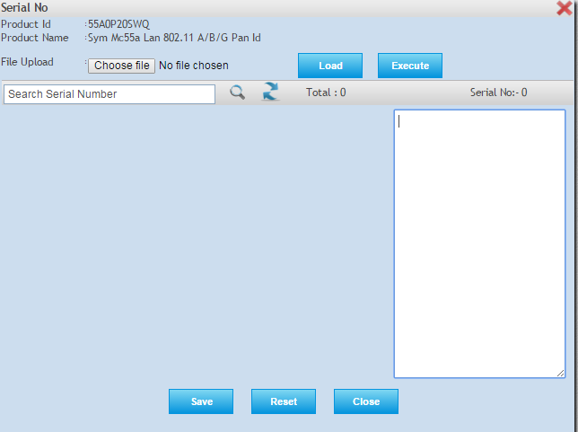

1. **Pending Order/ With Sales Order:-**

You can create the sales invoice against the purchase order.

Following stage to create sales invoices against the multiple sales order.

**Note:-Here you can create the one sales invoice against the multiple sales order and also multiple invoice against the one sales order.**

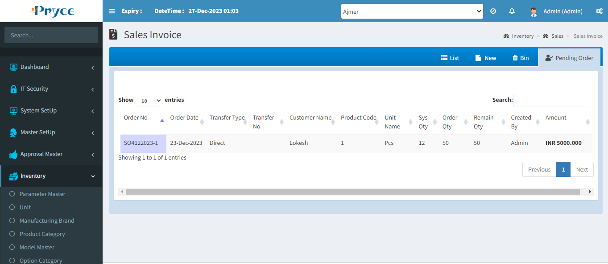

First of all you select the “Customer Name” from the suggestion list.

After that you can select the “Sales Order” option, According to customer name all sales order show. Sales Order or Product list shows with “Unchecked” check box. If you want to select product, then “Checked” check box.

Selected product price,quantity,discount,tax you can add or edit according to your requirement.

You can enter the sales quantity by adding the serial number.

**How to add the serial number:-**When you click on the add button, then serial panel will open.



Here set the focus in the text box and then scan the product from barcode scanner then the serial number will be in serial panel.

Net amount is calculated automatically according the grid total and net tax(%) and net discount(%).

If you “Unchecked” the sales order than sales order will be collapsed into the previous position.

**Note:- You can make the multiple sales invoice against the one sales order until the order quantity is not equal to the invoice quantity.**

**Bin-**

In this tab you will get all deleted records from the list.Here you can’t restore the record.

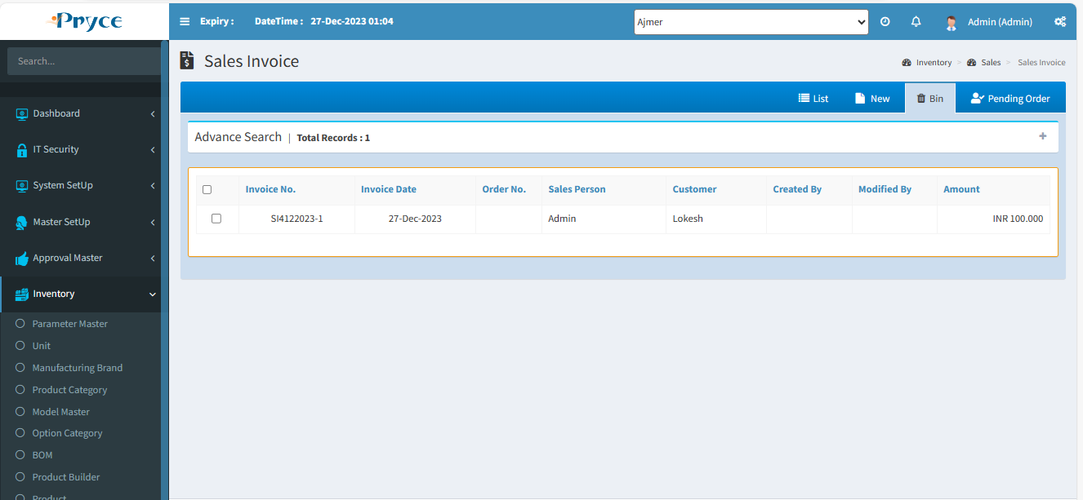

# 3.6 Sales Invoice Posting:-

In this panel have sales invoice for post the invoice record.

If you want to post the invoice, then first “Checked” check box of invoice which you want to post. When you select then click on “Post”.

**Note- At Invoice posting time product “stock quantity” must be greater or equal to “invoice quantity”.**

**Select All-**  You can select all records for posting by clicking on “Select all” button.

**Refresh Button-** You can refresh or “unchecked” selected record by clicking on refresh button.

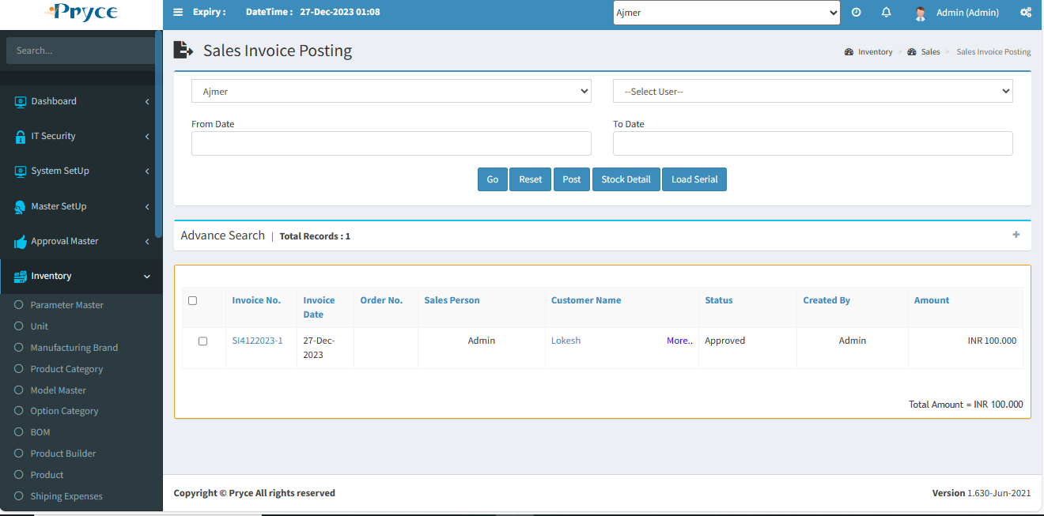

**Sorting-**

You can sort the record in ascending and descending order according to the column header in the grid (which is bold Heading).

**Search Criteria –**



Here you can search according to the field of Invoice Id,Invoice No.,Order No.,Invoice Date, Sales Person,Customer Name, Created By then you will get a list of related sales invoice posting.

Here to also search record date wise “From Date” to ”To Date” & click on “GO” button.If you want to print that record, then click on “Print” button.

**Search-**  After that click on the search button and you get records according to search criteria in a record list.

**Refresh-**  After that you want to get again all records, then click on the refresh button.

3.7 Sales Return:-

In this page customer return the product against the sales Invoice.

There are four tabs-

* List
* New
* Bin
* Sales Invoice

**List-**

In this tab you can get the all saved sales return record and here you can edit, delete, view,search and sort the record.

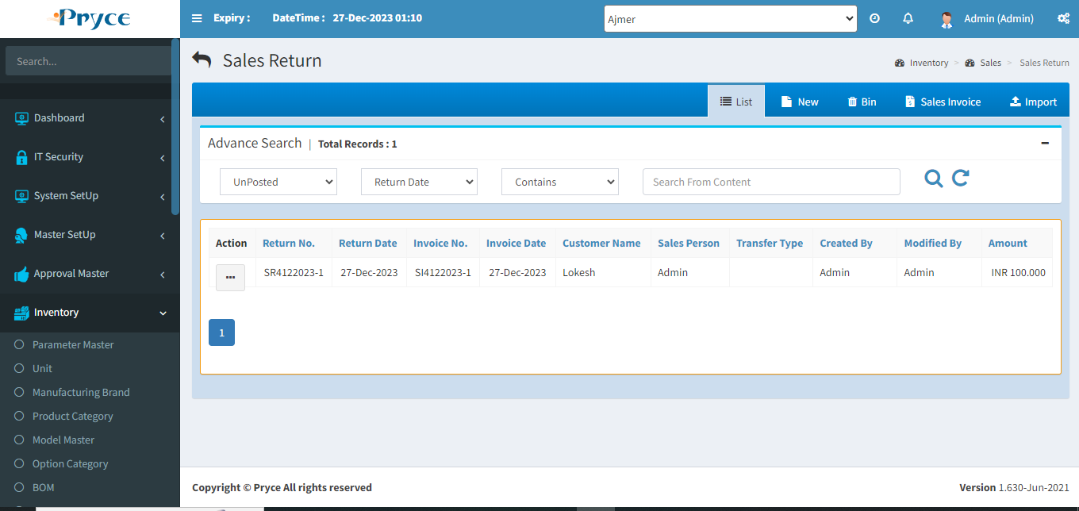

**Sorting-**

You can sort the record in ascending and descending order according to the column header in the grid (which is bold Heading).

**Search Criteria –**

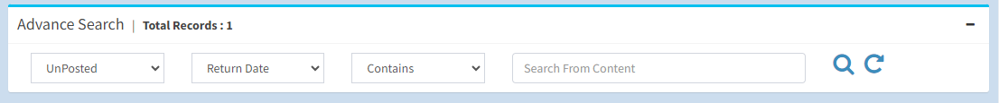

Here you can search according to the field of Return No.,Return Date, Invoice No., Invoice Date, Sales Person,Customer Name,Transfer Type than you will get a list of related sales return.

**Search-**  After that click on the search button and you get records according to search criteria in a record list.

**Refresh-**  After that you want to get again all records, then click on the refresh button.

**View-** 

You can view the record using view button.

**Note:-Here you can only view the record.**

On the click of view button the panel will be open with the sales return record related to this button like this -

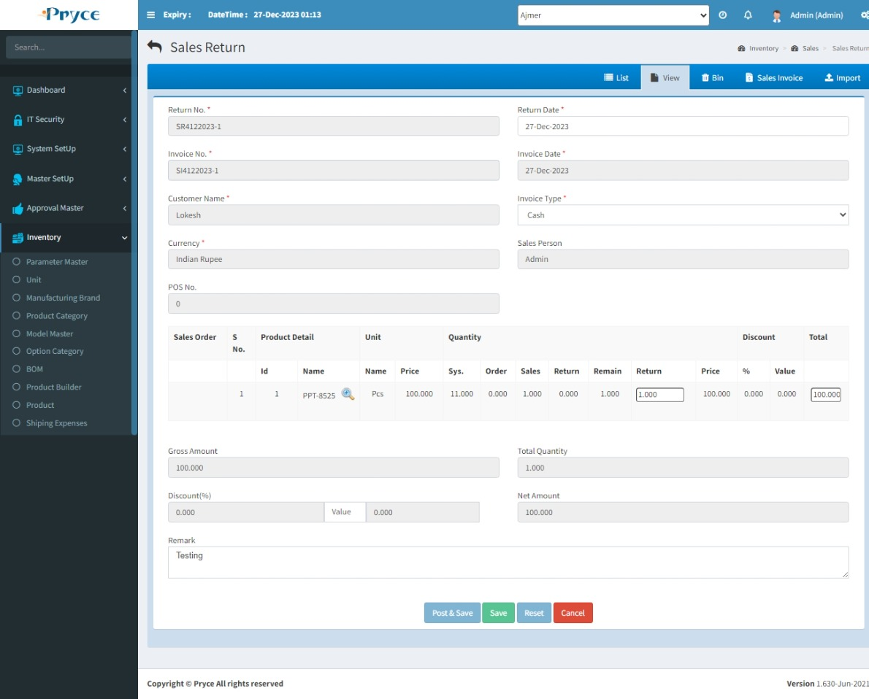

**Edit-** 

You can edit the record using the edit button.

When you will click on edit button the new tab is converted into the edit and all records related to this button is showing in the edit tab.

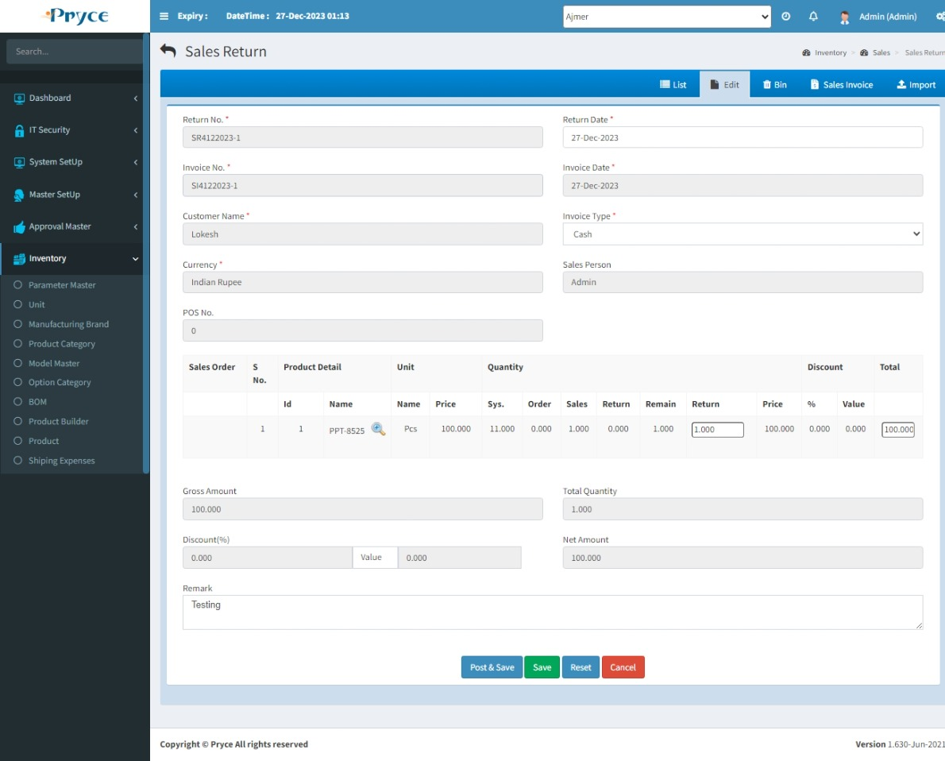

**Add Button-**  You can enter the return quantity by adding the serial number using the add button.

You can add the serial number as per your requirement, then click on save button than the return quantity is filled according the number of serial numbers.

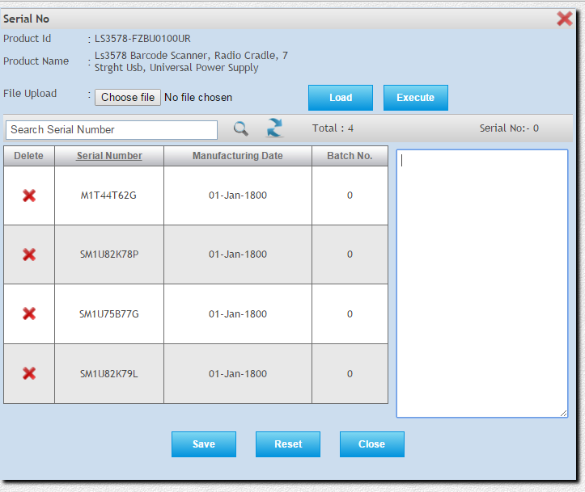

When you click on add button than the serial, panel is open.

You can enter the barcode of this product using the barcode option.

Here you can enter the serial number.

**Example-**You can enter two serial numbers than return quantity will be 2.

Using Same step you can add the serial number for another product of this invoice.

**Post & Save-**You cannot edit after post the record.

**Note:- Duplicate serial number will not accept.**

**Save-** You can save the record using save button.

**Reset-** You can clear the record using the reset button.

**Cancel-** You can redirect in list tab using cancel button.

**Delete-**

When you want to delete any record than click on delete button.

**Note:- You can delete only those records in which record is not posted.**

After deleting a particular record this record removes from this list and go into bin section.

**New-**

In this tab you can return the quantity against the sales invoice.

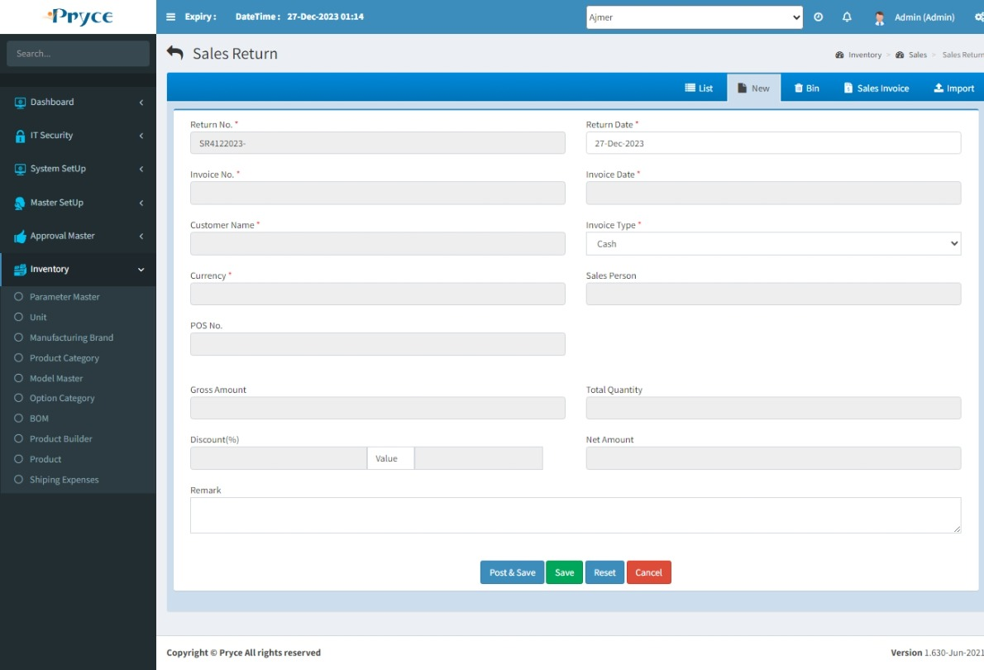

Follow the following steps to return the quantity-

First of all select the “invoice number” from the suggestion list.

When you select the invoice no.then related record show.And you can give here return quantity also discount according to your requirement.

**Post & Save-**You cannot edit after post the record.

**Save-** You can save the record using save button.

**Reset-** You can clear the record using the reset button.

**Cancel-** You can redirect in list tab using cancel button.

**Sales Invoice-**

In this all posted sales invoice there.

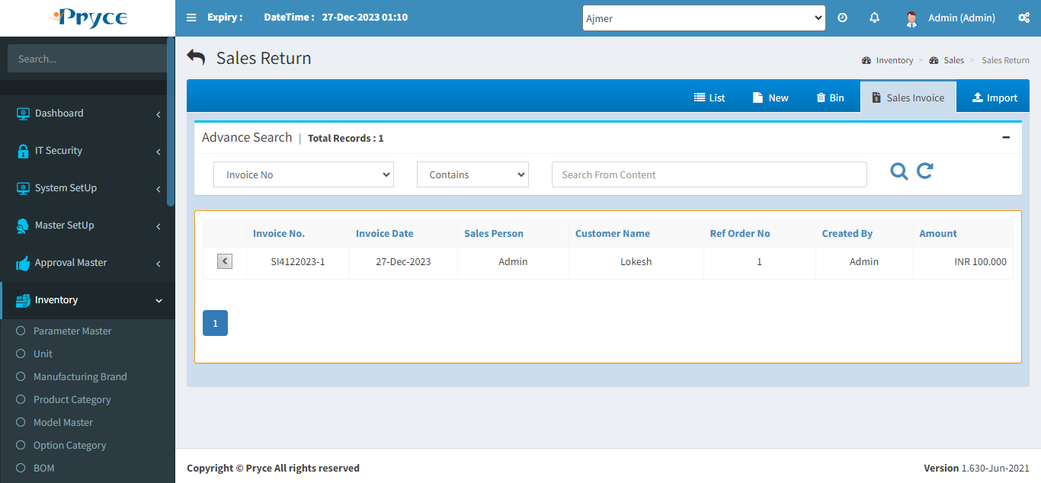

When you click on the arrow button (**<**) then related records will show in new tab.

Here you can give the “Return Quantity” by manually enter or add by serial no., when you give the return quantity, then “Total” show according to unit price and quantity.

Also, you can give here discount & Remark.After that you can “Save” or ”Post” the record.

**Bin-**

In this tab you will get all deleted records from the list.Here you can’t restore the record.

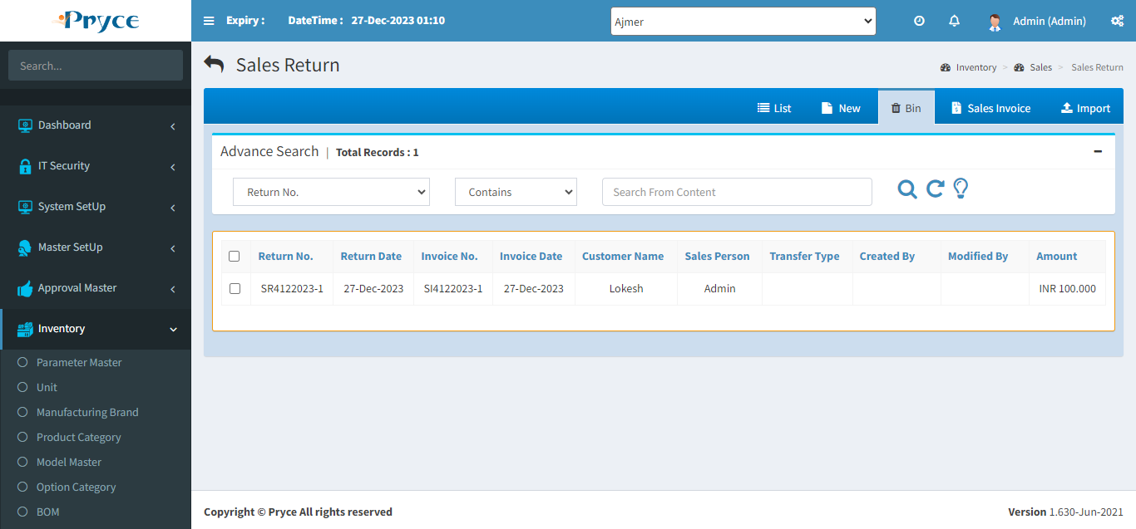

# 3.8 Delivery Voucher:-

A document accompanying a shipment of goods that lists the descriptions, and quantity of the goods delivered. A copy of the delivery voucher, signed by the buyer or consignee, is returned to the seller or consignor as a proof of delivery.

In this saved delivery voucher record, all those records come from sales order who’s “Delivery voucher” option “True”.

There are Three tabs-

* List
* New
* Pending Order

**List-**

In this tab all save, record are there like- Posted, Unposted, All. Here you can edit, view,delete,search & sort the record.

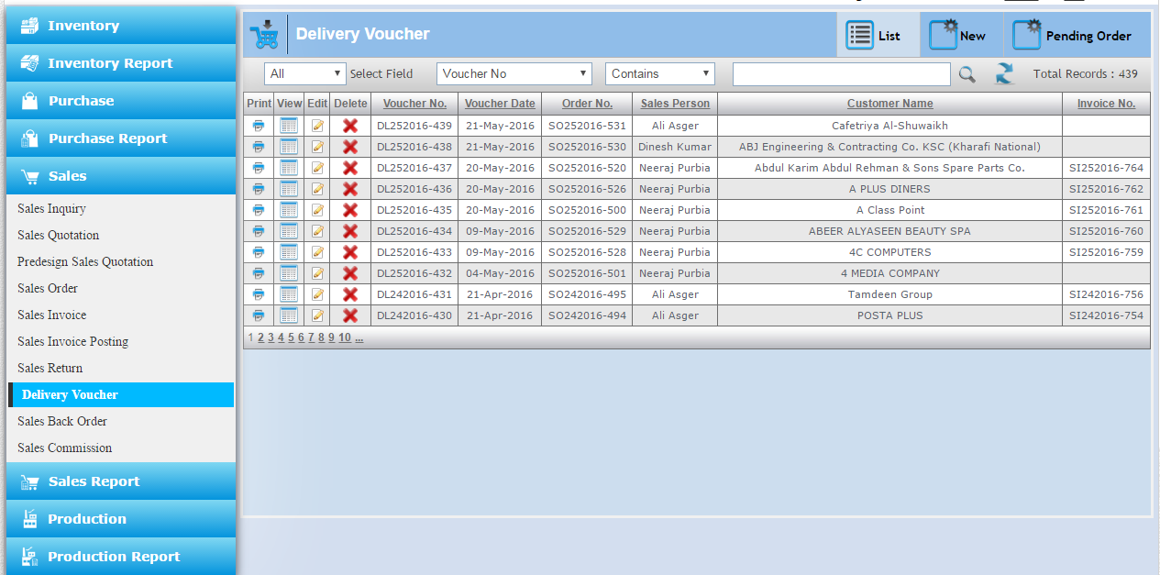

**Sorting-**

You can sort the record in ascending and descending order according to the column header in the grid (which is underlined).

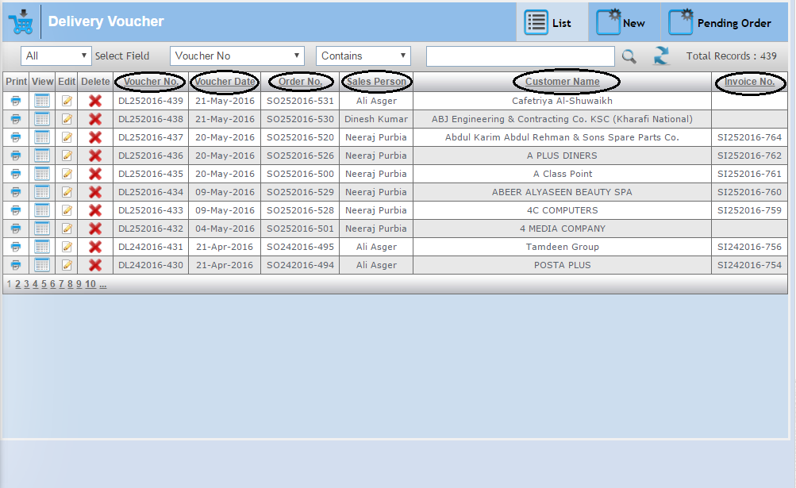

**Search Criteria –**



Here you can search according to the field of Voucher No., Voucher Date, Order No., Sales Person, Customer Name then you will get a list of related delivery voucher.

**Search-**  After that click on the search button and you get records according to search criteria in a record list.

**Refresh-**  After that you want to get again all records, then click on the refresh button.

**View-** 

You can view the record using view button.

**Note:-Here you can view & reset the record.**

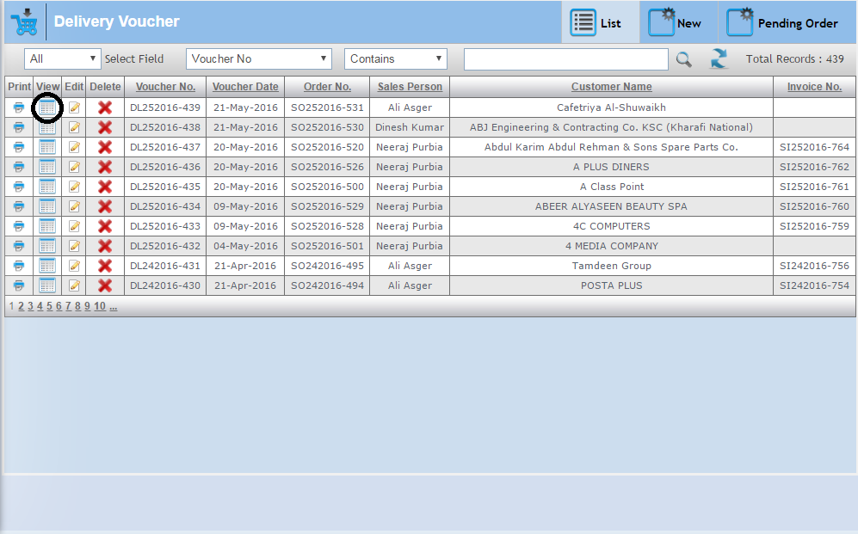

On the click of view button the panel will be open with the delivery voucher record related to this button like this -

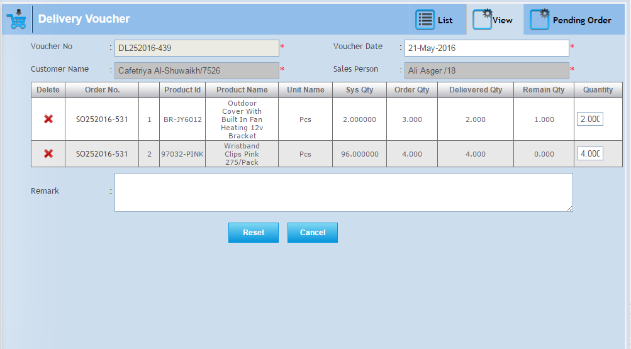

**Edit-** 

You can edit the record using the edit button.

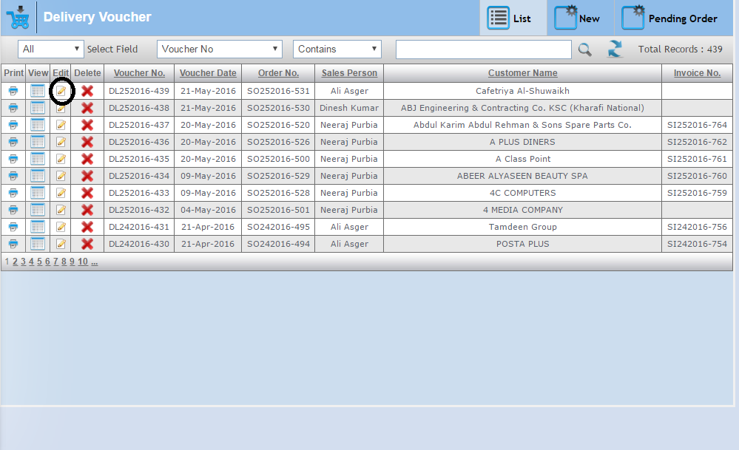

When you will click on edit button the new tab is converted into the edit and all records related to this button is showing in the edit tab.

Here you can edit the sales person field, quantity, remark.

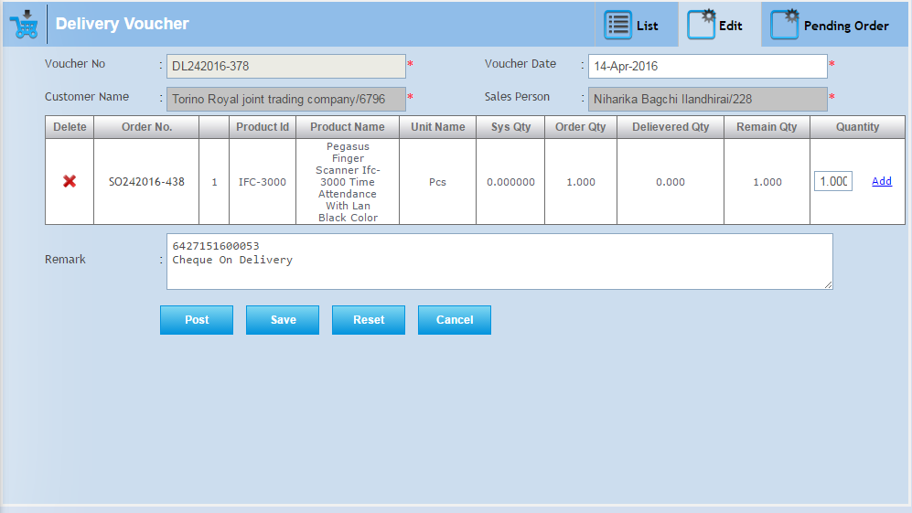

**Delete-**

When you want to delete any record than click on delete button.

**Note:- You can delete only those records in which record is not posted.**

After deleting a particular record this record removes from this list.

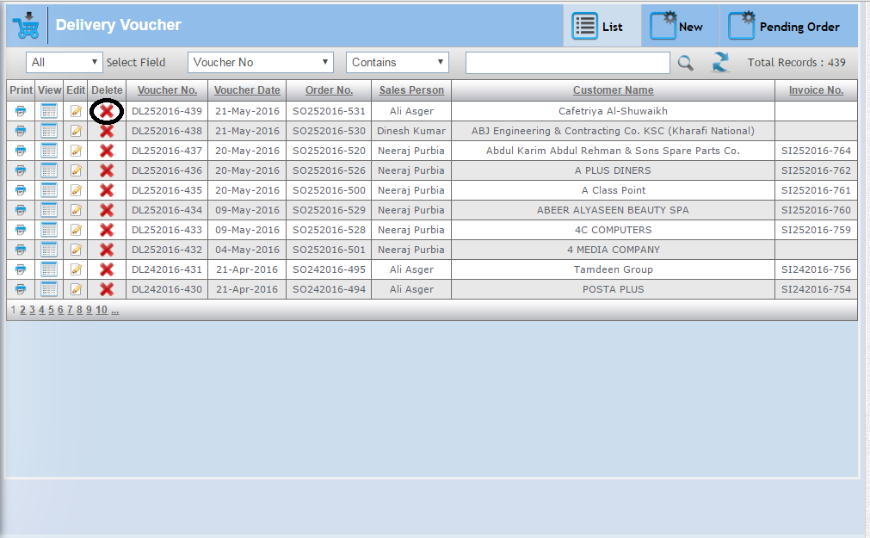

**New-**

In this create delivery voucher against pending order.

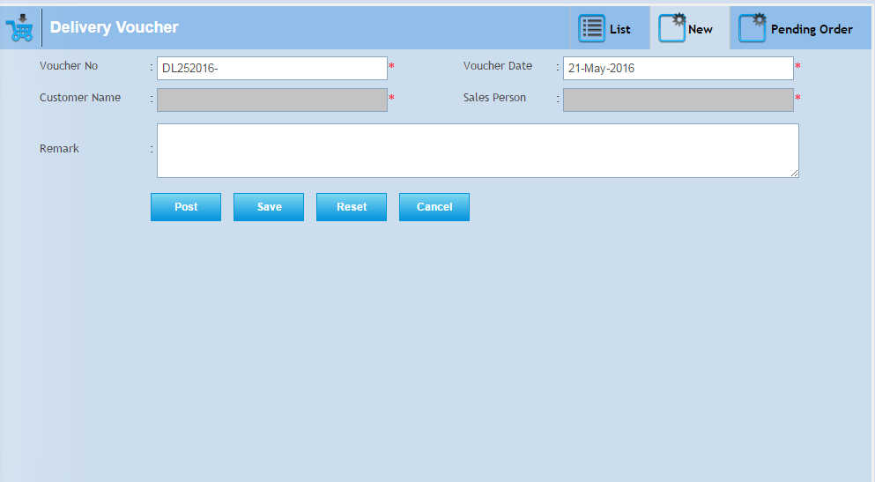

**Pending Order-**

In this tab pending order show who’s “Delivery Voucher” option “True”. And order show, according to product wise.Because of “Partial Shipment” option “True”. When partial shipment option true, then you can give **delivered quantity less than order quantity** and still remaining quantity of order show in the pending order list.

When partial shipment option false in the sales order, then here order not show product wise, also when you create delivery voucher and you give **delivered quantity less than order quantity,** then remaining quantity of order record not show in pending order.

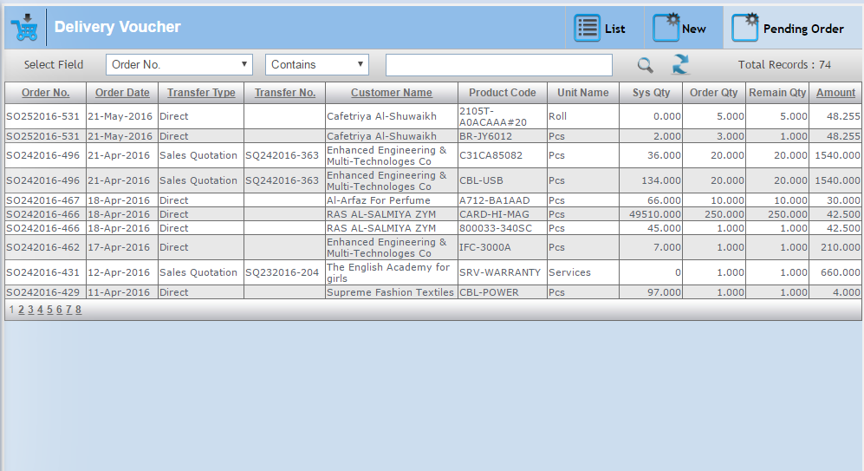

Delivery voucher creates against pending order, First select “customer name” from the suggestion list. Customer name selection according to pending order. Or who’s pending order.

When you select a customer name, then all related order or product show, according to customer selection. Here all those product show, Who’s customer name same.

Here you can select or checked the product which you want to create a voucher. Also delete the product in the selection list of products.

You can add quantity by “Add” button click, When you click on the add button, then the serial number page will open,Here you can add serial number quantities.

You can add quantity manually.

Here select sales person’s name and give remark. And you can save or post the record.

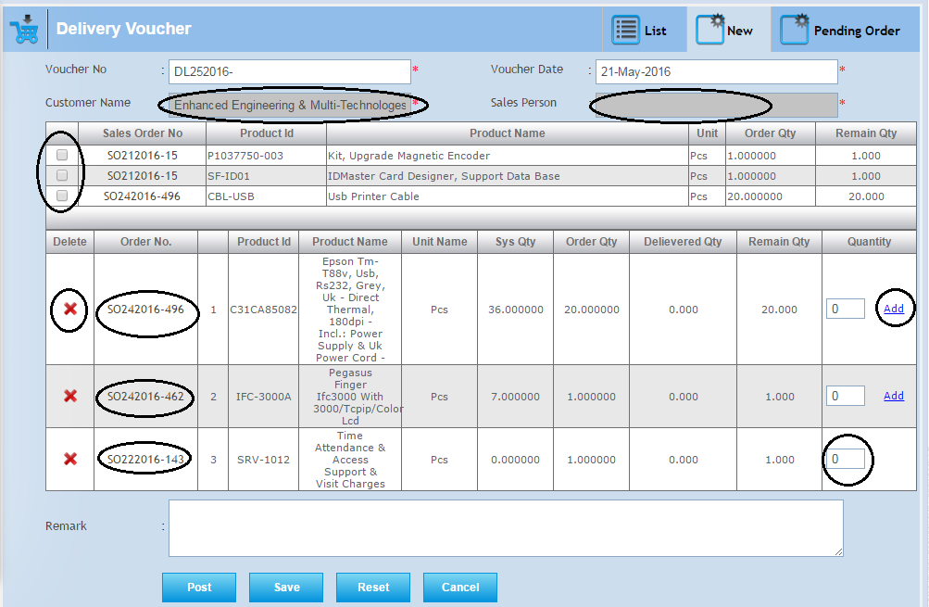

# 3.9 Sales Back Order:-

In this record comes from sales order for back order.

**List-**

In this tab you can get the all saved sales order record and here you can edit, search and sort the record.

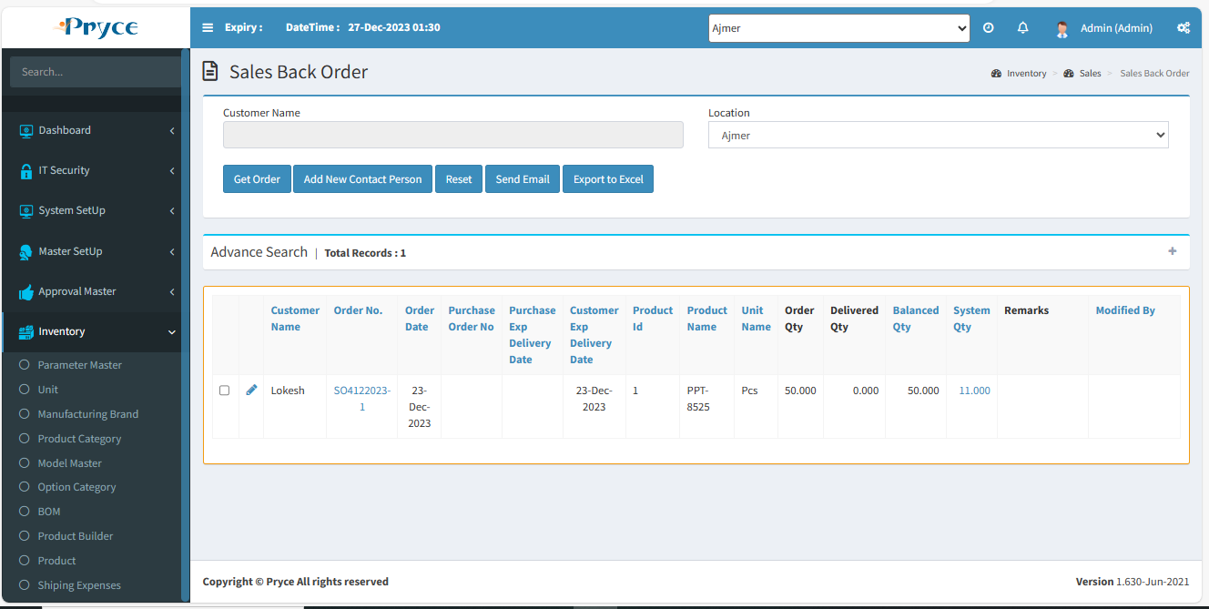

**Sorting-**

You can sort the record in ascending and descending order according to the column header in the grid (which is bold heading).

**Search Criteria –**

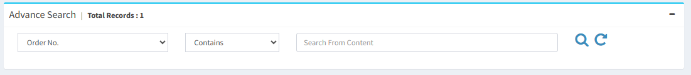

Here you can search according to the field of Order No., Order Date, Customer Name, Product Id, Product Name then you will get a list of related sales back order.

**Search-**  After that click on the search button and you get records according to search criteria in a record list.

**Refresh-**  After that you want to get again all records, then click on the refresh button.

**Edit-** 

You can edit the record using the edit button.

When you will click on the edit button, then related record show.Here you can’t edit any field only “Save” the record.Then this record edited.and remove from the list of records.

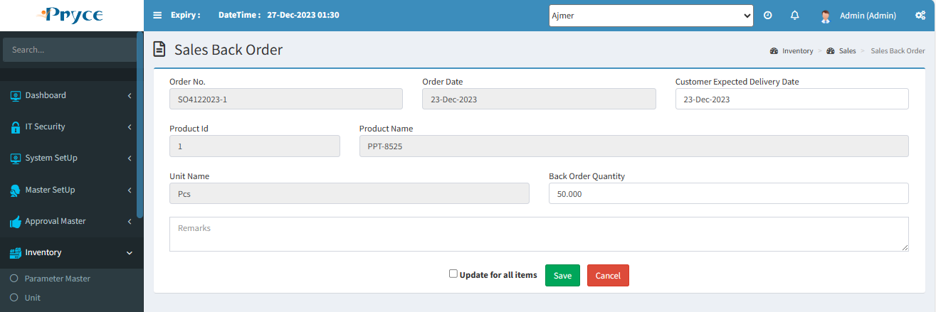

# 3.10 Sales Commission:-

Sales commission create according to the number of invoices created by employee. In this commission count for employees.

There are two tabs-

* List
* New

**List-**

In this tab saved record of sales commission, Also here you can edit, view, delete, search & sort the record.

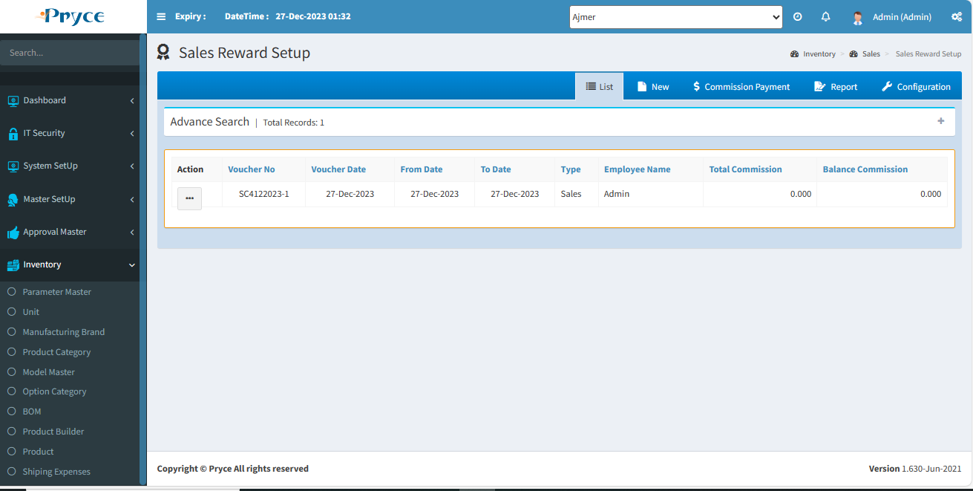

**Sorting-**

You can sort the record in ascending and descending order according to the column header in the grid (which is bold heading ).

**Search Criteria –**



Here you can search according to the field of Voucher no., Voucher date, Type, Employee name, then you will get a list of related sales commission.

**Search-**  After that click on the search button and you get records according to search criteria in a record list.

**Refresh-**  After that you want to get again all records, then click on the refresh button.

**View-** 

You can view the record using view button.

**Note:-Here you can view & reset the record.**

On the click of view button the panel will be open with the sales commission record related to this button like this –

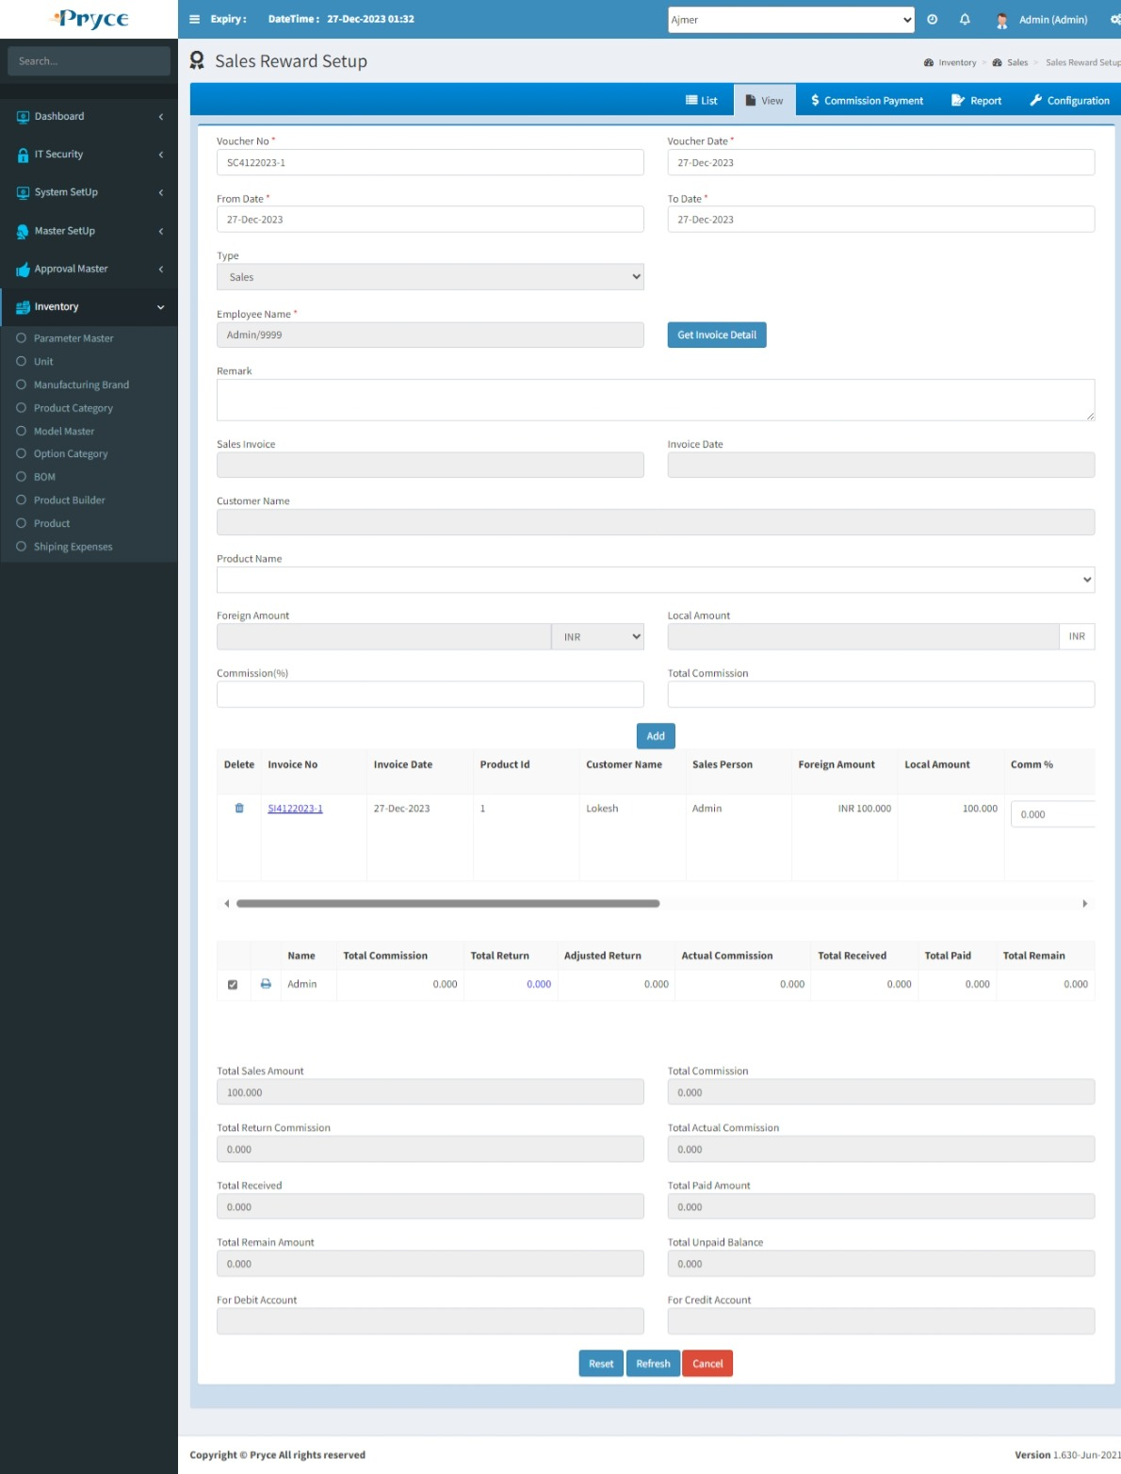

**Edit-** 

You can edit the record using the edit button.

When you will click on edit button the new tab is converted into the edit and all records related to this button is showing in the edit tab.

In “Commission Person” field, Click on “Add” button for adding the person one or more for commission, If you required. This case required when invoice created by more than one person. In this condition commission (%) distributed half-half.

If you want to add sales invoice, then sales invoice field selects from the suggestion list and fill required detail & click on Add.

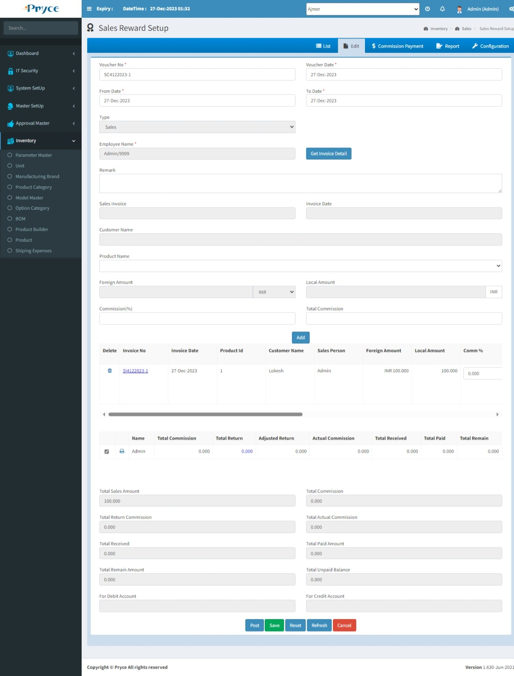

**Delete-**

When you want to delete any record than click on delete button.

**Note:- You can delete only those records in which record is not posted.**

After deleting a particular record this record removes from this list.

**New-**

In this tab you can get details of employee commission also invoice create details.

First, you select “From Date” to “To Date” according to your requirement.

Then select “Type” such as- Sales, Technical, Agent.

Select “Employee Name” which invoice detail you get.

When you select “Sales Invoice” no. from the suggestion list than Customer Name, Invoice Date show, according to sales invoice selection, Also here you can select the product name from the drop down list. Amount show, according to the selected product. Also here you can give commission and add to invoice detail list.

